User Guide: **Services Pending Provider** Report

# Overview

In September 2021, a new process will be deployed in SIMS to track details of certain pending in-home service referrals for consumers Services identified are interventions specific to a consumer’s assessed need and person-centered care plan.

The statewide tracking method establishes a consistent operational process and enables quantification of pending referrals for in-home service interventions for consumers. The tracking method and subsequent reporting provides pending service referrals by service, by region, by program, by key obstacle to service. It also allows a longitudinal view, counting the number of days a particular service need is unmet. This process tracks and quantifies unmet consumer needs for in-home services

* Chore
* Companion
* Home Health Aide
* Homemaker
* Personal Care
* Supportive Home Care Aide

For the details of data entry to record such a consumer’s unmet need (service, dates, units, etc.), see the Business Rule document **SAMS Job Aid Unknown Provider Pending Referral.doc** available at <**location name**> (<**link to location**>).

# Report Runner: Locate and load the report

The Services Pending Providers may be run only by authorized users with access role HAR Report Runner. Login to Report Library, using your current WellSky userid and password. If you do not have this access role, it can be requested through your ASAP’s Access Manager.

URL: <https://har4.harmonyis.net/MA/Report%20Library>.

Navigate to [Report Library](https://har4.harmonyis.net/MA/Report%20Library) > [Community](https://har4.harmonyis.net/MA/Report%20Library/Forms/AllItems.aspx?RootFolder=%2FMA%2FReport%20Library%2FCommunity&FolderCTID=0x012000F1AEBAEDCEA0F64F927CD7A91C5423F2&View=%7b78AEEA42-CE2C-4C4C-AAB5-12DE60C0E675%7d) > [Useful Reports](https://har4.harmonyis.net/MA/Report%20Library/Forms/AllItems.aspx?RootFolder=%2FMA%2FReport%20Library%2FCommunity%2FUseful%20Reports&FolderCTID=0x012000F1AEBAEDCEA0F64F927CD7A91C5423F2&View=%7b78AEEA42-CE2C-4C4C-AAB5-12DE60C0E675%7d)

Open the report whose title is [Services_Pending_Providers - r0 - 9-17-2021](https://har4.harmonyis.net/MA/Report%20Library/Community/Useful%20Reports/Services_Pending_Providers%20-%20r0%20-%209-17-2021.rdl). Note – this filename will change as the report is updated, so look for the report in this folder with the stem **Services Pending Providers**, with the most recent update date.

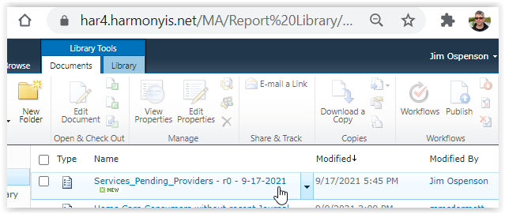

# Run the Report

## Set Parameters

A report runner can indicate their **ASAP**(s) of interest. Statewide **Care Programs** providing in-home services are defaulted.

### Care Programs

The report defaults to show Pending Provider service plans in all key Care Programs, in which this method is authorized. Most users will not want to adjust the Care Programs, but it is available.

|  |  |  |  |
| --- | --- | --- | --- |
| Choices / Waiver  Home Care Basic / Waiver | ECOP / Non-Waiver  Home Care / Over-Income  Home Care Basic / Non-Waiver  Respite / Over-Income | SCO - BMC HealthNet 1 (Primary)  SCO - Commonwealth Care Alliance 1 (Primary)  SCO - Fallon Navicare 1 (Primary)  SCO - Senior Whole Health 1 (Primary)  SCO - Tufts 1 (Primary)  SCO - United 1 (Primary) | One Care - Commonwealth Care Alliance  One Care - Network Health Unify |

### Agency

Set the AGENCY parameter to display the ASAP(s) of interest. You may choose more than one ASAP.

### Export to Excel

Export the report’s output to Excel. The rest of this User Guide will refer to the XLS and its named tabs.

# About the dataset

Each row of the dataset represents a unique Service Plan, specified by Consumer, Care Program, Care Plan, Service, Service Plan, and Service Schedule. A consumer might have several Service Plan rows, with Open or Not Open referrals, as a consumer might have renewed Care Plan or transferred programs while waiting for service. Open Referrals can be tracked across service plans and programs by use of the Service Plan Status Date, which can indicate that a consumer has been waiting since before the Service Plan Start Date.

Note that Service Plans within Care Plans where [Care Plan Start Date] >= [Report Run Date] are discarded. Care Managers will commonly prepare such Care Plans using the Copy Care Plan function, preparing for an Annual Redtermination. However referrals cannot have future start dates – they throw off calculations of Days Unmet.

See the section of this document headed **Tab: Flat File** for a list of the fields of the dataset. Most of the fields are from the Service Plan (aka Service Allocation) records, as well as the Consumers connected to the Service Plans. Other fields are calculated or derived from the various Dates, Allocations, and Statuses of related Service Plan, Care Plan, and Care Enrollment records.

## The query is based on Service Plans where Provider = **Unknown** & Service = **Referral_Pending**

There are currently six (6) services underpinning this report.

|  |  |
| --- | --- |
| Homemaker - Pending  Personal Care – Pending  Companion – Pending | Chore – Pending  Home Health Aide – Pending  Supportive Home Care Aide – Pending |

This report is based purely on looking for service plans where Provider = **Unknown Provider/Referral Pending** & Service = <Service> -Pending. All other information in these Service Plans must be accurate, according to the Home Care Business Rule.

## Setting the attribute [**Calculated_End_Date]**

This is filled with the Service Plan End Date. If the Service Plan’s End Date is blank, Calculated_End_Date is set to be the report’s Run Date, the date that a user ran the report. This is used to calculate days waiting for service and aggregating unmet need, and comparing open referrals to referrals where the provider has been located, of the consumer has withdrawn their referral.

## Setting the attribute **[Referral_Status]**

Within the dataset, Referral_Status is always calculated relative to today(), i.e. the report’s Run Date.

Referral_Status is calculated in order, sequentially:

| **IF {condition}** | **THEN Referral Status** | ***Meaning the referral is*** |
| --- | --- | --- |
| Consumer’s Care Enrollment has a Termination date | Terminated Care Plan | *not open* |
| [Service Plan End Date] <= [Care Plan End Date]  (and)  [Service Plan Status] = WITHDRAWN | Withdrawn | *not open* |
| [Service Plan End Date] < [Care Plan End Date] | Provider Located | *not open* |
| [Service Plan End Date] = [Care Plan End Date] | Terminated Care Plan | *not open* |
| [Service Plan End Date] is NULL  (and)  [Care Plan End Date] >= today()  (and)  [Care Enrollment Termination Date] is NULL | Open | *open* |

## Setting Other Attributes

| Calculated value for each row in dataset | Method |
| --- | --- |
| **[Days Unmet]** | Calculated by date math: the number of days [Calculated_End_Date] minus [Service Plan Start Date] + 1. Add 1 to avoid duration = 0. |
| **[Days Unmet using Status Date]** | Calculated by date math: the number of days [Calculated_End_Date] minus [Service Plan Status Date] + 1. Add 1 to avoid duration = 0.  Note: this element is calculated if and only if the [Service Plan Status Date] is earlier than the [Service Plan Start Date]. This construction avoids shortening the waiting time duration in case of accidental edit to [Service Plan Status Date]. |
| **[Allocation_Type_Error]** | Set to 1 if the Service Plan Allocation Type is Monthly or Duration Specified. Otherwise 0. |
| **[Error_Future_Start_Date]** | Set to 1 if [Service Plan Start Date] is greater than the Report’s Run Date. Otherwise 0. |

# Tabs in the exported report

Users will export the report output into an Excel document (XLS) and save it to their folder of choice. The XLS will contain the following tabs. See below for screenshots & descriptions.

|  |  |  |  |  |  |  |
| --- | --- | --- | --- | --- | --- | --- |
| Consumers x RefStatus x Service | Summary - Unmet Units this week | provider-facing (4) | Open Refs - Consumers x Zip | Open Refs - Unmet Units per wee | error log | Flat File |

## Tab: Consumers x RefStatus x Service

Shows all Referral Statuses. For more info on Referral Status, see the section “Setting the attribute **[Referral_Status]**”.

Counts unduplicated consumers waiting for service. A consumer who is waiting for Both Companion and for Homemaker would only be counted once in the Totals row.

Summarized by Referral Status, Agency, and Service.

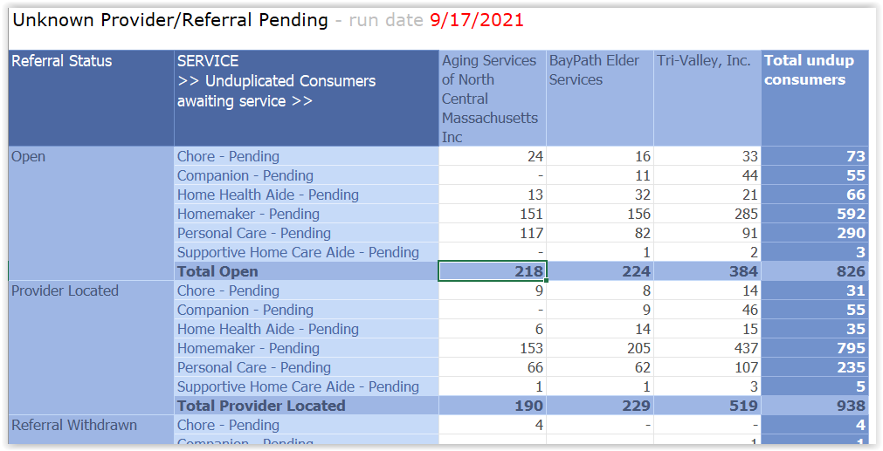

## Tab: Summary - Unmet Units this week

Sorted by Agency, Town, Zip, Consumer ID.

Filter: Referral_Status = OPEN only.

Summarizes Open referrals by obstacle to service, i.e. the aggregated sub-services (e.g. Pets).

Aggregates all services (e.g. HM, PC, Comp) to focus on the obstacles.

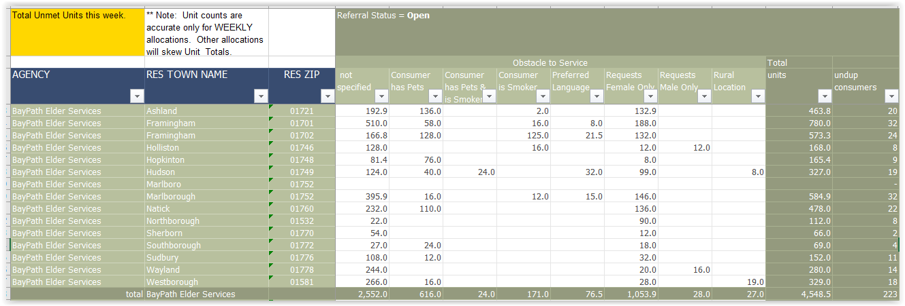

## Tab: provider-facing (4)

This tab is intended to be distributed to Providers.

Filter: shows Referral Status = OPEN only.

Sort by ASAP, Town, Zip, Consumer, Service.

One row per Open Referral, showing specific service, and circumspect Consumer particulars such as Town, Zip, Consumer Gender Identity, Preferred Language, Total Units Allocated and preferred service schedule day, if indicated by CM. The Free Text column contains the union of [Service Plan Desired Outcome] and [Service Plan Comments], as entered by the CM. Allocation Type Errors (e.g. Monthly) are indicated.

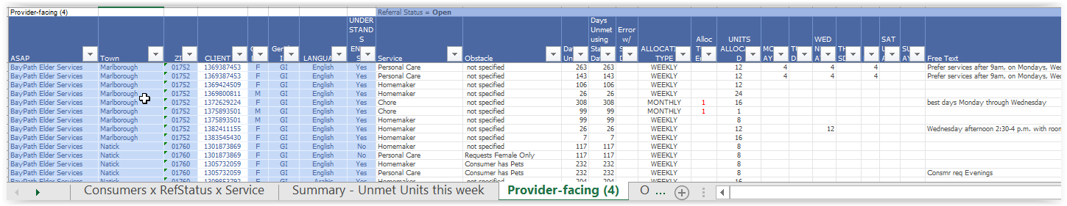

## Tab: Open Refs - Consumers x Zip

Open Referrals only.

Counts unduplicated Consumers waiting for Service, by Zip Code.

Sorted by Agency, Town, Zip.

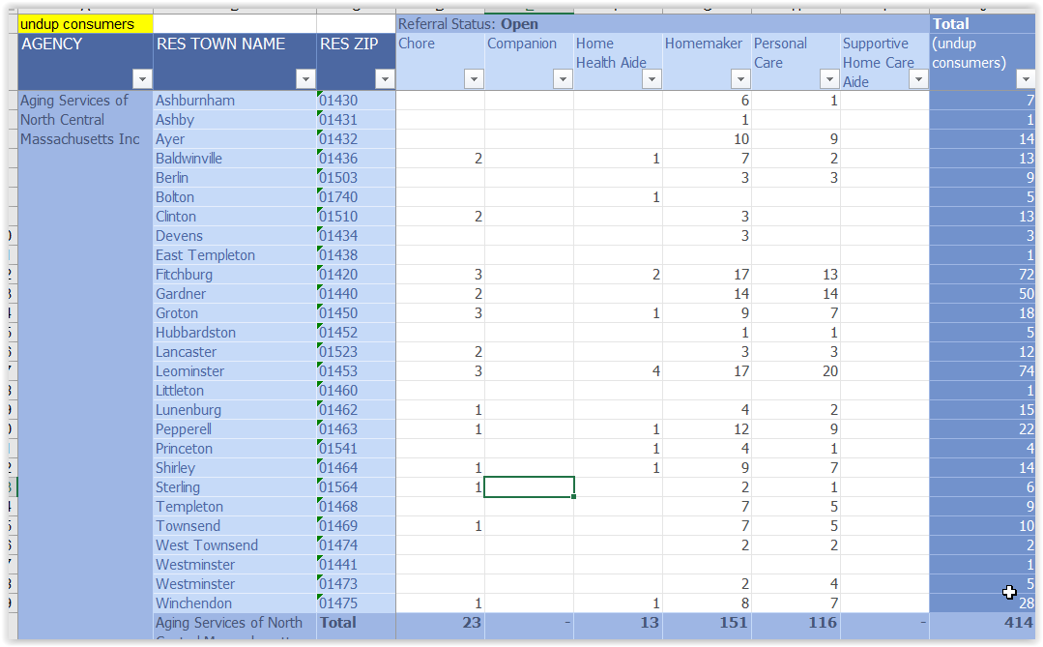

## Tab: Open Refs - Unmet Units per week

Open Referrals only. For more info on Referral Status, see the section “Setting the attribute **[Referral_Status]**”.

Summarizes units per week of unmet need, by Agency.

This report, deriving the unmet need by allocated units per week, depends on the assumption that all Service Plans to be considered are of Allocation Type = Weekly. Thus, Allocation errors are indicated, where the allocation is not Weekly. Contracts, see **[Tab: error log]** below to see which Consumer’s Service Plans have incorrect Allocation Type.

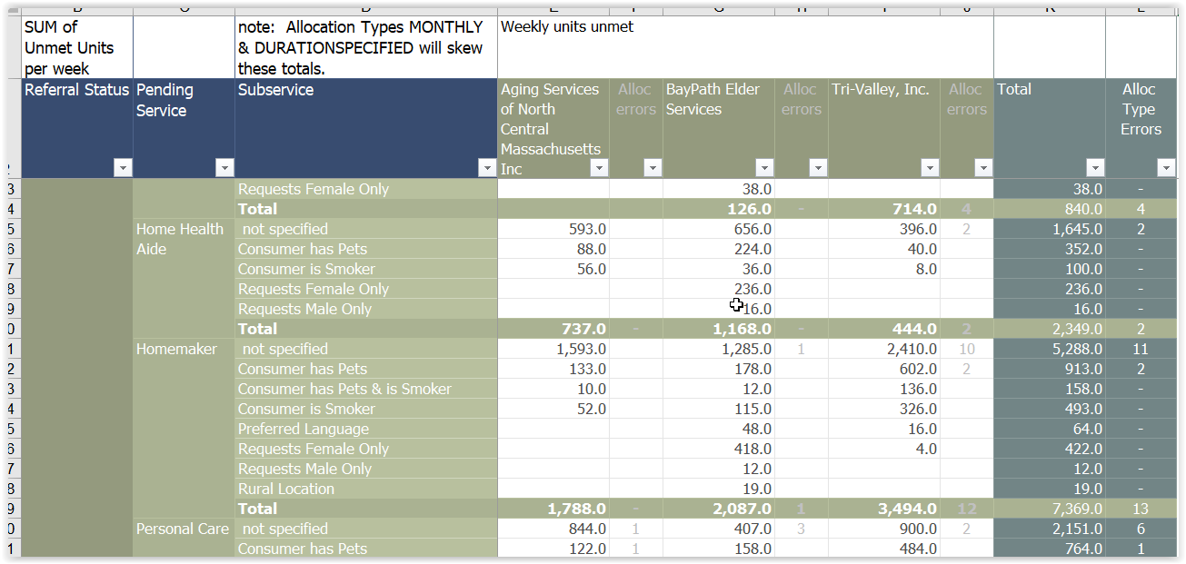

## Tab: error log for Allocation Type errors

Filter for Allocation Type errors only. That is, Allocation Type is Monthly or Duration Specified. Service Plans where the Allocation is WEEKLY do not appear on this tab.

Filter: Referral Status = OPEN only. For more info on Referral Status, see the section Setting the attribute **[Referral_Status]**.

Sort by Agency, Primary Care Manager, Consumer, Service.

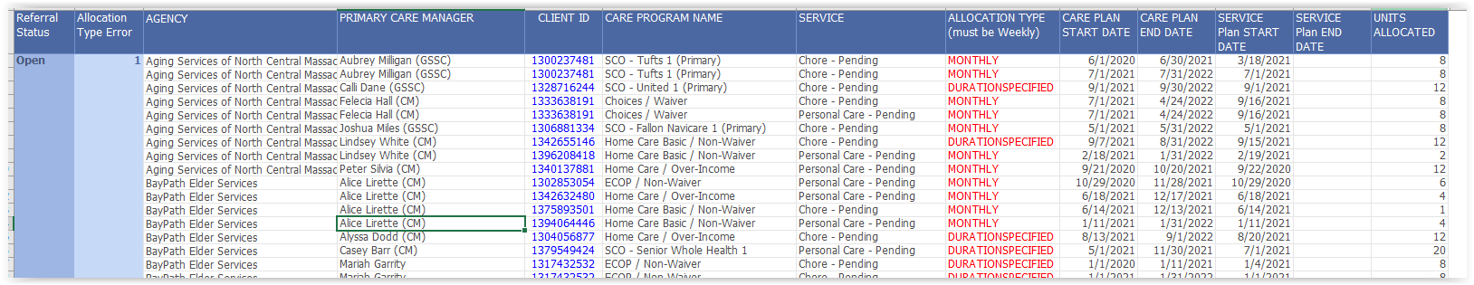

## Tab: Flat File

This tab contains all of the columns of the dataset, in order to answer useful questions.

Sort by Agency, Primary Care Manager, SAMS ID, etc.

Placeholder for 2021 new Gender Identity element to be implemented Oct 1, 2021.

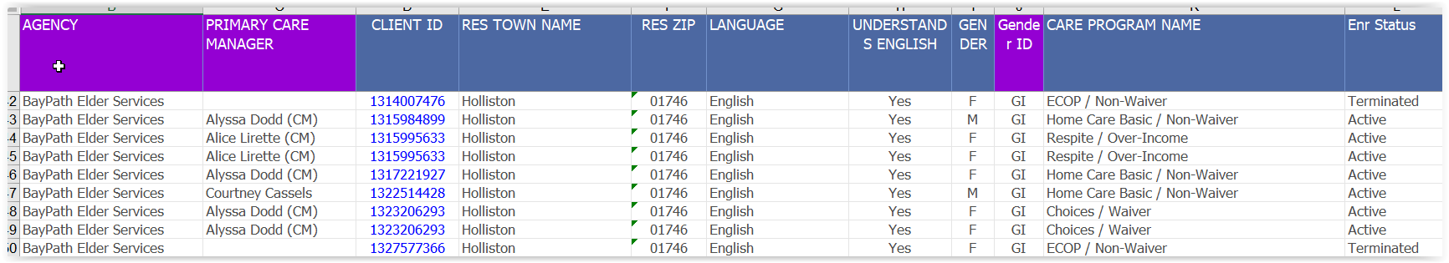

The Flat File contains all of the fields in the dataset, so that a user can check the data or perform their own analysis.

Note, there is one row per Service Plan. Each consumer will have one or several Service Plan rows, with different services, care programs, and referral statuses.

| n | Column in Tab: Flat File | Type of info |
| --- | --- | --- |
| 1 | AGENCY | ASAP Name |
| 2 | PRIMARY CARE MANAGER |  |
| 3 | CLIENT ID |  |
| 4 | RES TOWN NAME |  |
| 5 | RES ZIP |  |
| 6 | LANGUAGE |  |
| 7 | UNDERSTANDS ENGLISH |  |
| 8 | GENDER | m/f. Gender field is obsolete as of 10/1/2021 |
| 9 | Gender ID | Placeholder for new Gender Identity value, implemented as of 10/1/2021. |
| 10 | CARE PROGRAM NAME |  |
| 11 | Enr Status | Care Enrollment Status |
| 12 | Enr END DATE | Care Enrollment End Date |
| 13 | Enr TERM Date | Care Enrollment Term Date |
| 14 | CARE PLAN START DATE |  |
| 15 | CARE PLAN END DATE |  |
| 16 | SERVICE Plan START DATE |  |
| 17 | SERVICE Plan END DATE |  |
| 18 | Error Future Start Date | 0 if Start Date < today(), 1 if Start Date >= today() |
| 19 | Calculated End Date (i.e. Run date) | Set to report run date. Used to calculate unmet units, days, etc. to date, for all referrals active and inactive. |
| 20 | PROVIDER | Always Unknown Provider |
| 21 | SERVICE | Always SERVICE Pending, e.g. Companion_Pending |
| 22 | Referral Status |  |
| 23 | Service Short Name | Drop the “Pending” to remove visual clutter, and enable aggregation |
| 24 | Subservice Corrected | Drop the “(pc)” or “(hm)” parts to sub-services, enabling aggregation by obstacle across Service. |
| 25 | Key Obstacle | How to categorize the subservices |
| 26 | REASON |  |
| 27 | Service Plan Schedule START DATE |  |
| 28 | Service Plan Schedule END DATE |  |
| 29 | SERVICE Plan STATUS |  |
| 30 | Allocation FREQUENCY | Should always be = 1. |
| 31 | UNITS ALLOCATED | Service Plan Units Allocated |
| 32 | Days Unmet | Number of days: today() minus Service Plan Start Date |
| 33 | Days Unmet using Status Date | Number of days: today() minus Service Plan Status Date |
| 34 | SERVICE Plan STATUS DATE |  |
| 35 | Unmet units |  |
| 36 | Unmet units this week |  |
| 37 | Unmet hours this week |  |
| 38 | Weeks Unmet | Number of weeks: today() minus Service Plan Start Date |
| 39 | Months Unmet | Number of months: today() minus Service Plan Start Date |
| 40 | ALLOCATION TYPE | Should always be WEEKLY |
| 41 | Allocation Type **Error** | 0 if Weekly, 1 if Monthly of Duration Specified |
| 42 | MON | Planned units for Mondays. Optional. |
| 43 | TUE | Planned units for Tuesdays. |
| 44 | WED | Etc. |
| 45 | THUR |  |
| 46 | FRI |  |
| 47 | SAT |  |
| 48 | SUN |  |
| 49 | Free Text  (Desired Outcome + Comments) | Conjunction of Service Plan Desired Outcome and Service Plan Comments. |
| 50 | SERVICE ALLOCATION DESIRED OUTCOME | of Service Plan Desired Outcome |
| 51 | SERVICE ALLOCATION COMMENTS | Service Plan Comments |
| 52 | SERVICE ALLOCATION CREATE DATETIME | Service Plan Create Date Time |
| 53 | SERVICE ALLOCATION LUPDATE DATETIME | Service Plan Last Update Date Time |
| 54 | SERVICE ALLOCATION SCHEDULE CREATE DATETIME | Service Plan Schedule Create Date Time |
| 55 | SERVICE ALLOCATION SCHEDULE LUPDATE DATETIME | Service Plan Schedule Last Update Date Time |
| 56 | Unmet Units Formula | The formula used to calculate Unmet Units Per week |
| 57 | CONSUMER UUID | Unique identifier for Consumer record |
| 58 | SERVICE ALLOC UUID | Unique identifier for Service Plan record |

# Document Information for this User Guide

## Permanent Link to User Guide

Both the Report and this User Guide will be updated periodically. Find the most current version of this document at <https://har.800ageinfo.com/2021/09/pending-referral-provider-search-report-user-guide.html>.

## Version history

| date | Document Filename, comments | Author |
| --- | --- | --- |
| 9/20/2021 | User Guide – Services Pending Providers Report - R01 - First Public Draft 9-20-2021 | Jim O. |