**Revision History**

|  |  |  |  |
| --- | --- | --- | --- |
| Date | Version | Description | Author |
| 2021 | 1.0 | Initial publication | EOEA Home Care Team |

# Pending Service Referral and Provider Search Process

As of September 2021, a new state-wide process for service referral management was official deployed in SAMS for utilization. All documentation must adhere to Documentation Standards.

The service referral management system allows ASAPs to record and track the details of certain pending in-home service referrals for consumers within SAMS. Services identified are interventions specific to a consumer’s assessed need, authorized service plan and service schedule, and the corresponding person-centered care plan. The service referral management system also provides ASAPs the ability to report on pending referrals through HAR and thus disseminating the report to providers to broadcast consumer service referrals that need to be filled.

The statewide tracking method establishes a consistent operational process and enables quantification of pending referrals for in-home service interventions for consumers. The tracking method and subsequent reporting provides pending service referrals by service, by region, by program, and by key factors for service provision. The new process allows for a longitudinal view, counting the number of days a particular service request is unfilled.

This process tracks and quantifies pending service referrals for consumer needs for in-home services:

* Chore
* Companion
* Home Health Aide
* Homemaker
* Personal Care
* Supportive Home Care Aide

This business rule outlines the process by which ASAPs can use the provider named **Unknown Provider/Referral Pending** to track pending in-home service referrals for consumers whose service needs fulfillment. When the ASAP has assessed and authorized necessary in-home services such as **Chore, Companion, Homemaker, Home Health Aide, Personal Care, or Supportive Home Care Aide,** and is searching for a provider to fill the service(s) request, the ASAP will create a particular service plan and schedule for that individual consumer that needs service(s).

In SAMS, a single generic provider has been created called **Unknown Provider/Referral Pending** that is associated with all ASAPs. This provider is also associated with six specific services that include the term “Pending” in the service name.

**Chore – Pending**

**Companion – Pending**

**Homemaker – Pending**

**Home Health Aide – Pending**

**Personal Care - Pending**

**Supportive Home Care Aide – Pending**

In addition, five optional subservices have been created for each of the services above to allow agency staff to flag characteristics specific to the consumer relevant for service provision that a provider would need to have knowledge of for accepting a referral and assigning an aide.

**Consumer has Pets**

**Consumer is Smoker**

**Consumer has Pets & is Smoker**

**Preferred Language**

**Requests Female Only**

**Requests Male Only**

**Rural Location**

These Pending services listed above are only associated with the single Unknown Provider.

# SIMS Documentation in Consumer Record:

The intent is that each ASAP would create a consumer service plan authorizing one or more of the Pending services for the **Unknown Provider/Referral Pending** as a tracking placeholder so that the ASAP staff can document the planned service(s) while the ASAP searches to locate an actual provider that can deliver the authorized services to the consumer.

The Pending service plan is to be created under the individual, named consumer (not to be used with Consumer Groups) and is to include daily details in a Service Schedule for all variations of the actual services. Service Deliveries would **not** be posted against these Pending service plans.

**The six pending services should be used for all variations of the actual services. For example, the Homemaker – Pending service would be used to track Homemaker, Homemaker – Nights, Homemaker – 42+, etc.**

Once the ASAP has identified a provider who can provide in-home services to the consumer, the ASAP will close the pending service plan with an appropriate end date and then create a new service plan for the actual specific service and the actual named provider. There may be instances for partial fulfillment, where a pending service plan exists concurrently with an actual service plan.

This method of creating service plans using a Pending Service under the **Unknown Provider/Referral Pending** will allow ASAPs and EOEA staff to track and review consumer Service Plans and in-home pending service referral data to report on and analyze:

* the numbers of consumers in need of service and specific service types
* service days and service units that were needed but unfulfilled due
* specific factors for service provision
* geographic areas most in need
* trends in fulfillment
* increases and decreases in consumers pending services

# SIMS Data Entry Instructions:

To ensure accurate reporting across the state, it is imperative that the identified data elements are entered as instructed.

**Phase 1: *Original Pending Service Plan***

*Consumer has a service need to receive Personal Care services three days a week starting April 1, 2021. The consumer needs two hours on Tuesday and Thursday and one hour on Saturday. The ASAP enters the pending referral service plan authorization with a provider of:* ***Unknown Provider/Referral Pending*** *for the consumer.*

The ASAP staff creates a new service plan for the consumer:

* the **Provider = Unknown Provider/Referral Pending**
* the **Service = Personal Care – Pending.**
* the **Service Plan** includes:
  + a start date for when the consumer would be eligible to receive services.
  + status is =**Waiting**.
  + additionally, the Weekly **Schedule** includes Daily Details showing 8 units on Tuesday, 8 units on Thursday and 4 units on Saturday.

**The service schedule should always be of allocation type weekly.**

**Do not use monthly or duration specified.**

Daily details should be entered when known. When a consumer does not have a specific day, they are requesting and any day is available for care, then the weekly unit totals can be entered in the schedule without daily details as an alternative.

The optional subservice can be entered within the service schedule. See example in screen shot: *Requests Female Only*

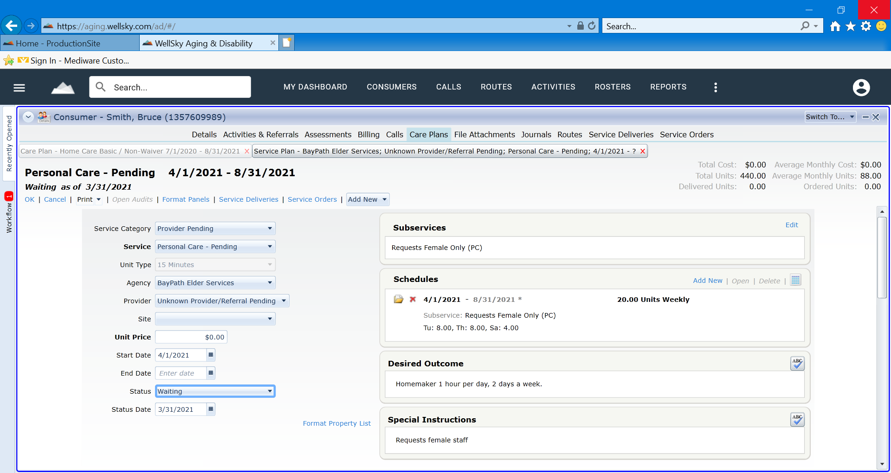

**Service Plan Fields (on the left):**

**Service Category**: Provider Pending

**Provider**: Unknown Provider/Referral Pending

**Start Date**: The start date of the service referral

**Status**: Waiting

**Status Date**: The start date of the service referral (this field will be helpful should the care plan need to be copied as part of an annual review)

**Service Plan Fields (on the right):**

**Subservice**: Will populate automatically if subservice is selected in the schedule

**Schedule**: should be allocation type weekly (do not use monthly or duration specified). Should include subservice when appropriate. Daily Details should be entered when consumer has specific preference. Daily Details can be left blank when consumer does not have preference.

**Desired Outcome**: Free text field available to track notes (will appear in report)

**Special Instructions**: Free text field available to track notes (will appear in report)

***Phase 2****:* ***Potential Provider has accepted referral, pending confirmation of specific aide, schedule and start date.*** *Once the ASAP identifies a provider who believes that they can service the consumer and the ASAP wants to signify that the referral has been accepted without confirmation of a home care aide or start date.*

The ASAP staff updates the Pending referral service plan to a new Status of **Active**. The Active status is used to indicate that a provider has been identified and is working with the ASAP to coordinate services, but the services have not yet been planned with an effective start date for the new provider.

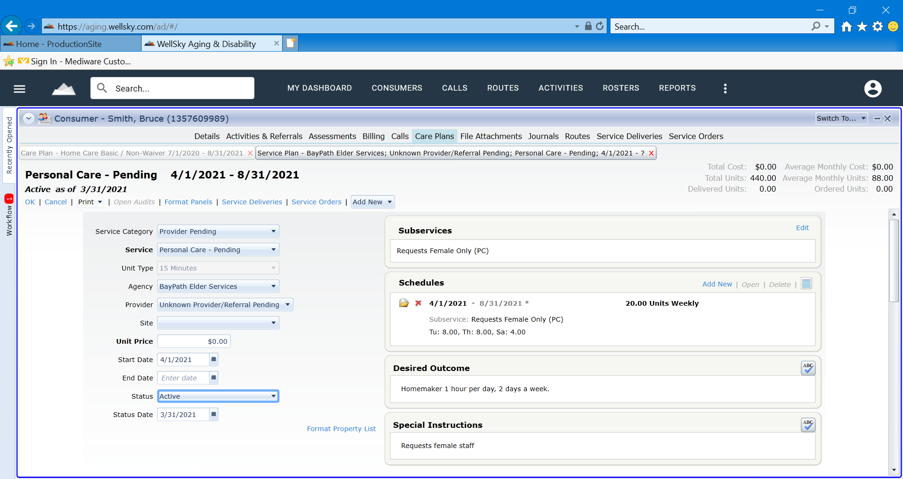***Phase 3A: New Provider, aide, schedule, and start date is confirmed***

*Once the ASAP gets confirmation that the provider can begin servicing the consumer starting on 6/8/2021.*

The ASAP staff closes the Pending service plan with an end date of 6/7/2021. The ASAP changes the status of the “pending service” to **Completed.** In addition, the ASAP creates new service plans for the specific service and provider. In this case, the consumer has two separate service plans, one for Personal Care on Tuesdays and Thursdays and one for Personal Care – Weekends on Saturday based on the ASAP’s contracts and business practice.

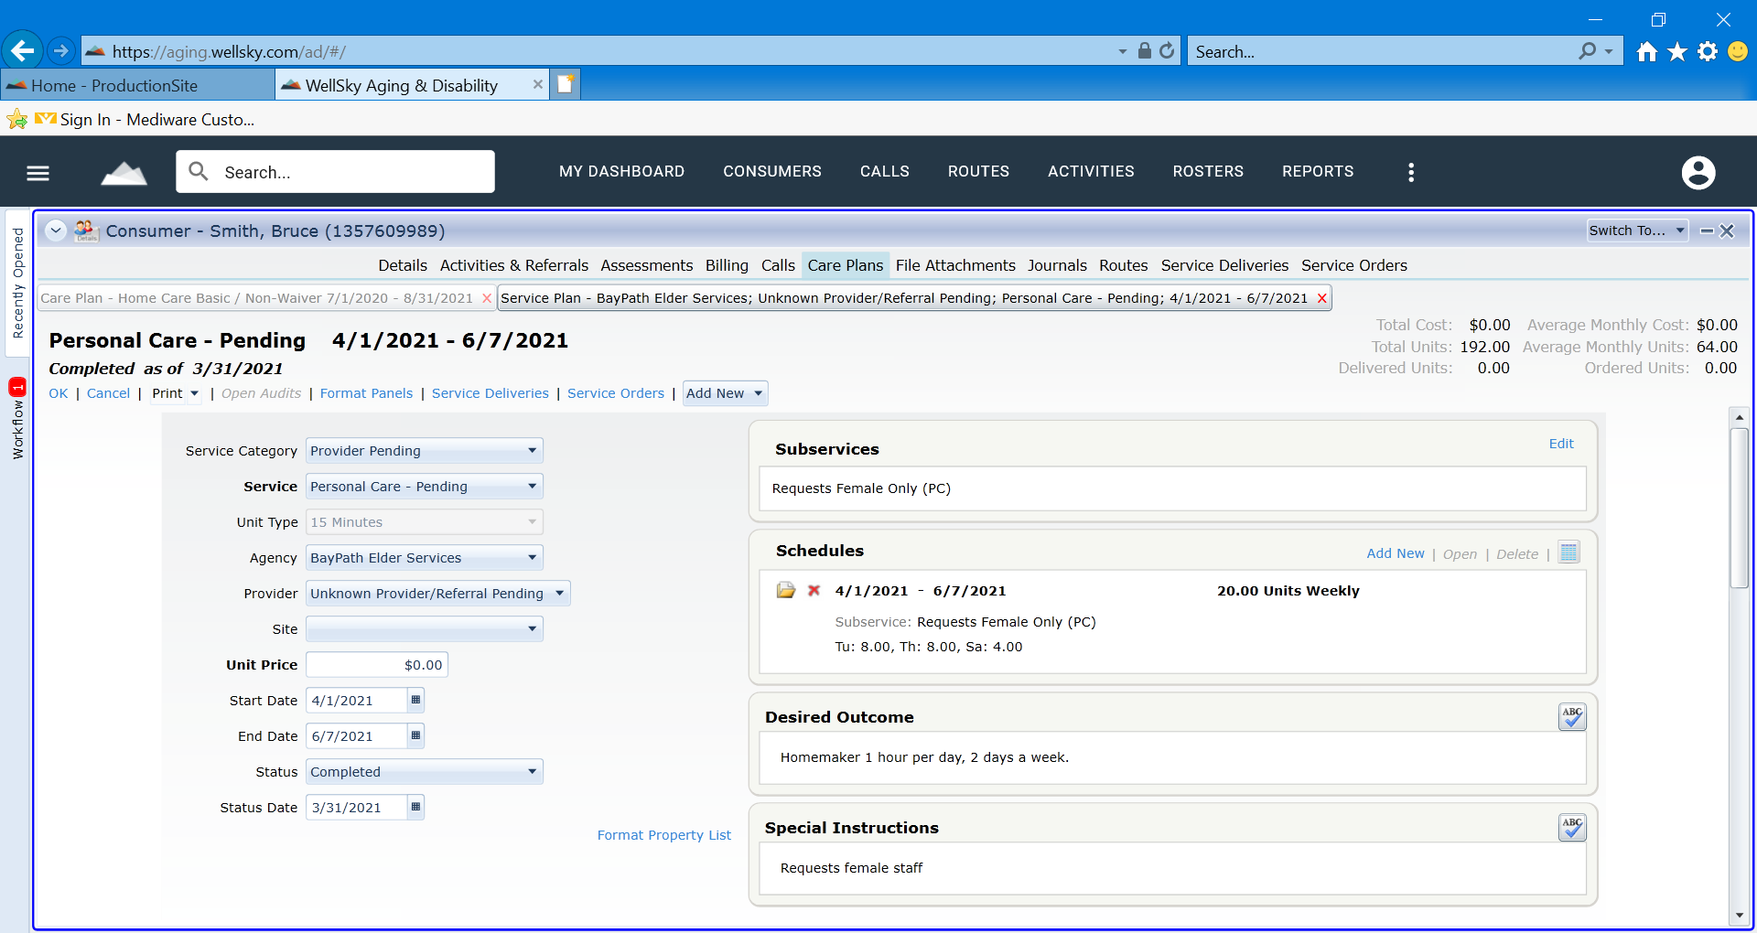

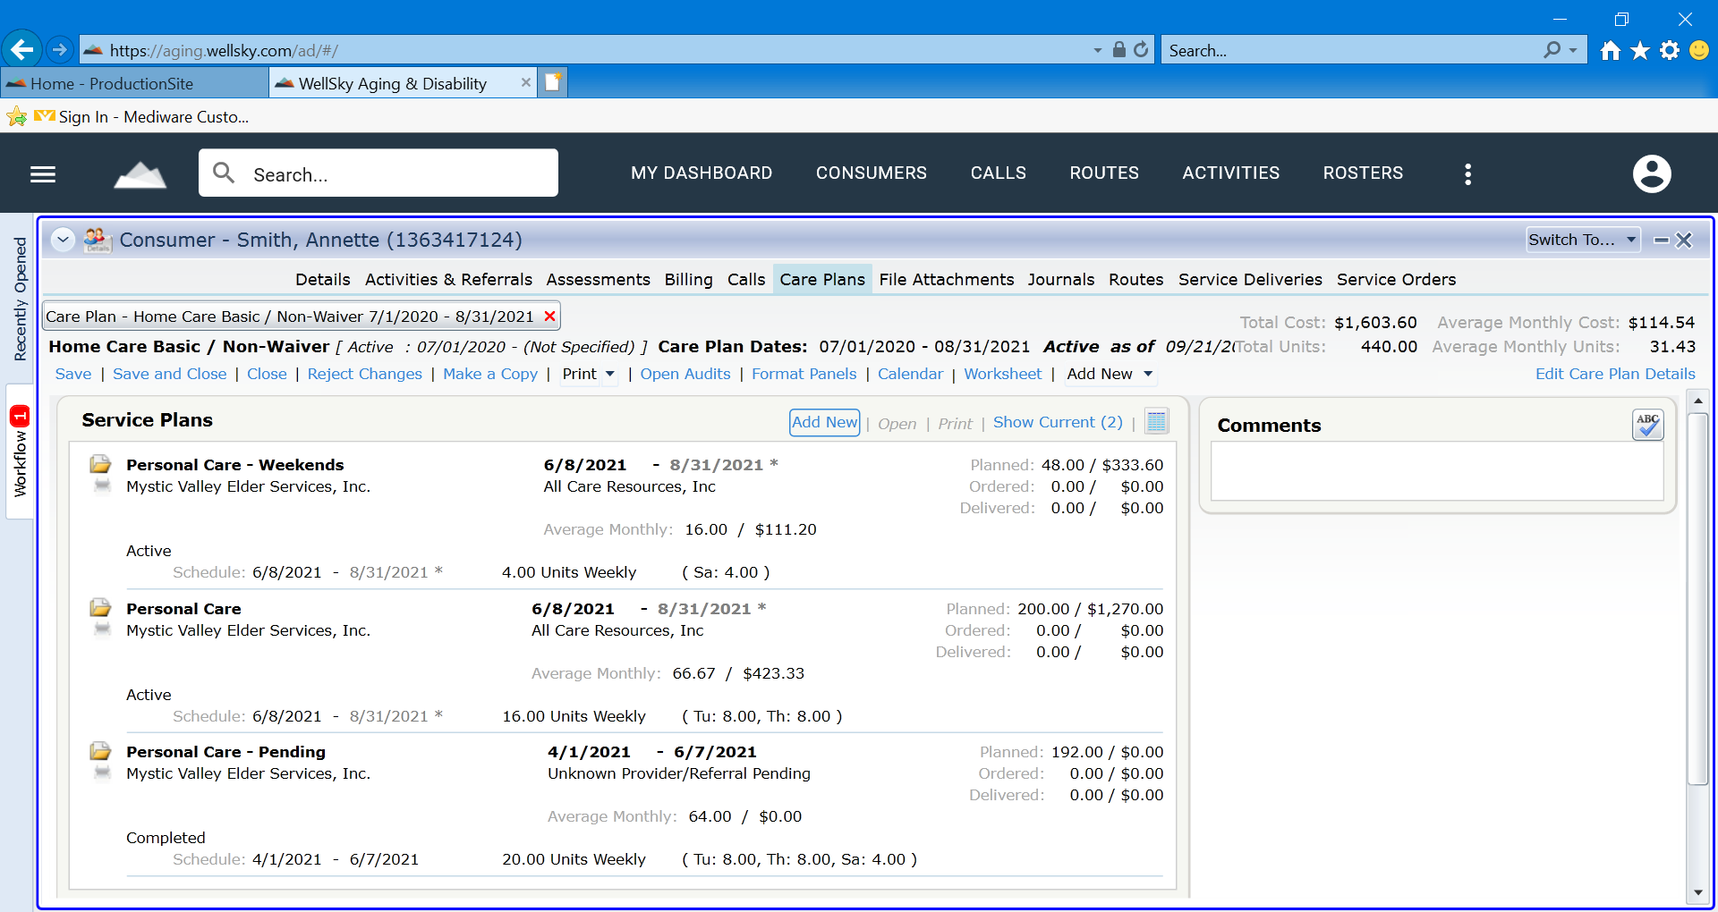

***Phase 3B: New Provider, aide, schedule, and start date is confirmed and accepts a Partial Referral (Partial Fulfillment of Service Need)***

*For the original scenario, where the consumer has a Personal Care - pending service plan for 20 weekly units, 8 units on Tuesday, 8 units on Thursday and 4 units on Saturday. A week later, the ASAP identifies a provider that can provide services on Tuesday and Thursday but that provider cannot provide a home care aide for Saturday and no other provider has been identified.*

The ASAP staff:

1. Closes the original pending referral service plan for 20 Weekly units with an end date of 6/7/2021. The ASAP changes the “pending service” **Status** to **Completed**.
2. Creates a new personal care – pending service plan for the hours unfilled on Saturday. The **Status Date** within the new “pending service” plan shall remain the initial service referral status date (carry over from original pending service plan). The Start date of the new pending service plan shall be 6/8/2021. **Status** of **Waiting**.
3. Creates an actual personal care service plan for the specific service, provider, service schedule, and start date of service.

In this case, the consumer has one actual service plan for Personal Care on Tuesdays and Thursdays and one pending service plan for Personal Care – Pending on Saturday since the weekend hours are still not filled.

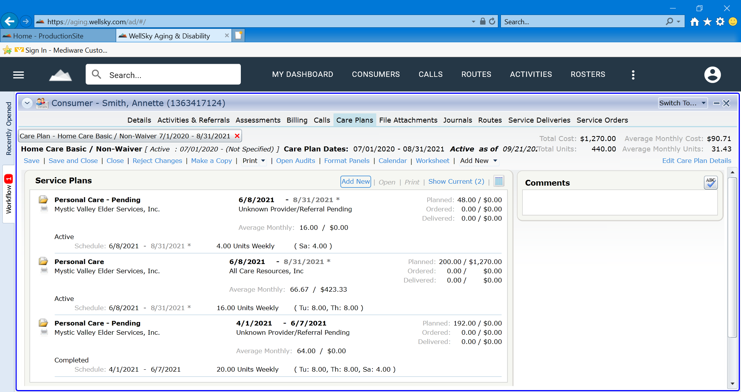

Waiting

**Phase 4: Need is no longer present for services**

In instances where the consumer is no longer in need of the services prior to the ASAP provider being assigned, accepting, and implementing the service request. The ASAP will update the pending service plan by changing the “pending service” status to “**Withdrawn**”. The ASAP will then update the “Journal Notes” section of the consumer record to reflect the specific reason why the consumer is no longer in need of the services requested. All documentation must adhere to Documentation Standards.

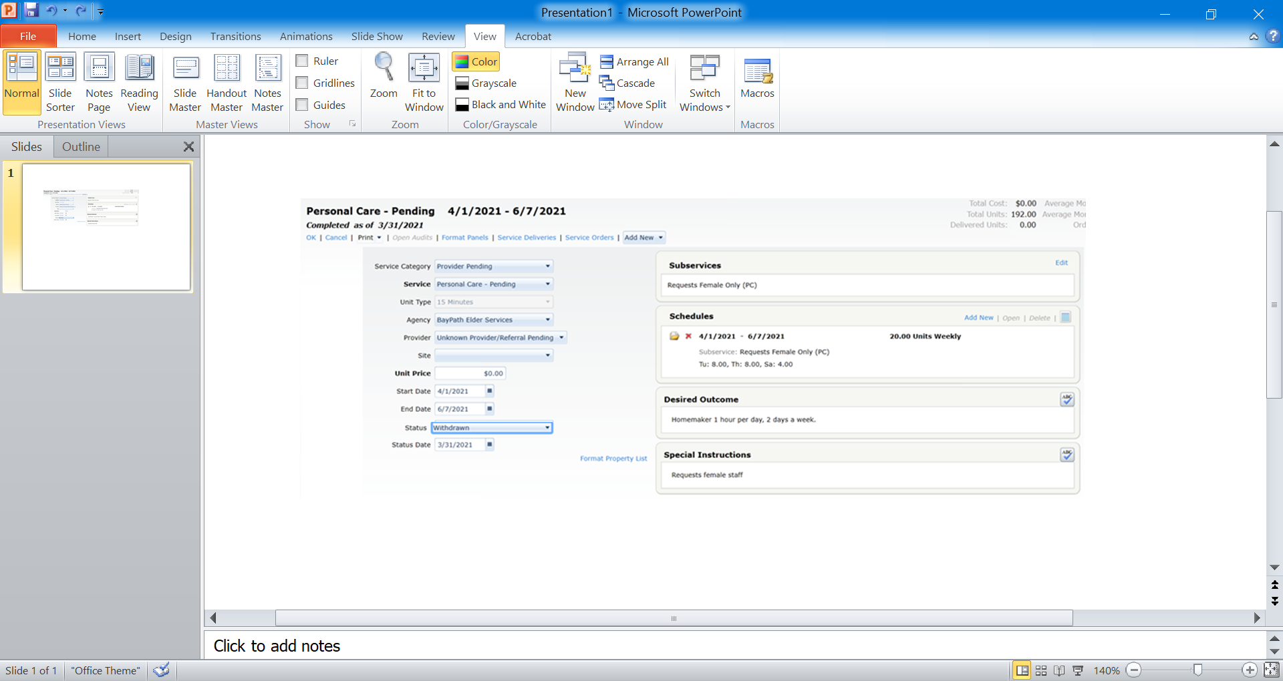

**Care Enrollment Change:**

In instances where the consumer’s Care Enrollment is being changed from one Care Enrollment to a different Care Enrollment (Example: Home Care Basic / Non-Waiver to ECOP) the ASAP will update the **status date** of the new pending service referral service plan to reflect the **status date** recorded in the previous pending service plan under the prior care program. The status date is the date the consumer began waiting for services to maintain historical data. This can reflect a date before the start date of the Care Enrollment and care plan.

# Payment Voucher (PV) Reporter Impact:

Note that an ASAP will receive a positive PV billable unit based on the planned services for the pending service plans, but a negative, retroactive adjustment would be made in PV Reporter the following month in the event that a consumer never receives actual service deliveries for a given month.

# Reporting:

**Report Monitoring:**

**HAR Reporting is available and will be utilized as follows:**

• **ASAP** – Incorporate service referral management into ASAP Policies & Procedures:

* include utilization management protocol for different roles and uses of reports including, but not limited to:
  + Care Management
  + Service Procurement
  + Quality Management
  + Supervision and Program Management
* reflect appropriate frequency for running reports

• **EOEA** – Frequent reporting and oversight:

* Minimum of monthly reporting
* Network Analysis and Summary
* Service, referral and data management and engagement with ASAPs