Quick Reference Guide



Omnia Analyzer makes reporting on your hard earned assessment data easy by breaking the report creation process into three parts:

- Client Populations
- Analysis Sets
- Report Definitions or layouts

These three elements work in concert to produce your final report.

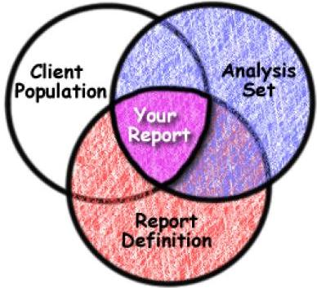

Client Populations:

- Defines the group of people that you are gathering information about (the "who").

- Is a subset of the clients in SAMS.

- Can be List based (you manually select consumers) or Criteria Based (dynamically updating - based on filter criteria).

- Filter criteria can look at SAMS data elements or Omnia data elements. The following is a list of the data elements that are available as filter criteria:

Omnia Criteria List:
Active
DOB
First Name
Last name
MI (Middle Initial)
SSN (Social Security Number)

SAMS2000 Criteria List
Active
DOB (Date of Birth)
First Name
Last Name
MI (Middle Initial)
Gender
Lives in Rural Area
Lives in Poverty
Lives Alone
High Nutritional Risk
ADLs
State
County
Town
Race (Ethnic Races in SAMS2000)
Service Agency
Service Provider
Service
Subservice
Service Delivery Date
IADLs

Analysis Sets:

- Allow you to define which assessment questions or data that you want to see on your report (the "what").

- The assessment questions you select in an analysis set will appear as items on the final report.

- Omnia Analyzer offers two types of analysis sets:
  - Assessment based– pulls data form the specific assessment form or forms you select (CDS, I&R Intake, etc…).
  - Catalog based– pulls data from any form or forms that contains the question(s) you select

Reports:

1. Consumer Listing Report
Groups the data defined in your analysis set by Client.

2. Question Listing Report
Groups the data defined in your analysis set by Question, also includes summary information and cross tab chart for each question.

3. SAMS Biographic Report
Similar to Consumer Listing report, but also displays Town/County and is sort-able by Town, County, or Name.

4. Cross-Tab Report
Returns a table that analyzes one field against another for you consumer population. Does not use an Analysis Set. A list of Available data fields for Columns/Rows follows:

ADL Count
Age
Agency
Client (Consumer) ID
Gender
High nutritional risk status
IADL Count
In poverty status
Is rural status
Lives alone status
Provider
Race (Ethnic Races in SAMS2000)
Residential county
Residential town

5. Continuous Outcome Measurement Report
Displays numeric question responses over time in a graph from a date range of assessments. Works with numeric assessment fields only. Also works with Indicators that return Numeric value.

6. Two Column Outcome Measurement Report
Compares numeric question responses from one set of assessments with another set of assessments. You can display service delivery records with each consumer to better understand how services affected the change of responses.

