Overview
800AgeInfo.com is a website that provides Massachusetts elders and their families with valuable tools, resources and other information on programs that serve the elder community and their families.

The My Inquiries section of 800AgeInfo.com gives users at the serving Agencies the ability to view messages from visitors to 800ageinfo.com, and to record follow-up notes if desired. Note: the web portal does NOT include a way to respond to the user directly. Responses will be via phone or email, outside the 800ageinfo.com portal.

This Job Aid instructs Agency Users how to login, to view messages, to update a message with follow-up notes, and to manage their user profile (password, email address, and preference to receive email notifications of new messages).

Table of Contents
Overview 1
Table of Contents 1
Revision History 1
Contact Us Page on the New 800AgeInfo.com 1
Accessing My Inquiry Notifications via Email 2
Accessing My Inquiry Messages via 800AgeInfo Website 5
Managing Your Profile 8

Revision History
Date | Version | Description | Author
Sept 8, 2009 | 1.0 | First edition: published for user training on September 8,9,10, 2009 | 800AgeInfo Project Team

Contact Us Page on the New 800AgeInfo.com
Elders, their family members and caregivers have the ability to request information directly from the “Contact Us” page of 800AgeInfo. Each message is related to an ASAP or AAA, because the website visitor has identified either the agency or the town in which an elder resides.

When the request forms are completed with all required fields and saved, a notification email is sent to I&R users at appropriate servicing Agency.

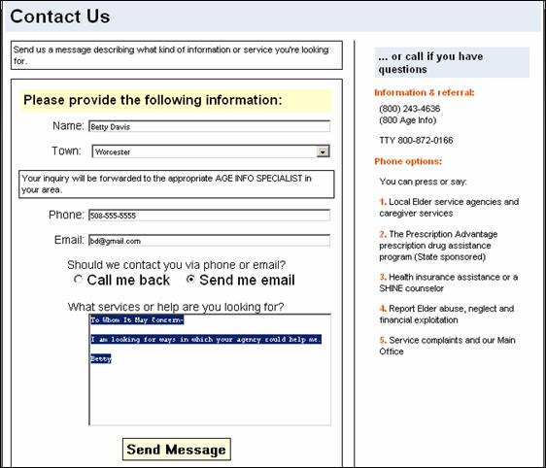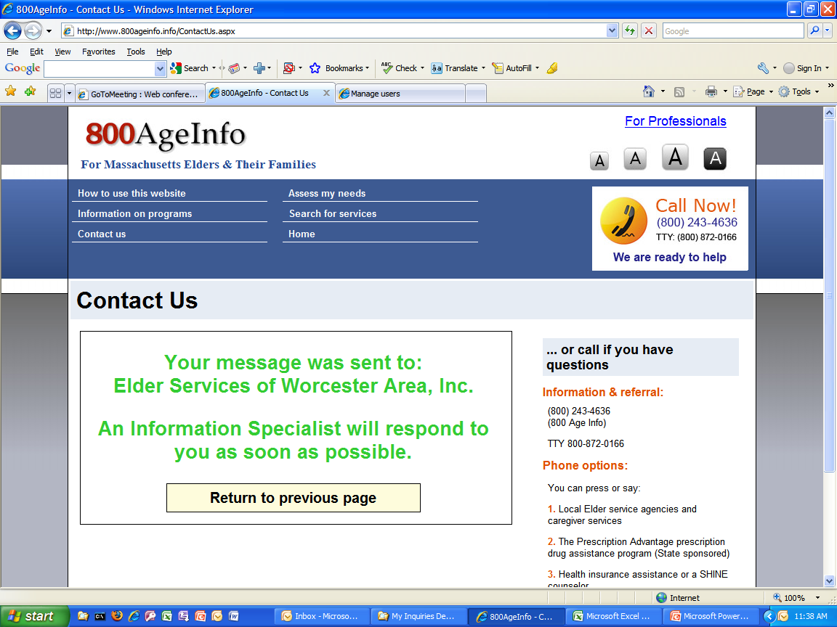

Accessing My Inquiry Notifications via Email
Users who elect to receive email notifications when an inquiry comes in from the 800ageinfo.com website will be notified via email that a new inquiry has come in for their agency.

The email that will arrive in your inbox will be from 800AgeInfo.com and will include the message number, requester and supporting Agency’s name.

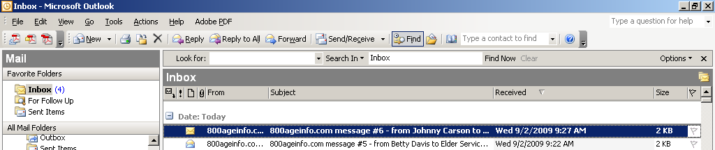

- When you open the email, you will be provided with a link that will bring you directly to the My Inquiries login screen, or directly to the message itself (depending on whether you're already logged in or not).

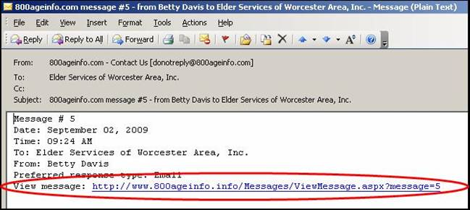

- Enter Username & password (if not already logged in). Only authorized Agency Users will be able to access “My Inquiries”.

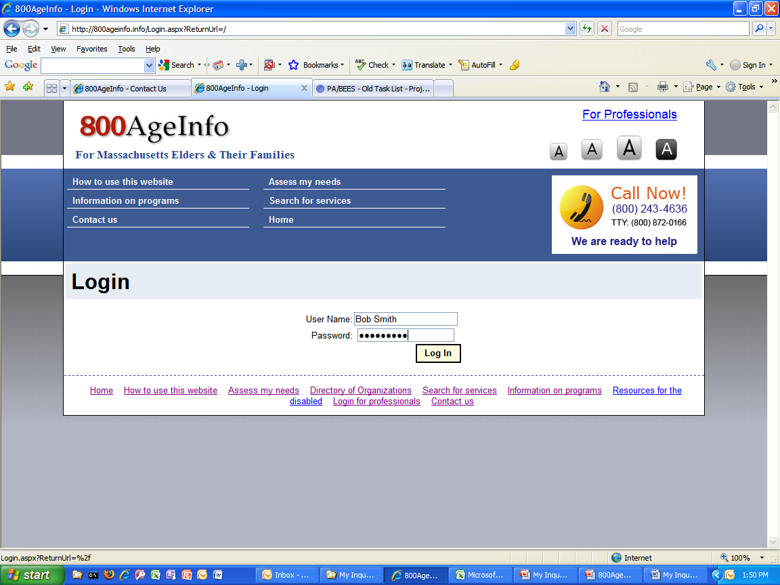

- After you log in, the system will bring you directly into the message. View message; enter a follow-up message in the space provided. This can be as brief or lengthy as desired. Then click Save Follow-up.
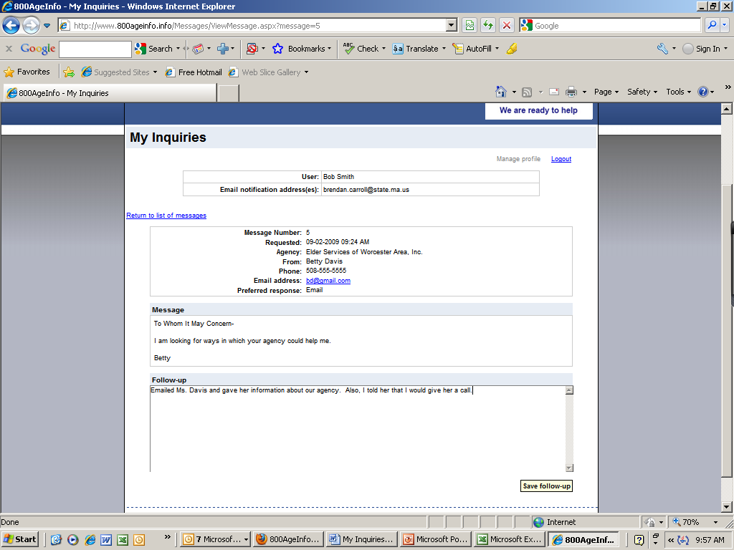
Your follow-up notes will be saved, along with your userid, email address, and the date-time.
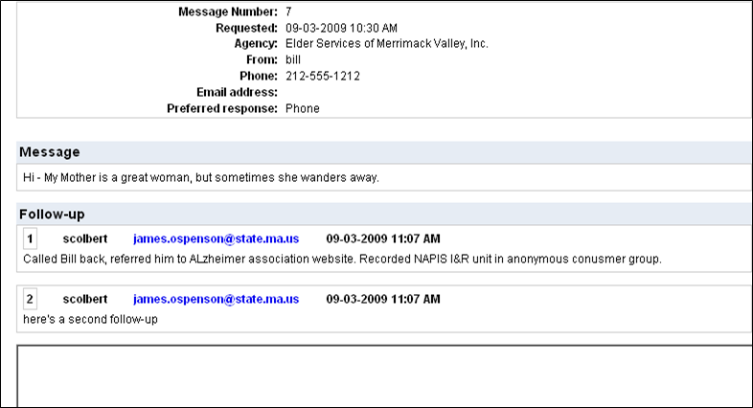

- To return to the “My Inquiries” page, click on the Return to list of messages link.

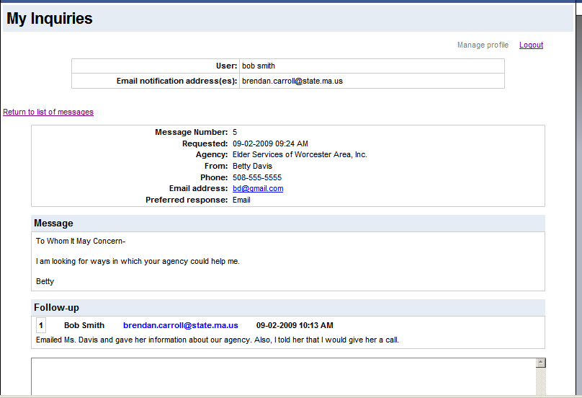

Accessing My Inquiry Messages via 800AgeInfo Website
Users also have the ability to access their Agency’s Inquiries by going to: http://contactus.800ageinfo.com/Messages/

- The above link will display the Login screen and prompt the user to login.

- After a successful login, the Message List page (called "My Inquiries") is displayed. The list of messages is filtered: only messages related to your agency are displayed.
When the My Inquiries page opens up, you will see a list of messages in reverse date order - most recent at the top of the list.

  - From the My Inquiries Page you can sort your messages by clicking the desired column title in the Heading bar, click on the View link and view the message. The message “view” gives you data specific to that message and any follow up activity that you or someone from your agency has recorded.

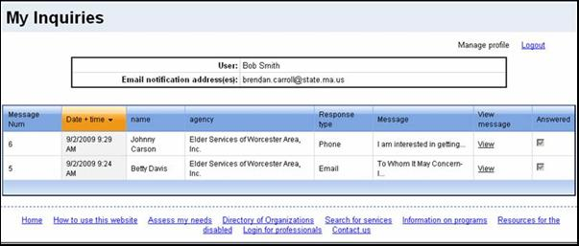
Click View to read the message.
Heading Bar

- While viewing a message you’ll be able to record follow-up notes in the Follow-up section. Click on the Save follow-up button when you’re done.
Note: The My Inquiries system is a notification and tracking database tool and does not allow you to Reply or respond directly to an inquiry.
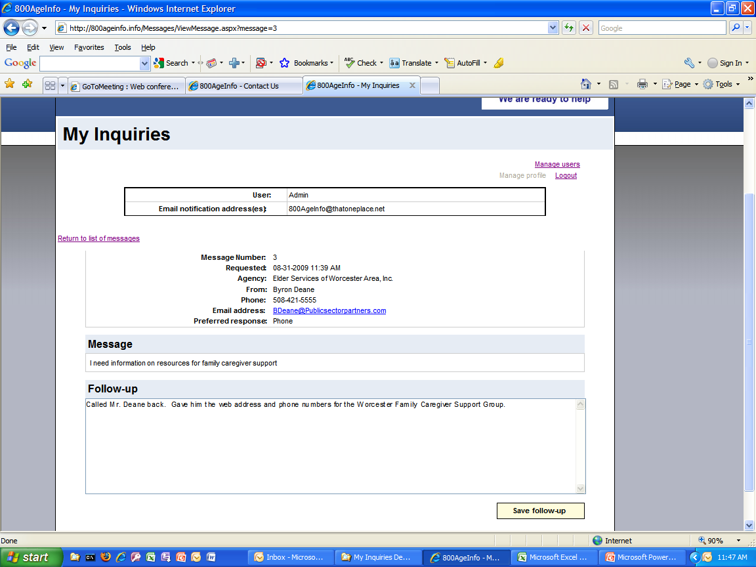
When the first Follow-up note is saved, the Message is tagged as Followed-up. On the Message List, a checkbox will display in the Follow-up column,
Add Follow-up Notes here

- The Follow-Up history is saved and tagged with the date-time, the userid and email address of the person who saved the follow-up note, and the actual follow-up notes.
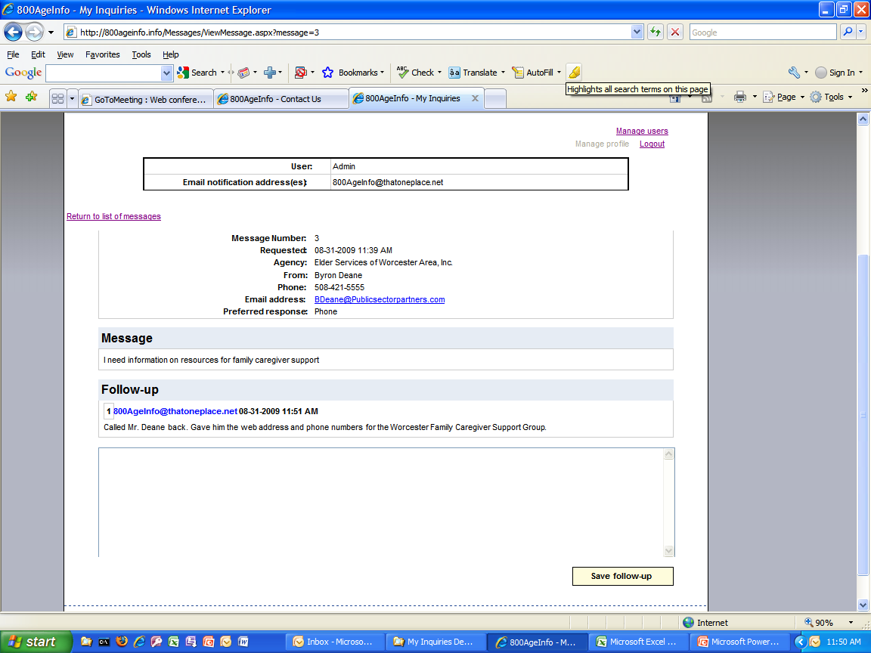

- Click on Return to List of Messages to return to the list. You’re your done reviewing, writing and saving your messages and notes, you can return to the “My Inquiries” page by clicking on the “Return to list of messages” link here.

- Review messages to ensure those acted on are now marked as such with a check in the check box as “Answered”. (Messages are marked "Answered" when the first follow-up is saved.)

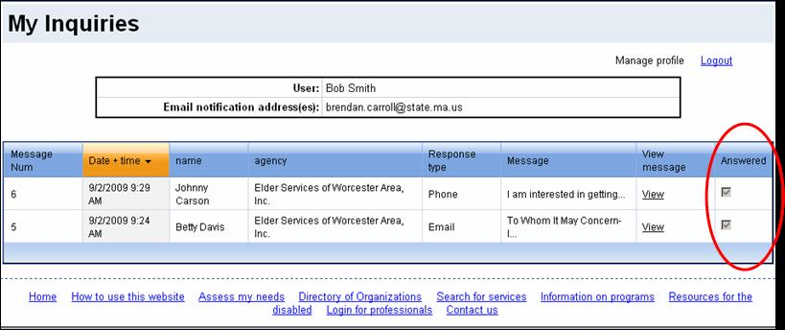

Managing Your Profile
By clicking the Manage Profile link, users will be able update and change their passwords and indicate whether or not they get email notifications when new inquiries come in for their Agency.

