Table of Contents
Table of Contents 1
Overview of LTCOC Process 1
Introduction 2
Entering a New LTCOC Contact 2
Adding LTCOC Service Deliveries 3
Scheduling Follow-Up 5
After the Follow-Up 5
Tracking Client Outcomes & Referrals 5
Completing an LTCOC Case 7
Tracking LTCOC Outreach in SAMS 8
LTCOC Reports 10
Agency Summary Report 10
Questions the Agency Summary Report will answer: 10
Sample Print Parameters for the Agency Summary Report: 11
SAMS Call Topic Report 11
Questions that the Topic/ report will answer: 11
Sample Print Parameters for the SAMS Call Topics Report: 11
Sample Report Output: 12
Activities & Referrals Report 12
Questions that the Activity & Referral report will answer: 12
Sample Print Parameters for the Activity/Referral Report: 13
Consumer Listing Report 13
Questions that the consumer listing report will answer: 13
Sample Print Parameters for the Consumer Listing Report: 14
Appendix: Required Setup in SAMS Before Getting Started 15
Agency Contracts & Service Delivery Templates 15
Optional Setup 15

Overview of LTCOC Process
- Enter New Call in SAMS.
- Identify and search for Caller & Consumer.
- Identify referral source (Referred By).
- Document Disability (when available).
- Enter in notes.
- Determine if call needs to be referred to LTCOC Counselor.
- Capture Consumer’s Goal via Topics.
- Schedule LTCOC session either phone/face-to-face.
- Conduct LTCOC counseling.
- Deliver services in Call Screen.
- Create Activity & Referral for LTCOC follow-up in 30 days.
- Follow-up with consumer.
- Document consumer outcome in call screen.
- Document referrals.
- Mark call as Complete.
- LTCOC Reporting.

Introduction
Please note: In this process, users will use a SAMS “Call” to track the entire Long Term Care Options Counseling (LTCOC) lifecycle for a client. This may represent several distinct telephone contacts and face to face visits.

Entering a New LTCOC Contact

- Click on New Call.

- Click on ellipsis 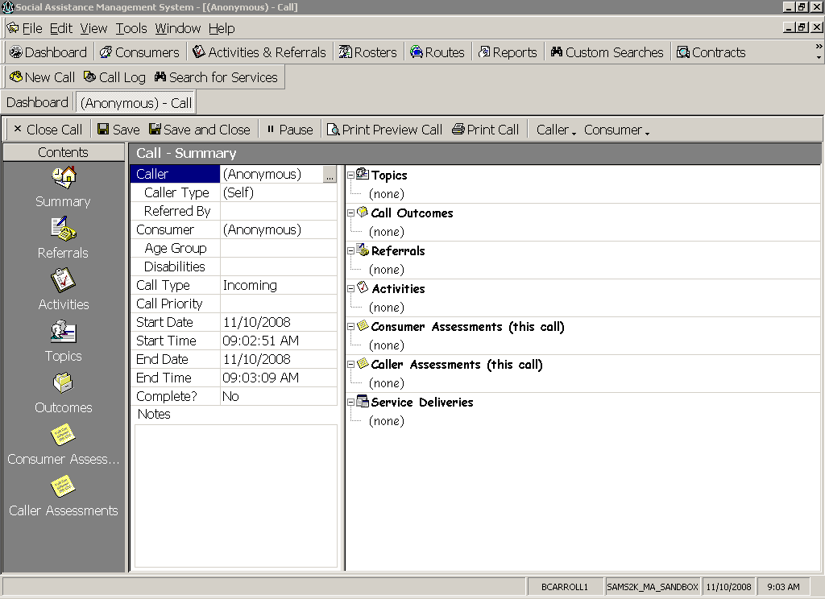 to search for Caller. The Search Consumers dialog box will appear. Enter caller’s information and click find. If the caller exists in SAMS then highlight their name and click OK. If they do not exist in SAMS, then click Add New button.
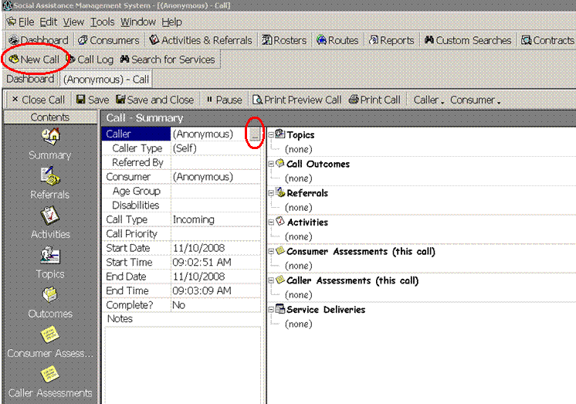
- From the Referred By drop down, select how the call was referred to your agency.

- If the Consumer is the same as the Caller, you will see their name is already populated in the Call screen. If the Consumer is different, click on ellipsis to search for Consumer. The Search Consumers dialog box will appear. Enter consumer’s information and click find. If the consumer exists in SAMS then highlight their name and click OK. If they do not exist in SAMS, then click Add New button.

- If the Consumer’s record contains a date of birth, then the Age Group field will auto-populate the consumer’s age group. If not, then select the appropriate age group for the consumer.

- When necessary collect the Disability information by clicking on the ellipsis and select the appropriate Disability and click OK.

- Determine if call is a LTCOC call.

  - If intake user is LTCOC counselor, then proceed to Step 8.

  - Does caller need to be referred to a Long Term Care Options Counselor?

    - If this is the case, and you will be referring to a counselor who is a SIMS user, then click on Activities and fill out the Activities screen according to your agency's business practice using the Action=LTCOC Referral. No time should be recorded as an LTCOC counseling service yet.

    - If you need to refer the caller to an ILC counselor, then you will need to notify the ILC outside of SIMS through an agreed-upon process. This call should be completed as a regular NAPIS I&R call, and no time should be recorded as an LTCOC counseling service.

- Click on the Topics section of the call and select the LTCOC topic that best describes the consumer’s goal:

  - LTCOC – Goal NF Admission.
  - LTCOC – Goal NF Discharge.
  - LTCOC – Goal to Stay in Community.

- Add Notes in record as necessary. Be sure not to use Protected Health Information (PHI) in Notes.

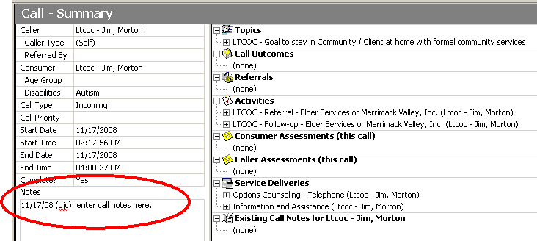

Adding LTCOC Service Deliveries
At this point, the Options Counselor has either counseled the consumer via telephone or met with the consumer Face-to-Face. Service deliveries need to be recorded in the Consumer’s call record.
- Click on Call Log.

- Find & Open Consumer’s LTCOC call record.

- Click on Service Delivery button.

You will then be presented with a Record Service Deliveries dialog box with the following four (4) services listed.

Description | Care Program | Service | Unit Type
<Agency Name> – Information and Assistance | NAPIS Title III | Information and Assistance | 1 unit =  1 occurrence
<Agency Name> – Travel – to/from face to face LTCOC | Long Term Care Options Counseling (LTCOC) | Travel – to/from face to face LTCOC | 1 unit =  15 minutes
<Agency Name> - Options Counseling - Telephone | Long Term Care Options Counseling (LTCOC) | Options Counseling Telephone | 1 unit =  15 minutes
<Agency Name> - Options Counseling – Face-to-Face | Long Term Care Options Counseling (LTCOC) | Options Counseling – Face-to-Face | 1 unit =  15 minutes

- Click the checkbox in the leftmost "Inc." column next to the appropriate LTCOC service that you would like to deliver.

Please note: The default set service in this service delivery screen is Information and Assistance under NAPIS Title III, be sure to uncheck the Inc? box if you only delivered LTCOC services. In most cases, the NAPIS Title III unit of Information and Assistance will be delivered to the consumer on the initial contact with the agency. The initial contact should be the only time that the NAPIS unit of service should be delivered for that consumer.

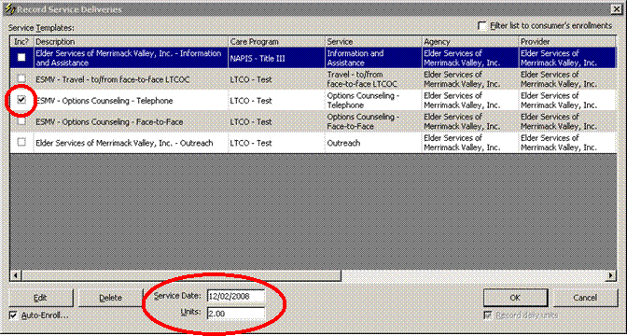

- Enter the appropriate Service Date.

- Enter in the appropriate number of Units.

- Click OK.

Scheduling Follow-Up
After the LTCOC counselor has met with the consumer and concluded active counseling, they should schedule a follow-up phone call 30 days later to check-in with the consumer. We recommend creating an activity in SAMS to track this future task.

- Click on Call Log.

- Find & Open Consumer’s LTCOC call record.

- Click on Activities and fill out the Activities screen using the following:
  - Agency = <Your Agency>.
  - Subject = <enter free text here>.
  - Action=LTCOC Follow-up.
  - Due Date = 30 days from final counseling session.

- Click OK.

After the Follow-Up

Tracking Client Outcomes & Referrals
This section to be completed after the follow-up has taken place.

- Click on Call Log.

- Find & Open Consumer’s LTCOC call record.

- Click on Topics.

- Locate the topic that was identified initially as the goal and highlight it.

- Click once in the Outcome column next to the topic, a dropdown arrow will appear.

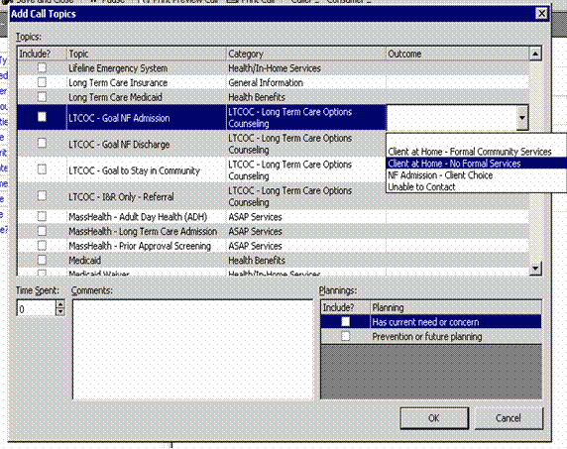

- Select the appropriate Outcome that corresponds with the Topic (goal).

Topics (Goals) | Outcomes
LTCOC – Goal NF Discharge | - Client remains NF – by choice  - Client remains NF – obstacles remain  - Discharge following a short term stay (1-90 days)  - Discharge following medium term stay (91-365 days)  - Discharge following long term stay (>1year)  - Unable to Contact
LTCOC – Goal to stay in Community | - Client at Home – Formal Community Services  - Client at Home – no formal services  - NF Admission – Client Choice  - NF Admission – obstacles unable to be overcome  - Unable to Contact
LTCOC - Goal NF Admission | - Client at home - Formal Community Services  - Client at home – no formal services  - NF Admission – Client Choice  - NF Admission – obstacles unable to be overcome  - Unable to Contact
LTCOC – I&R Only – Referral | - BayPath Elder Services  - Greater Lynn Senior Services  - HESSCO  - ILCNSCA - North Shore  - Elder Services of Merrimack Valley  - Minuteman Senior Services  - MWCIL - MetroWest Center for Independent Living  - Mystic Valley Elder Services  - NILP - Northeast Independent Living Program  - North Shore Elder Services  - SeniorCare, Inc.  - Springwell  - Tri-Valley, Inc.  - Unknown Organization

- In the Comments field, type in all referrals made to the consumer.

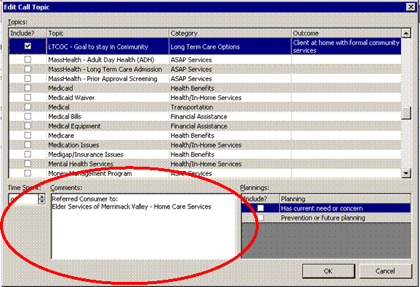

- Click OK.

Completing an LTCOC Case
- Click on Call Log.

- Find & Open Consumer’s LTCOC call record.

- If you were able to contact the client for the follow-up, be sure to record your time spent during the follow-up in a service delivery for either telephone or face-to-face counseling.

- Mark the Call as Complete, by clicking in Complete? field and selecting Yes from the drop down.

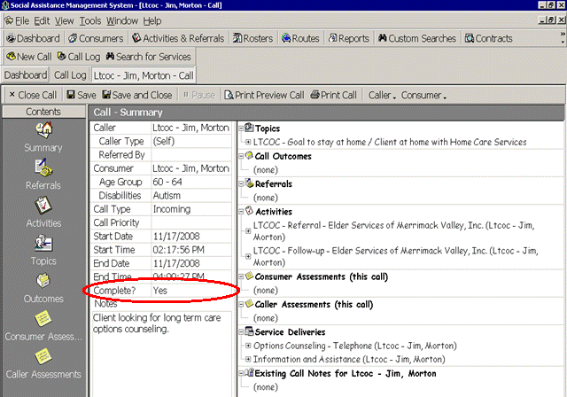

- Click Save & Close.

Tracking LTCOC Outreach in SAMS
The service Outreach should be used to track professional education. A consumer group should be created in SAMS to track outreach done in the community.

To create a Consumer Group:
- Click on Consumers.

- In Consumer Type Drop-down, select Consumer Group.

- Click on New
  - In Description field, enter in your Agency prefix followed by where you did the outreach (i.e. ESMV – Lawrence Medical Center – LTCOC Outreach).
  - Enter in Town, State, and Zip Code.
  - In Agency field, select your agency.
  - Click on Care Enrollments, and enroll the Consumer Group in LTCOC – Long Term Care Options.

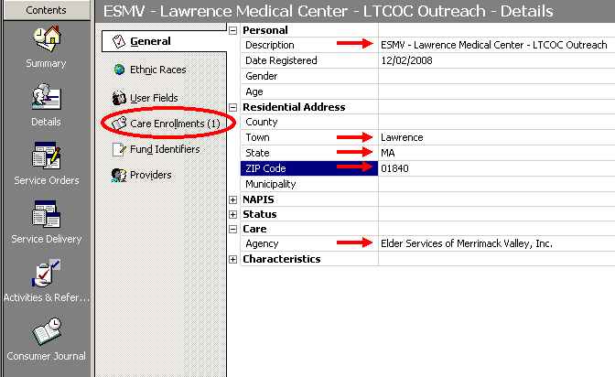
To create a Service Delivery for a Consumer Group:

- In left hand Contents Pane, click on Service Delivery.

- Click on Add Service.
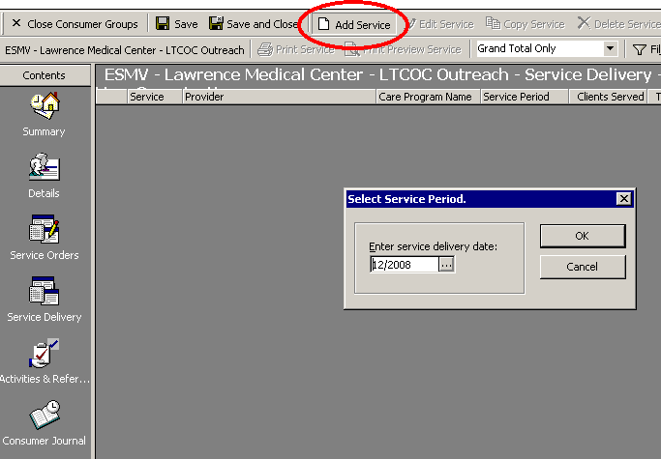
- In Select Service Period dialog box, select the appropriate month in which the outreach was delivered and Click OK.

  - Select the Care Program LTCOC.
  - Select your Agency as the Agency.
  - Select your Agency as the Provider.
  - Select the service Outreach.
  - In Consumers Served field, enter in the number of attendees.
  - In Total Units field, enter in 1.
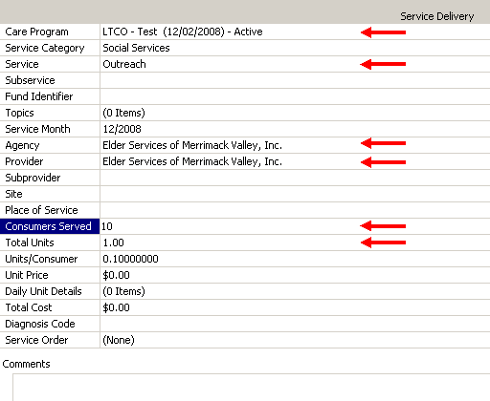

- Click Save & Close.

- When back in Consumer Group record, click Save & Close.

LTCOC Reports
Agency Summary Report
Summary report showing service delivers in a defined period of time.

Questions the Agency Summary Report will answer:
- Show me all the services delivered under the LTCOC program in a defined period of time.

- Click on Reports.

- Click on Services in the left hand contents pane.

- In top half of screen, double click on Agency Summary Report.

- Go to Service Delivery section

  - Enter in Service Start Date (on or after).

  - Enter in Service End Date (on or before).

  - Enter in your Agency into Agency field.

  - Select LTCOC – Long Term Care Options as the Service Program.

- Click Print Preview.

Sample Print Parameters for the Agency Summary Report:
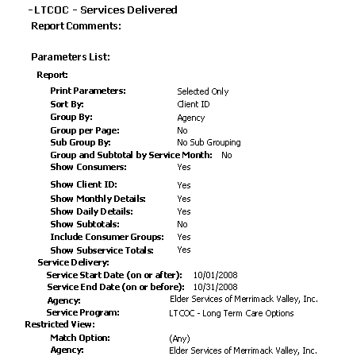

SAMS Call Topic Report
A listing of call topics based on selected filters.

Questions that the Topic/ report will answer:
- Show me how many LTCOC consumers selected each topic (goal) and totals for each outcome.

- Click on Reports.

- Click on I&R Reports in the left hand contents pane.

- In top half of screen, double click on SAMS Call Topic Report

- Under Report section:

  - Group By: Topic.

  - Subgroup By: Outcome

- Under Call Section:
  - Select you Agency in the Agency field.
  - Enter in Call Start Date (on or after).
  - Enter in Call End Date (on or before).
  - Click on Topics field, select the following Topics:
    - LTCOC – Goal to Stay at Home.
    - LTCOC – Goal NF Discharge.
    - LTCOC – Goal NF Admission.
    - LTCOC – I&R Only – Referral.

- Click Print Preview.

Sample Print Parameters for the SAMS Call Topics Report:

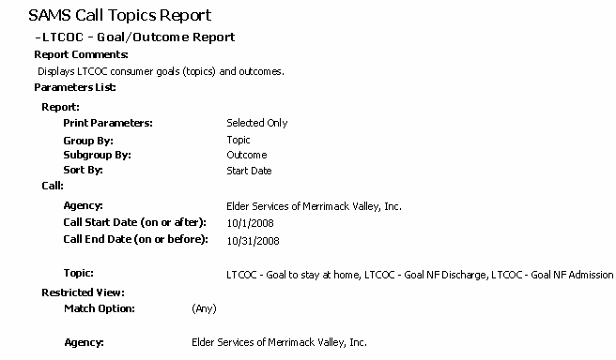

Sample Report Output:
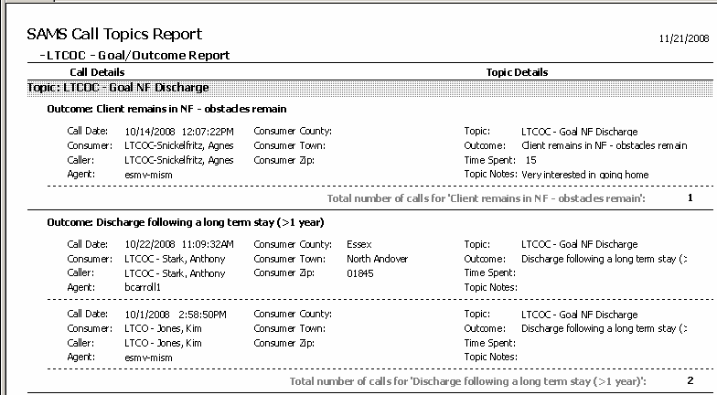

Interpreting the results: In the report output above, we see three (3) LTCOC consumers had the goal of NF Discharge. Out of those three (3) consumers, 1 consumer had the outcome: Client remains in NF – obstacles remain; and 2 consumers had the outcome: discharge following a long term stay (>1 year).

Activities & Referrals Report
A report showing all consumer activities and referrals.

Questions that the Activity & Referral report will answer:
- Show me incomplete LTCOC referrals.
- Show me incomplete and upcoming LTCOC follow-ups.

- Click on Reports.

- Click on Activities & Referrals in the left hand contents pane.

- In top half of screen, double click on Consumer Activity/Referral Report.

- Under Activity/Referral section
  - For incomplete LTCOC Referrals, select the Action: LTCOC Referral, for incomplete LTCOC Follow-ups, select the Action: LTCOC Follow-up.
  - In Status field, select Not Started.

Sample Print Parameters for the Activity/Referral Report:
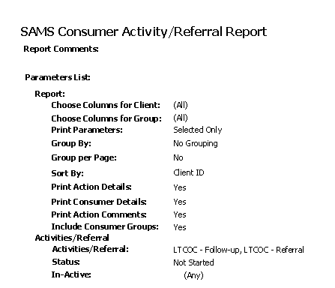

Consumer Listing Report
This report lists an unduplicated count of consumers based upon certain criteria selected.

Questions that the consumer listing report will answer:
- Show me a listing of consumers who have an active Long Term Care Options (LTCOC) Care Enrollment.

- Click on Reports.

- Click on Consumers in the left hand contents pane.

- In top half of screen, double click on Consumer Listing Report.

- Under Care Enrollment section, select LTCOC – Long Term Care Options as the Service Program.

- In Status field, select Active.

- Click Print Preview.

Sample Print Parameters for the Consumer Listing Report:
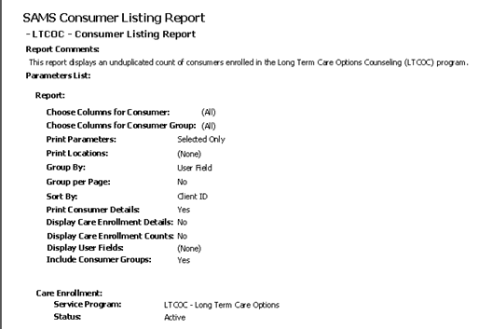

Appendix: Required Setup in SAMS Before Getting Started

Agency Contracts & Service Delivery Templates

- In order for your agency to able to track data in SAMS, agencies will need to add the following LTCOC services to their existing agency SAMS contracts:

  - Travel – to/from face-to-face LTCOC
  - Options Counseling – Telephone
  - Options Counseling – Face-to-Face
  - Outreach

- Once these services have been added to the agency contract, send an email to Brendan Carroll (Brendan.carroll@state.ma.us) so that he can create the service delivery templates for you to use.
- Once you’ve gotten word that Brendan setup the service delivery template, you will be ready to track LTCOC data in SAMS.

Optional Setup
If you have new LTCOC counselors that you would like to assign Activities & Referrals to, please send an email to SIMS Support (sims.support@state.ma.us) requesting them to add the counselor’s name to the Care Manager table.

