Overview
This Job Aid document is published to support the new functionalities of the User Dashboard, Saved Searches, Departments, and the revised Consumer Summary screen. These will be released to production with SAMS 2.0 (scheduled for September 2008).

Other Job Aids will be published to support the new functionalities in this release.

Table of Contents
Overview 1
Table of Contents 1
User Dashboard 1
Customizing your Display 2
User Setting to Display Dashboard on login 4
Widget Buttons (functionality) 5
Displaying Custom Searches on Your Dashboard 6
Departments in Widgets 6
Refreshing your Dashboard to show updated information 7
Consumer Summary Screen (Updated) 7
New Information 7
Assessment Information 8
Customizing your display 9
Custom Searches 9
Setting Search Parameters/Filters 10
Sharing 11
Custom Searches are accessible through Consumer List 13
Configuring Departments 14
User Roles with Access 14
How to set up a new Department 14
Screenshot of a Department 15

Revision History
Date | Version | Description | Author
July 28, 2008 | 1.0 | First Draft, published for Webinar July 30, 2008 | Brendan Carroll, Jim Ospenson
July 30, 2008 | 2.0 | Second Draft | Brendan Carroll

User Dashboard
SAMS 2.0 will feature dashboards to present key information to users. A dashboard is defined as a custom view comprised of multiple widgets (or visual objects that provide easy access to frequently used functions).

The following widgets have been created in SAMS to help Case Managers keep track their consumers and upcoming tasks:
- Assessments Due
- Activities Due
- Care Plans Expiring
- Recent Consumers Assigned
- Search Consumers
- Up to 5 Saved Search Widgets (Saved Custom Searches)

Users will have the ability to customize their dashboard to show all, some, or none of the above widgets, repositioning the widgets on the dashboard according to their own preferences and needs.

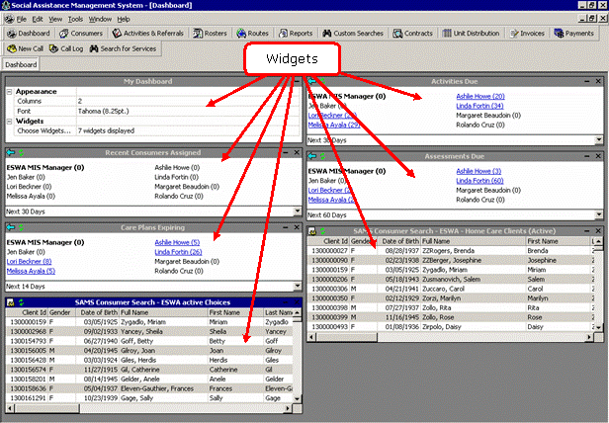

Customizing your Display
Each user can customize their Dashboard display using the My Dashboard widget. The My Dashboard widget allows them to:

- Choose how many columns you would like to display on your dashboard.
- Choose the font type and size of the words within the widgets of the dashboard.
- Choose background color.
- Choose font color.
- Choose the inactive background color.
- Choose the inactive font color.
- Select which widgets you would like to display on your dashboard.
- Move widgets around.

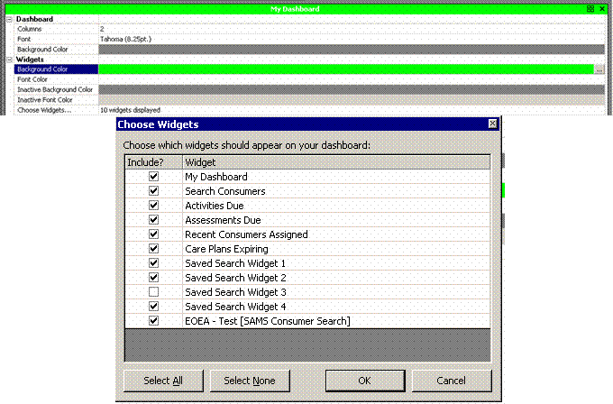

Additionally, users can move their widgets around. Here's how:

Roll the mouse over the widget's menu bar. The Cursor changes its look from a single arrow to a four-pointed arrow.
Mouse-down on the widget's menu bar.
Holding down your mouse, drag the widget to a new location.
Release the mouse.

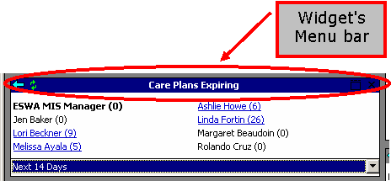

User Setting to Display Dashboard on login
The first time a user opens SAMS after SAMS 2.0 is released, s/he will be asked whether they want the dashboard to automatically display at each login of SAMS. The prompt comes up the first time a user clicks the Dashboard button (not immediately at login):

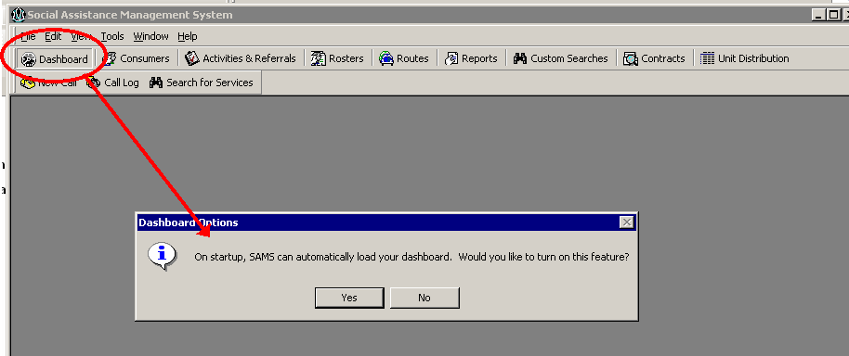

After selecting [Yes] or [No] the user receives another prompt informing them where they can find this setting, if should they change their mind.

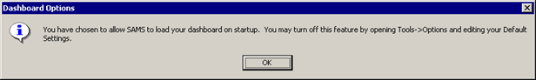

The dashboard auto-display upon login can be turned on or off using the Tools >Options menu.

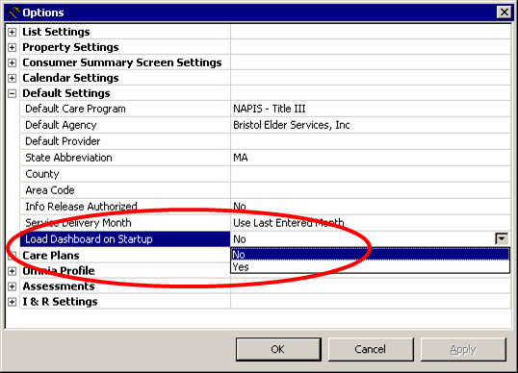

These prompts are only displayed the very first time a user click the “Dashboard” button (or the first time after doing a ‘reset user interface’).

Widget Buttons (functionality)
The Widget Menu bar contains buttons that affect its content.
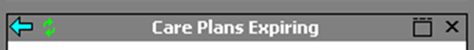
Users are able to:
- Go back by clicking 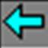 button.
- Refresh the information contained in each widget by clicking 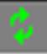 button.

- Return to dashboard view by clicking 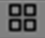 button.
- Maximize the widget by clicking button.

- Close the widget by clicking 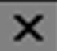 button.
- Choose a timeframe, using the dropdown menu, to display the desired information (selected widgets only).
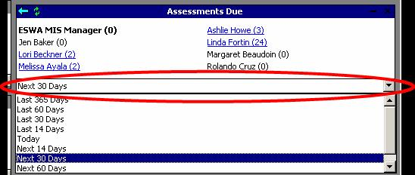

Displaying Custom Searches on Your Dashboard
Users will be able to display up to five (5) saved Custom Searches.

To display the results of a saved search, users select their saved search from the dropdown menu.

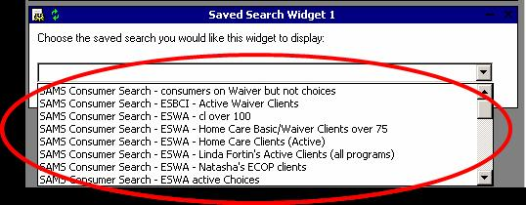

Once a saved search is selected, the results display on the user's dashboard.
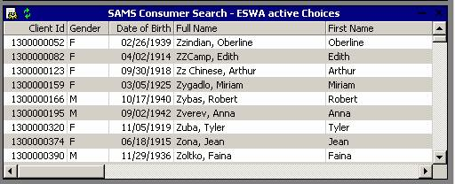

Users can access a consumer’s record by double clicking their name on the list. A significant convenience of the dashboard approach is that the user will see the information related to the widget: if the consumer is listed in the Care Plans Expiring widget, when the user double-clicks, the consumer's Care Management screen is displayed, listing all Care Plans.

Changing Saved Searches in a Widget
The saved search widgets 1-5 do not contain a back button, instead they contain a change saved search icon 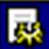, which bring you back to the saved search selection screen. Use the drop-down to select which saved search you would like to display on your dashboard.

Departments in Widgets
The Department feature in SAMS 2.0 will allow MIS Managers and Program Managers to define a group of users as a department. A department in SAMS is comprised of agency users who are identified as either a supervisor or members.

- Supervisors: Users tagged as a supervisor of a department will be able to view their own and their department members' Recent Consumers Assigned, Assessments Due, Activities Due, and Care Plans Expiring in the dashboard section of SAMS. If the user is a supervisor of more than one department, they see data related to all members of all departments.

- Members: See Recent Consumers Assigned, Assessments Due, Activities Due, and Care Plans Expiring, from among their own consumers (where the member is tagged as Primary Care Manager)

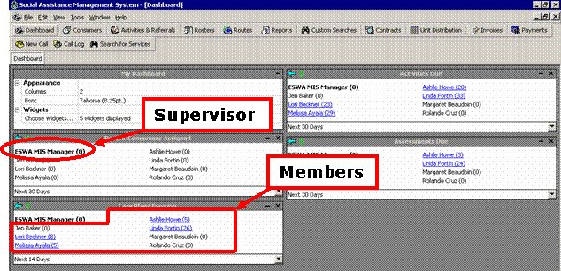

Refreshing your Dashboard to show updated information
By clicking the Refresh button in the Dashboard toolbar, users will have the ability to refresh the entire dashboard, including all widgets, to show the most updated information.

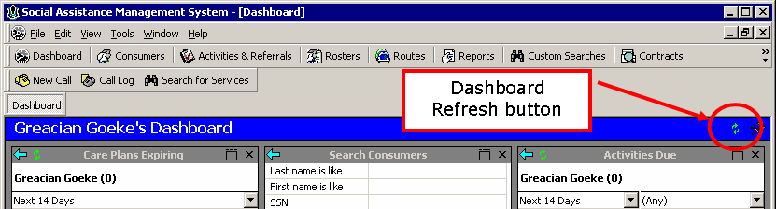

Consumer Summary Screen (Updated)

New Information
The Consumer Summary screen has been updated to display additional consumer information in a more intuitive fashion. Users will be able to get a better snapshot of the different aspects of the consumer from the new screen and be able to interact with different parts of the record via the Add/New and Edit buttons without needing to go to the individual areas. In addition, through Tools / User Options users can adjust the font, font size, number of columns, header and sub-header colors.

Screenshot: New Consumer Summary Screen
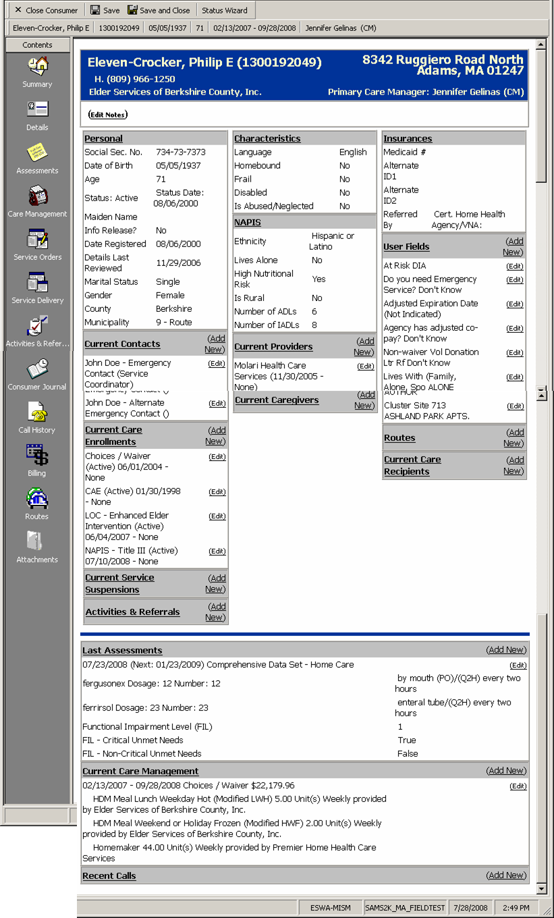

Assessment Information
This data element contains hyperlink buttons to view the consumer's list of Assessments, or to [Add New] (adding a new assessment), or to edit/view a recent assessment. Although the link says [edit], in accordance with Massachusetts configuration, an assessment is only editable to seven (7) calendar days from its creation.

The current Assessment section of the consumer summary screen has been enhanced to display
- Medications
- Functional Impairment Level from the Social module
- Critical Unmet Needs (true/false)
- Non-Critical Unmet Needs (true/false)
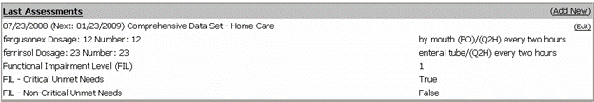

NOTE: since the CDS is assumed to contain Protected Health Information (PHI), information displayed here will come from the most recent CDS that is visible to the user in accordance with organizational security. If the user cannot see a CDS for the client due to its Assessment Agency and Assessment Provider elements, no information will be displayed here, even if an assessment from another agency exists.

Customizing your display

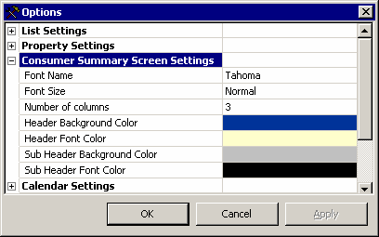 | Using Tools>Options menu, users have the ability to customize their consumer summary screens to their liking. In the Options menu, users can adjust the font, font size, number of columns, and header and sub-header colors.

Custom Searches
SAMS 2.0 will have a new button on the tool bar for “Custom Search”. This feature allows individual users the ability to create custom consumer views by specifying filter definitions within SAMS without have to go to the SAMS Reporting section. These custom consumer views can be shared with other SAMS users. These searches or views can be saved to be used repeatedly. The saved search/views can be accessed by going to the “Customer Search” section or from the consumer list page by selecting it from the consumer type filter.

To create a custom search, click on the Custom Searches button.

Note: Not all users will have the need to create custom searches. Managers and Administrators can create Custom Searches for their staff.

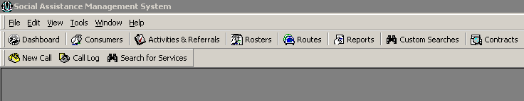

Custom Search Settings are the same as the settings for similar SAMS Reports, such as the Consumer Listing report. At present, there is only one Custom Search Title on the top half of the screen and the Custom Search Definitions to which you have access will be listed on the bottom half of the screen.
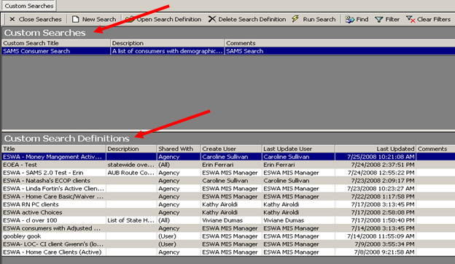

Setting Search Parameters/Filters
Setting Parameters, saving and previewing Custom Search is similar to setting SAMS report criteria. When naming saved searches, you should use your agency acronym as part of the naming convention populating the Search Title field, just as you do with SAMS Report Definitions.

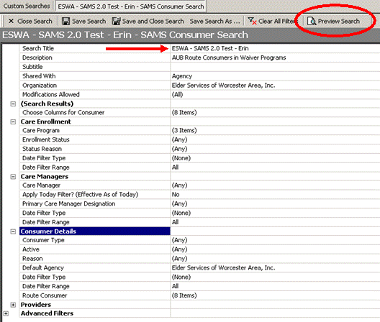

Sharing
Access to Custom Searches/Views is limited to the user’s organizational security settings. However, there is a new “Share with” functionality that allows users to share views. Users can Share with All, None, Agency, Provider, State and the level of modifications allowed can also be set.

For new Saved Searches, the default will be to share with the creating user's Agency with all modifications allowed.

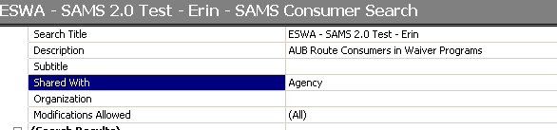

Creating Searches for your use only
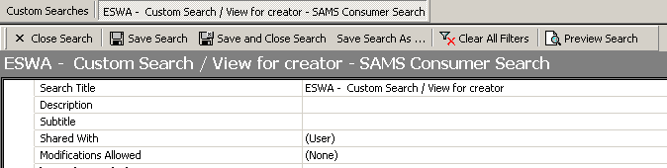

Preview Your Search
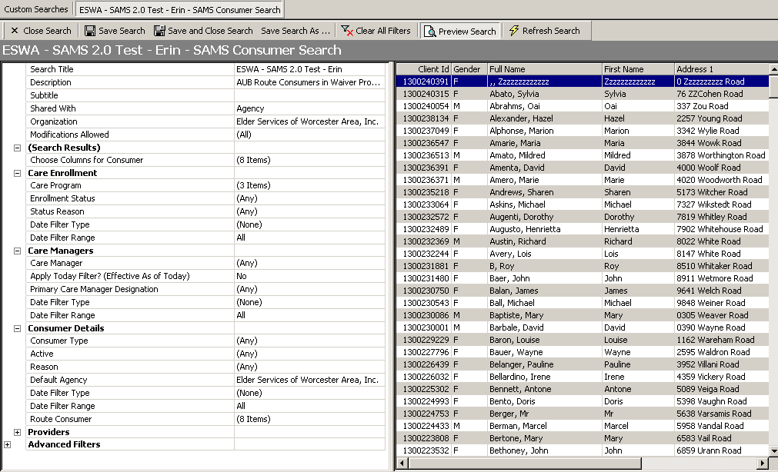

NOTE: The previewed list is not functional - if you double-click a consumer name it will NOT open the consumer record. The purpose of the preview is to enable the user to verify the parameters, but not to enable full use of the results list. The full functionality of the custom search results list is available on dashboard widgets and from the consumer list.

Also, we expect that the print and export function will be on this preview screen before the September 15, 2008 release of SAMS 2.0.

Custom Searches are accessible through Consumer List
Customer searches that have been saved can be accessed via the SAMS Consumer list screen.
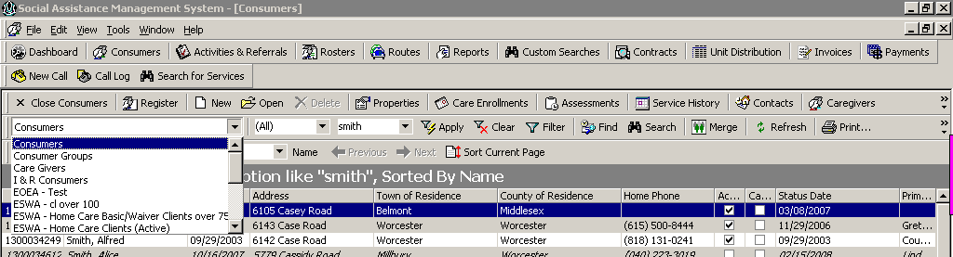

Please notice that once you open a customer search/view, you have the ability to Edit, Delete, print list, export results, find and refresh from the results page. It is important to delete custom searches if you are not going to use them as this list of searches could potential become long.

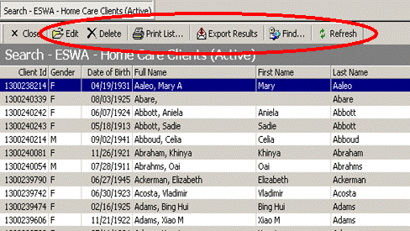

NOTE: The results of any custom search/view may not exceed the consumer list limit of 10,000 row. If more than 10,000 rows would be returned, only the first 10,000 will be displayed. Paging is not supported with this feature.

Configuring Departments
The full benefit of most of the Dashboard widgets will be gained by configuring Departments, comprised of Case Managers and other Agency staff who are assigned to consumer records in the Care Manager section of the consumer record, or who are assigned to Activity/Referrals as Activity Providers.

User Roles with Access
Users with the MIS Manager and Program Manager role will have access to create and manage Departments. The Department feature in SAMS 2.0 allows users with the appropriate access to define a group of users as a department and can identify users as either members or supervisors. Users appointed as a supervisor will be able to view their own and their member’s Recent Consumers Assigned, Assessments Due, Activities Due, and Care Plans Expiring in the dashboard section of SAMS.

How to set up a new Department
To create a Department, users will click on Tools > Departments

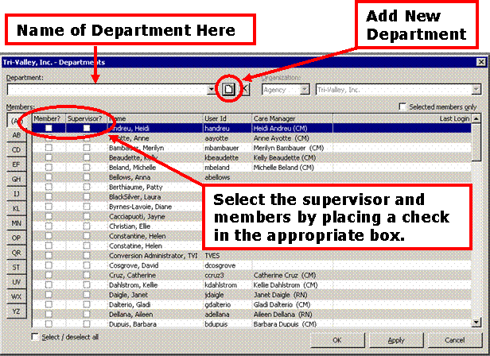

Screenshot of a Department
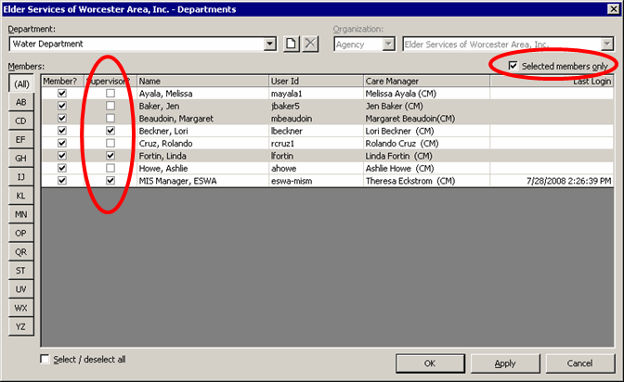

Some Notes on this department listing:
- A department can have more than one supervisor. Each supervisor will see a view of department activities through their own dashboard widgets.
- The selected Members only checkbox provides a convenient view of the department.
- Contact SIMS Support if there is a mismatch between the User ID and Care Manager columns. If these two elements are disconnected (for any user) then the Widget Information may be incorrect. Harmony will make an effort to link Care Managers to valid user ids.

