Overview
This Job Aid document is published to support the first training webinar related to the release of SAMS 2.0 (scheduled for September 2008)

Other Job Aids will be published to support the new functionalities in this release.

Table of Contents
Overview 1
Table of Contents 1
Route Modifications 1
Organizational Security for Reports 2
Sharing Report Definitions 3
Modifications Allowed 4
Frequently Asked Questions 4
Audit Trails 4
Assessment Enhancements 5
Information Release Authorization 6

Route Modifications
The consumer record has been updated to include a new section called “Routes”. Also, the new and improved consumer summary screen will now display a route section, with the list of routes with which the consumer is associated. (Note: the new Consumer Screen will be described further in an upcoming Job Aid).
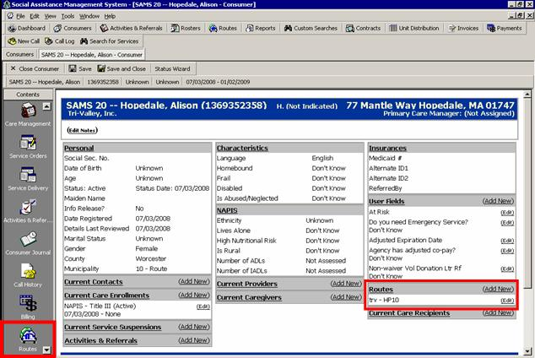

When users click the “Routes” button they will be able to view the list of routes (filtered by organization) that a consumer is currently on. A consumer’s participation on the route list can be modified from the Routes section of the consumer record. Users will now be able to manage routes within the consumer screen without needing to go to the Routes section of SAMS. Consumers can be removed from a route they are currently on by clicking the Remove from Route button or added to an existing route by using the Add to Route button.

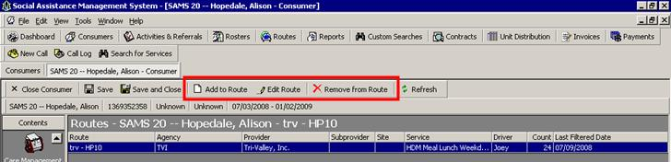

Organizational Security for Reports
A new section entitled “Report Security Access" has been added to each of the SAMS reports. Reports definitions will now obey organization security and will only be visible to users at your organization, unless the report definition is shared with another agency or provider.

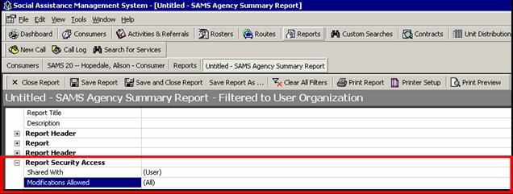

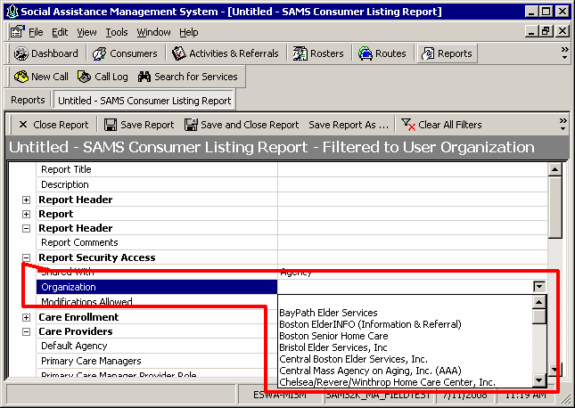

Sharing Report Definitions
Users will be able to share reports definitions with the following:
Type | Who Will Be Able to See the Report Definition?
(User) | Not shared, only they would be able to see the report definition.
(All) | Statewide access, every user state-wide would be able to see the report definition.  Please train your users to select this option carefully. If you select this option, make sure to name your Report Definitions with your Agency's abbreviation as a prefix, as is the current practice.
Agency | User must identify their agency or another agency.  If selected, a new field labeled "organization" appears. The user must specify which Agency to share with via the organization Dropdown field. Enter your own or another Agency.
Provider | User must identify a Provider with SIMS users, such as a standalone nutrition provider.  If selected, a new field labeled "organization" appears. The user must specify which Provider to share with via the organization Dropdown field. Select the name of a Provider
State Unit | If chosen, EOEA users only will be able to view the report definition.

Modifications Allowed
Users will also be able to select whether to allow modifications on the report:
Type | What Modifications Can Be Made?
(All) | Any users who can view the report definition can change any field.
(None) | User cannot change any fields.
Date Fields Only | Any users who can view the report definition can ONLY change date fields within the report definition.

Frequently Asked Questions
- The conversion of existing report definitions will be based on last update user. By default, the report will be shared with users that are associated with the same organization as the last update user.
- The default on existing report definitions will be ‘Agency’.
- Users can opt to assign a report definition to an organization other than their own, but they will continue to have access to this definition as the original create user.
- EOEA created report definitions will default to ‘Shared with All’.
- If a user wants to edit a report that they can view but do not have modification rights to, the user could do a ‘save as’ and would then become the ‘create user’ and would have full rights to the newly created copy of the report definition.

Audit Trails
Users with the MIS Manager and Case Manager Supervisor roles in SAMS will have access to audit trail information. This access will allow users the ability to view modifications made to the following: consumer data and consumer transaction data including: consumer status (Active/Inactive), action items, service orders, service deliveries, care plans, service plans, care enrollments, and journal entries. For instance, Audit Trails will display the user and organization that has modified the Consumer Default Agency element, for each such change.

To access audit trails, go into the section you would like to audit and you can either go to Tools>Audit Trail or Right Click and select Audit Trail.

Audit trail data is currently not available for items that are deleted in the consumer record. This functionality will come in a future release.

Please note: For merged consumers, where a secondary consumer is merged into a primary consumer, the audit trail will be tied to the primary merged consumer and linked to the user who performed the merge. The secondary consumer will be deleted and thus not auditable until a future release.

Audit trail data will be visible via a pop-up window that can be accessed from any record for which auditing is enabled.

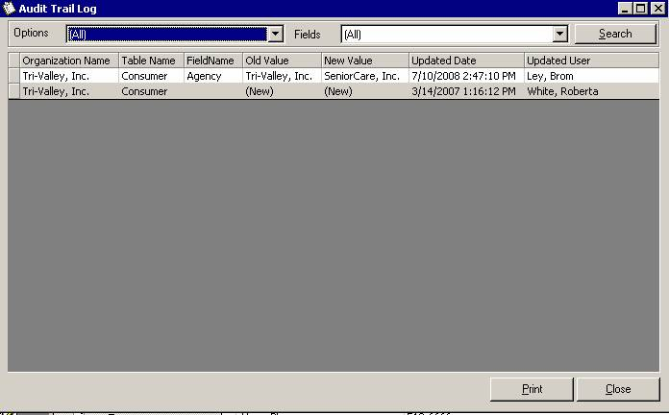

Assessment Enhancements
Assessment enhancements coming in SAMS 1.11 service release on July 28th, 2008.

- User preferences for Omnia Font and Font Size - Users will now have the ability to change the size of the assessment question and response fonts by clicking the “Choose Font” button in the assessment form. Users will specify their font (style, size, and color) and screen layout preferences and the system will hold those preferences from one session to the next.
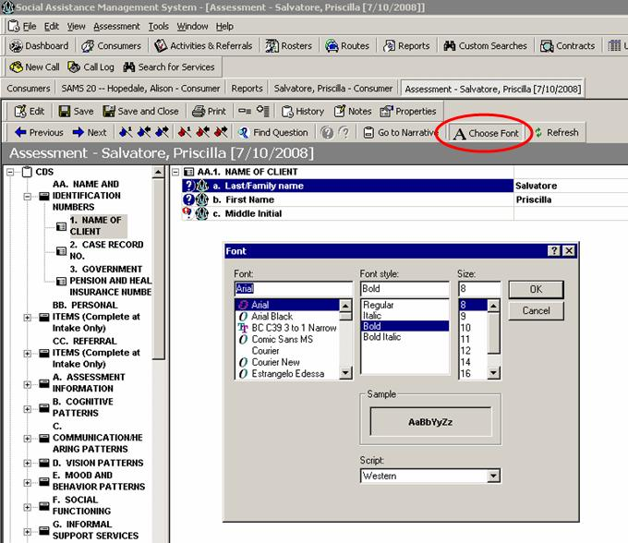

Please note:
- Printed assessments will not reflect the font size set in the assessment.
- Font settings are not transferred to and from the local version of Omnia and the network version. Therefore, these setting will need to be set up once in each version independently.

- Word wrapping of question prompts - Assessment forms will now support text wrap capabilities in both the question prompt and response.

- Display SAMS Linked Questions Icons - An Omnia icon (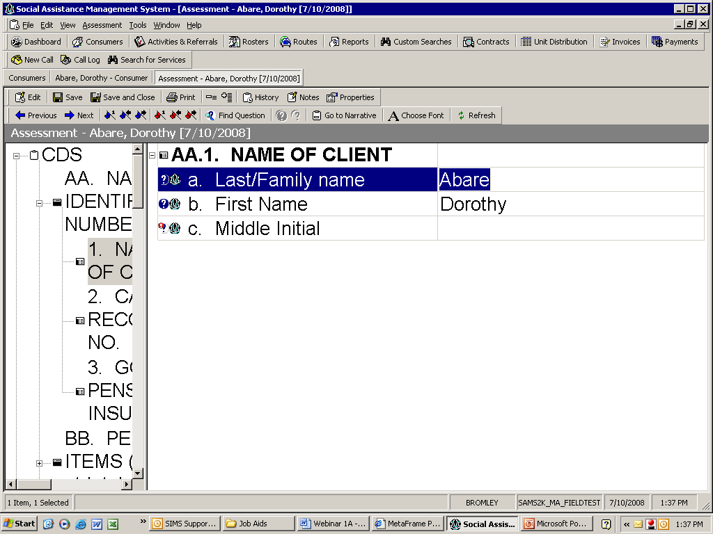) will be displayed next to questions that map back to the consumer record.
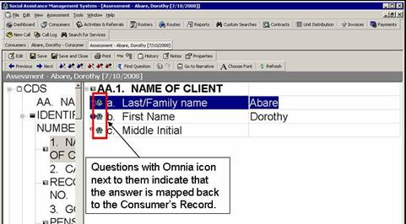
- Display Required Questions Icon – A red icon (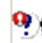) will be displayed next to questions that users are required to answer.

- Navigate to Required Unanswered Questions – Three (3) buttons have been added to the toolbar which will take users to the first required unanswered question, next required unanswered question, and previous required unanswered question. Note: at present, most Massachusetts assessments do not use the required question attribute. This will be used in future assessments.

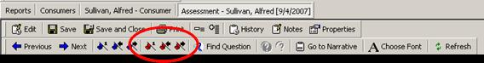

Information Release Authorization
The SAMS consumer record has been updated to support the indication of consumer contacts and consumer providers whom the consumer or guardian approves the release of their care information to.

When adding a consumer contact you would indicate, at the contact level, whether that contact is authorized for consumer information release. Likewise, when adding a consumer provider you would indicate, at the provider level, whether that provider is authorized for consumer information release.

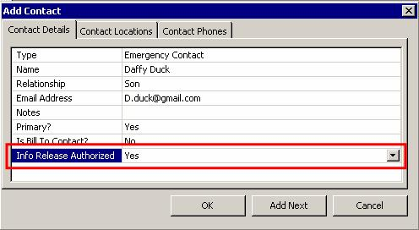

A new filter will be added to the Consumer Contact Report giving users the ability to filter by the ‘Info Release Authorized’ field value.

Please note: When creating adding new contacts or consumer providers, the Info Release Authorized field will default to what the consumer record is. Therefore, if the Info Release Authorized’ field in the consumer record is set to ‘No’, when the user adds a consumer provider record or consumer contact record, the info release field will default to ‘No’. The user will have the ability to override this value, although the default will always be whatever is set at the detail level of the consumer.

Please note: With the implementation of SAMS 2.0, Harmony has applied a “No” value for existing consumer “Contacts”. Harmony has applied a “Yes” value for existing consumer “Providers” in SAMS. An Information Memorandum will be issued soon regarding the use of this element.

