Overview
Overview/Detail:

This report called “EOEA Copay Validations” is located in the Consumers category of SAMS Reports.

The purpose of this report is to identify households that may be receiving double billings, for example, once for the Consumer and again for the Spouse, and to identify Relations that may have been chosen incorrectly due to same or similarly spelled names. In the latter case the Billing cycle could be pulling in Services from an unrelated Consumer.

Revision History
Date | Version | Description | Author
June 24, 2008 | 1.0 | Draft for release to SIMS Community | Jesse Gibson

Features & Functionality
The report is a generic Consumer search with all standard Consumer filters (e.g. Agency, Care Enrollments, Care Providers, Consumer Details, etc.). Once a Consumer population is configured one of two scans may be run against the Consumer/Copay/Relation records from that population.

Note that Care Programs do NOT enter the Copay picture at all for these scans

Other than setting the Consumer Population via Enrollments, Care Programs are ignored. Once a population is established EVERY Copay/Relation set of records for that Consumer is looked at regardless of what (or even if any) Care Programs are set up for the Copay. The only Copay exclusions are based on filters for Copay Amount and Copay Start/End Dates as specified for the run. Sample Scenarios follow.

Scenario #1 – Duplicate Billing:
This report scans for Consumer/Copay/Relation records where a Consumer with a non-$0 Copay amount also exists as a Relation on another Consumer’s non-$0 Copay amount record during the same billing period.

Scenario #2 – Relation Verification:
This report scans for Consumer/Copay/Relation records where the Relation’s Agency, City, or Town is different than that of the Consumer.

Scenario #3 – All (both at once):
This will show all copays listed in scenario #1 and #2. This is not recommended, but the report is capable of running both.

Scenario #4 – Excel Export:
Exporting as an Excel file will allow for further analysis. The export is very clean and easy to read. Note: No highlighting will be reflected in the export

Basic Run of the Report Scan

# | Step | Notes
1 | Under Reports, select Consumers in the category pane
2 | Double click the report EOEA Copay Validations
3 | Complete a Report Title | If the report is to be saved enter a Report Title, E.g. “Springwell Duplicate Billing Feb 08.” It is suggested to use the Scan Type as Part of the Report Title.
4 | Select your Agency | This is a required parameter. To reduce run time of the report, select only your agency.
5 | Select your preferred Sort By criteria. | Options include Client ID, First Name, and Last Name.
6 | Set Reporting Period From/Thru | Set this to your period of interest, typically one month (Billing Period) at a time. It will select ONLY Copay records Open at least one day in the period. If you extend beyond a month false positives may appear when Copay values were changed (especially Closed and Re-Opened) appropriately in different months but the scans still pick them up across the whole period and misidentify them as repeats and conflicting.
7 | Select the desired Scan Type. | Options include “Duplicate Billing” and “Relationships” and “All” should you wish to run both at once.
8 | Optional Group By. | Group by allows sorting/counting results by Primary Care Manager. Group per Page will additionally allow easy separation for delivery to the CM’s
9 | Optional Scan Filters:  Excel Export  Show Discrepancies Only  Copay Threshold >=  Use Highlighting | These variations to the basic scan will be discussed farther down
10 | Other Optional Consumer Filters | Any/All of the additional standard Consumer filters may be used to determine the Consumer Population to be scanned. In addition one of the following is required:
9 | Required: Select a Care Program(s) or Level of Care. | Select specific Care Program(s) or Level(s) of Care for more specific review of consumer records. At least one of either must be chosen to avoid scanning everything.
11 | Select Print Preview to run the report
12 | When finished close the report | Save changes to the report definition as desired, but be sure to use Save As if you started with someone else’s.

Regardless of scan type the report layout is identical, split down the middle with Consumers and their Agency, Town, Zip and their Copay Amount, Start, and End Dates on the left. On the right Relations are shown with their Agency, Town, and zip. Both sides begins with a Scan column where the scan results are posted, ‘Dup/OK’ for Duplicate Billing or ‘Rel?/OK’ for Relationships.

Scenario #1 – Duplicate Billing Run

# | Step | Notes
1 | The Scan Type filter: Duplicate Billing | Whenever a particular Consumer is present on BOTH the Consumer side and the another Consumer’s Relation side it is considered a duplicate and the Scan column(s) are set to ‘Dup’. These are potential situations where two bills may have gone out to the same household
2 | Copay Threshold >= | Typically set to $.01. Copay amounts for Relations (Spouses) are normally set to $.00 and should be excluded.
3 | Show Discrepancies Only | Typically set to Yes. However, if desired, set it to No for a “Master” List. Most rows will be ‘OK’ and any ‘Dups’ will be bolded, either side along with their Client ID/Name.
4 | Use Highlighting | ‘Dups’ are always bolded for colorless printing, but online/color prints may use this for Yellow highlights. Unlike a few other reports, ‘OK’s are not shown in blue, they are left colorless.

A Scan Result sample from a very contrived test system is on the following page, using a Report Definition of:

Agency: Springwell, Inc.
Sort By: Last Name
Billing Period From: 11/1/2005 (Use only one month when running for
Billing Period Through: 4/30/2007 real in Production)
Excel Export: No
Scan For: Duplicate Billing
Show Discrepancies Only: Yes
Copay Threshold >=: $0.01
Use Highlighting? Yes
Group By: No Grouping
Group Per Page: No
Level of Care: State Programs

Understanding the Report Results for Duplicate Billing

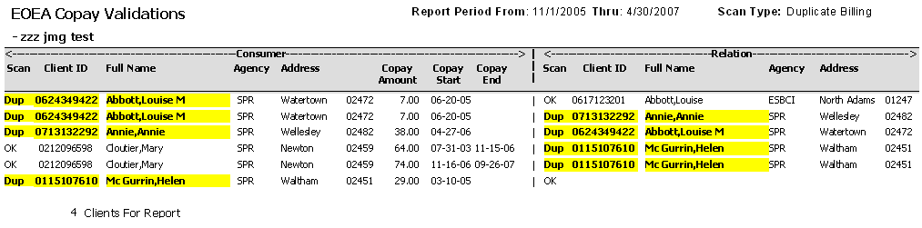

Line | Results | Notes
top | Report Period | Reporting Period prints on header at top, every listed Copay Start/End intersects at least one day of that range.
top | Scan Type | ‘Duplicate Billing’ prints at top
all | Copay Amount | Note All Copay Amounts are greater than a penny, as specified
1/2 | Abbott,Louise M | On lines 1 and 2, Louise M appears twice, one row for each Relation in her 06-20-05 Copay for $7.00.  Her first Relation, Louise is not a duplicate.  Her second Relation, Annie IS on the report farther down as a Consumer, and so designated and highlighted.  Louise M herself is highlighted as a Duplicate on the Consumer side; because she is also someone else’s Relation. When this happens any of her rows are always highlighted at the left. The right-side depends on her Relation’s individual status.
3 | Annie,Annie | Consumer Annie exists elsewhere as a Relation and her Relation. Louise M, exists elsewhere as a Consumer and everything is highlighted (predictable per Lines 1 and 2)
4/5 | Cloutier,Mary | Mary is OK but her Relation, Helen, exists elsewhere. Note also (per the Copay dates) that the rows this time are two Copays, not two Relations on the same Copay.
6 | McGurrin,Helen | Helen exists elsewhere, at least once, as a Relation. Her own Relations (in this case none at all) are fine.
bottom | 4 Clients for Report | There are 4 unique Consumers whose Copay settings bear investigation. You also get the same unique count as a sub-total when grouping by Primary Care Manager

The cases above were contrived just to test the report. It is probably rare that a Consumer will have more than one Relation or Copay during a Billing Period.

It is probably also rare that a particular Consumer will be a duplicate Consumer, have all duplicate Relations, and also be a duplicate Relation on another Consumer(s) all at the same time.

Scenario #2 – Relationships Run

# | Step | Notes
1 | The Scan Type filter: Relationships | Whenever a Consumer’s Relation has a different Agency, City, or Town, ‘Rel?’ appears in the Relation’s scan column. The particular field(s) that differs is highlighted.  These are cases where a similarly named person may have been miss-chosen during Copay Relation Setup and Maintenance. As of this writing, the SAMS Maintenance screen shows only the name and it is not possible to verify correctness at a glance. This report and others that expose the Relation’s client ID is the only current method to do so.
2 | Copay Threshold >= | Typically set to $.00. It could be argued that only billable situations need investigation, but all should be fixed in case a no-bill turns into a yes-bill in the future.  One might also set this to .01 for a historical research run into who may have been billed incorrectly (pulled in wrong Relation’s Services) in the past.
3 | Show Discrepancies Only | Typically set to Yes. However, if desired, set it to No for a “Master” List. Most will be ‘OK’ and any ‘Rels’ will be highlighted, along with the field difference.
4 | Use Highlighting | ‘Rels’ are always bolded for colorless printing, but online/color prints may use this for Yellow highlights. Unlike a few other reports ‘OK’s are not shown in blue, they are left colorless.

A Scan Result sample from a very contrived test system is on the following page, using a Report Definition of:

Agency: Springwell, Inc.
Sort By: Last Name
Billing Period From: 11/1/2005 (Use only one month when running for
Billing Period Through: 4/30/2007 real in Production)
Excel Export: No
Scan For: Relationships
Show Discrepancies Only: Yes
Copay Threshold >=: $0.00
Use Highlighting? Yes
Group By: No Grouping
Group Per Page: No
Level of Care: State Programs

Understanding the Report Results for Relationships

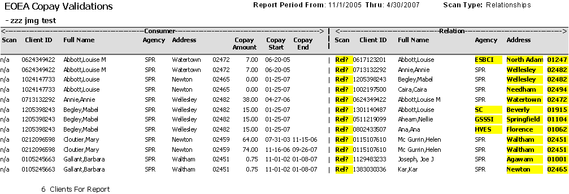

Line | Results | Notes
top | Report Period | Reporting Period prints on header at top, every listed Copay Start/End intersects at least one day of that range.
top | Scan Type | ‘Duplicate Billing’ prints at top
all | Copay Amount | Note that we now have a few $0 Copay Amounts this time, as specified
all | Scan (Consumer) | Always ‘n/a’ on a Relationship run. Consumer values are assumed to be correct; although there is a chance the Relation is actually the correct one.
all | Scan (Relation) | Always ‘Rel?’ on a Relationship run, unless Show Discrepancies Only is set to No when ‘OKs’ will show up, sort of a de facto Master List.
all | Agency or  Address (Relation) | One or more of the Agency, City, or Zip fields will be highlighted on the Relation side.
bottom | 6 Clients for Report | There are 6 unique Consumers whose Copay Relations bear investigation. You also get the same unique count as a sub-total when grouping by Primary Care Manager

The cases above were obviously wildly contrived for testing. One will probably never see more than one Relation per Consumer Copay; never mind 3 on Mabel Begley, and doubles on 3 of the remaining 5. Nevertheless, should it occur, the scan will examine it.

Note again per the Start/End Dates, that Mary Cloutier is NOT a double Relation situation. She is two different Copays each having one Relation.

Scenario #3 – All (Both At Once) Run

# | Step | Notes
1 | The Scan Type filter: All | This version is arguably confusing but it does work and combines the best of both scans at the same time. On the left-side Consumer only ‘Dups’ or ‘OK’ can appear. On the right- side, a Relation could be a ‘Dup’ and a ‘Rel?’ at the same time, in which case
2 | Copay Threshold >= | Typically set to $.01 due to the inclusion of Duplicate Billing at the same time.
3 | Show Discrepancies Only | Typically set to Yes. However, if desired, set it to No for a “Master” List. Most will be ‘OK’ and any ‘Rels’ or ‘Dups’ or ‘Both’ will be highlighted.
4 | Use Highlighting | ‘Rels’ and ‘Dups’ are always bolded for colorless printing, but online/color prints may use this for Yellow highlights. Unlike a few other reports ‘OK’s are not shown in blue, they are left colorless.

A Scan Result sample from a very contrived test system is on the following page, using a Report Definition of:

Agency: Springwell, Inc.
Sort By: Last Name
Billing Period From: 11/1/2005 (Use only one month when running for
Billing Period Through: 4/30/2007 real in Production)
Excel Export: No
Scan For: All
Show Discrepancies Only: Yes
Copay Threshold >=: $0.01
Use Highlighting? Yes
Group By: No Grouping
Group Per Page: No
Level of Care: State Programs

Understanding the Report Results for All (Both At Once)

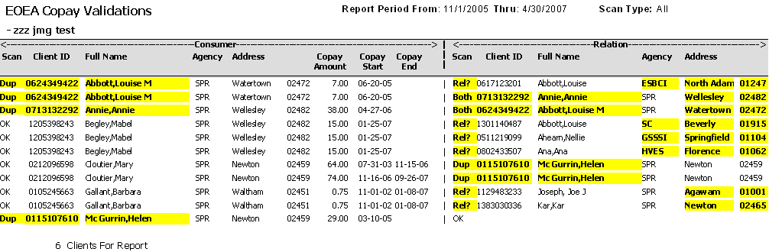

Line | Results | Notes
top | Report Period | Reporting Period prints on header at top, every listed Copay Start/End intersects at least one day of that range.
top | Scan Type | ‘All’ prints at top
all | Copay Amount | Note, back to .01 or greater this time
all | Scan (Consumer) | Always and only ‘Dup’ or ‘OK’ on an All run.
all | Scan (Relation) | 4 possibilities now, ‘OK’ or ‘Dup’ or ‘Rel?’ or ‘Both’
All | Duplicate highlighting | The duplicate results are identical on both sides until and unless a Relation also has an Agency/Address issue when the Relation’s scan flips from ‘Dup’ to ‘Both’. Lines 2 and 3 are an example. Also there will be many more rows than a straight Duplicate run, one for each Relation issue only situation.
all | Agency or  Address (Relation) | One or more of the Agency, City, or Zip fields will be highlighted on the Relation side.
bottom | 6 Clients for Report | There are 6 unique Consumers whose Copay and/or Relation settings bear investigation. You also get the same unique count as a sub-total when grouping by Primary Care Manager

The cases above were again obviously wildly contrived for testing. Sharp eyes will reveal we had to change Helen’s address back to Newton to show an example of ‘Dup’ rather than ‘Both’ on the Relation-side in this mixed run.

Scenario #4 – Excel Export Run

# | Step | Notes
1 | Excel Export | Set to ‘Yes’. Verify content is what is desired with a regular report run first.
2 | All Other filters | Any type of desired run, settings
3 | Use Highlighting | Ignored for Excel Exports, leave it turned on if more convenient than changing it back and forth each time.

A Scan Result sample from a very contrived test system is on the following page, using a Report Definition of:

Agency: Springwell, Inc.
Sort By: Last Name
Billing Period From: 11/1/2005 (Use only one month when running for
Billing Period Through: 4/30/2007 real in Production)
Excel Export: Yes
Scan For: All
Show Discrepancies Only: Yes
Copay Threshold >=: $0.01
Use Highlighting? Yes
Group By: Primary Care Manager
Group Per Page: No (ignored for Excel but Yes useful for Report)
Level of Care: State Programs

Understanding the Report Results for Excel Export

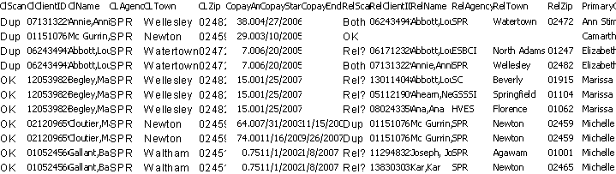

Line | Results | Notes
1 | Column Headings | Field Names that will appear in line one of the Excel. Names are short but there are no embedded blanks so they will be handy for auto-importing into MS- Access, etc.
2+ | Column Values | Raw data for each line on the report, in columns.

Note that there is no bolding or highlighting, but the Scan Columns ARE present. In this example we also grouped by the Care Manager. It is the right-most column and has taken sort precedence. Consumer Last Name is now within Care Manager. Follow the normal SAMS export procedure choosing ‘Microsoft Excel (Data Only) (.xls)’ as the File Format. Once downloaded and opened in Excel it will look as follows

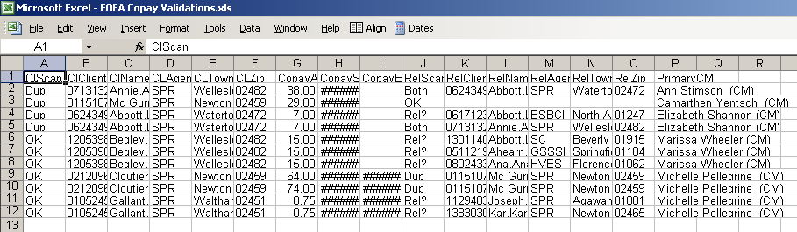

To finish formatting:
- Click the square to the left of the A column to select everything.
- On top tool bar use Format, Column, AutoFit Selection, to expand column widths.
- Repeat for Format, Row, AutoFit Selection, for a little extra height.

