Overview
This document is a Job Aid that shows how to record data in SIMS consistent with PI-08-11 Managed Intake.

The program instruction outlines programmatic requirements for managing waitlists for Home Care Basic-NW and ECOP-NW. As indicated in the PI, waitlists for Home Care Program/Non-Waiver and ECOP/Non-Waiver are to be maintained at all ASAPs whose caseload capacity stands at 105% or greater.

The process for SAMS documentation of current waitlist clients and enrollment of new waitlist clients is detailed below.

Contents
Overview 1
Notes regarding this Job Aid 1
New Care Programs for HCP Waitlists 2
Requirements: Keeping Consumer on Waitlist 3
New Waitlist-specific Reason Codes for Care Enrollments 3
Adding Consumer to Waitlist 4
Update Consumer on Waitlist after monthly check-in 5
Promote Consumer from Waitlist - Enroll in Same Program 6
Promote Consumer from Waitlist - Enroll in Different Program 9
Remove Consumer from Waitlist - without Enrollment 9
Reports - current and historical Waitlists 12
Reports: Data validation to show consumers with incorrect data 15

Revision History
Date | Version | Description | Author
Feb 12 2009 | 1.0 | Draft for release to SIMS Community, related to CCF 0346-A | Jim Ospenson

Notes regarding this Job Aid

Target Audience
This Job Aid is targeted to users who are familiar with basic elements of consumer enrollment records; use of the Status Wizard; and with basic reporting.
- For more information about the Status Wizard, please review the document Job Aid - Status Wizard - v02 - April 23, 2008.doc, produced by SIMS Support in April 2008. This document is available on 800ageinfo.com.
- For information about basic reporting and creation of report definitions, please inquire with Agency colleagues who have attended any of the report trainings conducted in Fall 2008.

Use of the Status Wizard is recommended but not required
The Consumer Status Wizard, available from the Consumer Details screen, is recommended for use in transfers and terminations from the Waitlist. We feel that this functionality is superior to simple manipulation of care enrollments, despite a known issue (described below in section Promote Consumer from Waitlist - Enroll in Same Program: see step 3 on page 6 of 17 below.).

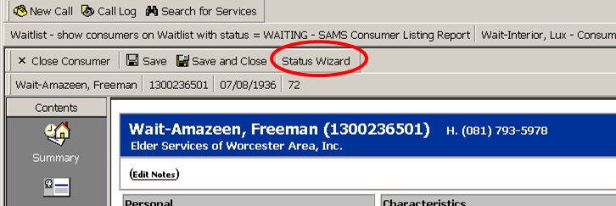

However, users may elect *not* to use the Status Wizard, and are welcome to open and close enrollments using the basic functionality [Add Enrollment] or [Edit Enrollment], available from the Consumer Details > Care Enrollments screen.

All enrollment reason codes must be employed as documented below, regardless of method used to manage enrollments.

Typographical convention used in this document
Information enclosed in angle brackets should be replaced with the appropriate information. For example, if the instruction below indicates "Status Date: <today's date>", then it should be understood to mean that the current date at time of data entry, whatever it might be, should be entered as the value for Status Date in the user interface.

New Care Programs for HCP Waitlists
Two (2) new care programs have been added to the SAMS Administrator to enable ASAP staff to manage waiting lists for Home Care Basic - Non-Waiver and for ECOP-Non-waiver. The names of the care programs are as follows:

- WAITLIST for Home Care Basic - Non-Waiver
- WAITLIST for ECOP - Non-Waiver

Once an Agency determines that they are at 105% of program enrollment for either of these two programs, then the Agency must add clients who are deemed potentially eligible for home care services to the appropriate waitlist.

Data Quality
It is important to follow the steps in this Job Aid so that EOEA can have statewide visibility to the waitlists. This will enable EOEA to best manage reallocations of Home Care Program funding to minimize the waitlist, as described in PI-08-11 Managed Intake.

In order to ensure data quality, report filtering and criteria are described below that will show consumers with incorrect settings for enrollment status or reason codes. Agencies should view these reports monthly in order to ensure that all consumers are correctly on the waitlist.

Agencies should keep their data as accurate as possible at all times, keeping their data up-to-date in SAMS on a timely basis. EOEA may review waitlists at any time.

Requirements: Keeping Consumer on Waitlist
Periodic contact with the elder or caregiver is required to verify that the elder should remain on the waitlist. Agency staff should contact waitlisted consumers at least once every thirty (30) days.

Documentation of consumer contact:
- Journal Entry
- Update Status Date on Waitlist enrollment record for reportability. See below.

New Waitlist-specific Reason Codes for Care Enrollments
A set of new reason codes has been added to SAMS and associated with specific enrollment statuses. The reason codes shown below are intended to be used only for purposes related to waitlists, as described in this document. Please use them as directed, and do not use other reason codes available in SIMS.

Sample report definitions are provided below to support efforts to improve data quality and reduce errors. See the section Reports: Data validation to show consumers with incorrect data, below.

Enrollment Status | Reason Code | note
Active | Transfer from WAITLIST (ECOP Waitlist) | Use these codes in Home Care Basic - Non-Waiver, ECOP-Non Waiver, or Choices only.  Not for use in a waitlist program
Active | Transfer from WAITLIST (Home Care Basic Waitlist)
Terminated | Withdrawn from WAITLIST - Adequate Formal Support | Use these codes in Waitlist programs only.
Terminated | Withdrawn from WAITLIST - Adequate Informal Support | Use these codes in Waitlist programs only.
Terminated | Withdrawn from WAITLIST - Death | Use these codes in Waitlist programs only.
Terminated | Withdrawn from WAITLIST - FIL Ineligibility | Use these codes in Waitlist programs only.
Terminated | Withdrawn from WAITLIST - Financial Ineligibility | Use these codes in Waitlist programs only.
Terminated | Withdrawn from WAITLIST - Moved from Service Area | Use these codes in Waitlist programs only.
Terminated | Withdrawn from WAITLIST - Nursing Facility Admission | Use these codes in Waitlist programs only.
Terminated | Withdrawn from WAITLIST - Other Reason | Use these codes in Waitlist programs only.
Transfers | Transfer to Choices (from HCB Waitlist) | Use these codes in Waitlist programs only.
Transfers | Transfer to Choices (from ECOP Waitlist) | Use these codes in Waitlist programs only.
Transfers | Transfer to ECOP (from ECOP Waitlist) | Use these codes in Waitlist programs only.
Transfers | Transfer to ECOP (from HCB Waitlist) | Use these codes in Waitlist programs only.
Transfers | Transfer to HCB (from ECOP Waitlist) | Use these codes in Waitlist programs only.
Transfers | Transfer to HCB (from HCB Waitlist) | Use these codes in Waitlist programs only.
Waiting | WAITLIST - No Home Visit | Use these codes in Waitlist programs only.
Waiting | WAITLIST - Home Visit Conducted | Use these codes in Waitlist programs only.

Adding Consumer to Waitlist
As stated in the PI, when an agency's enrollment for Home Care Basic - Non-Waiver or ECOP-Non-Waiver are at 105% of the EOEA-issued caseload target, consumers who are (1) presented for intake, (2) believed eligible for one of these programs, and (3) do not meet the PI's exception criteria must be added to the appropriate waitlist.

Steps to add a consumer to the waitlist:

- Identify the consumer. Create a SAMS consumer record, after verifying there is no existing SAMS consumer record already (this is a standard component of intake).
  - If a consumer record already exists, take immediate steps to set your agency as the consumer's Default Agency. It is not sufficient to "share" the consumer via adding a Consumer Provider element. Only the consumer's Default Agency may add a client to a waitlist. See the recent email from SIMS Support entitled SIMS Client Sharing Process – Follow Up, sent January 20, 2009 at 9:12 am for Job Aid for Client Sharing and Policy regarding data updates.

- Identify the program for which the consumer is potentially eligible (HCB-NW or ECOP-NW).
  - A Home Visit may or may not be performed.

- Create an enrollment into the appropriate waitlist (WAITLIST for Home Care Basic - Non-Waiver or WAITLIST for ECOP - Non-Waiver). Set the enrollment's data elements as follows:
  - Application Date and Received Date = <the date the intake process began>, or in accord with agency process. These elements cannot be left blank, and the dates must be on or before the Start Date.
  - Status = WAITING. (Required).
  - Reason = either "WAITING - Home Visit Conducted" or "WAITING - No Home Visit", whichever is correct. (Required).
  - Status Date = <date of most recent contact with the elder or family>. (Required).
  - Start Date = <date of addition to the waitlist>. (Required).
  - End date = BLANK. (Required).
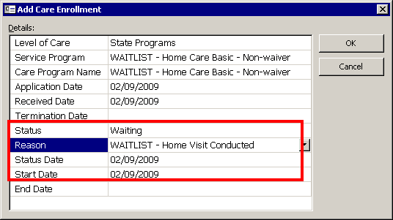

- Document activities in Journal Entries as appropriate.

Update Consumer on Waitlist after monthly check-in
According to the PI, ASAPs must contact the consumer of family at least once a month. A Case Manager should contact the consumer, or a family member, at least once a month to verify that the consumer should remain on the waitlist.

Steps to update SAMS waitlist record after monthly contact:

- Modify the existing enrollment record. Set the enrollment's data elements as follows:
  - Status Date = <date of most recent contact with the elder or family>. (Required).
  - No other changes.
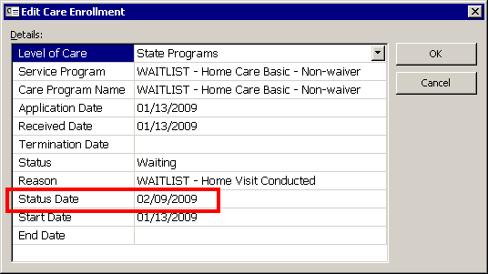

- Document activities in Journal Entries as appropriate.

Promote Consumer from Waitlist - Enroll in Same Program
When space in a waitlisted program frees up, consumers who had been waitlisted for the program will be evaluated for priority on the waitlist in accordance with PI-08-11, and a home visit conducted as necessary. Certain consumers will be promoted from the waitlist into the corresponding program.

Here's how to promote (move) a consumer from WAITLIST for Home Care Basic - Non-Waiver into active enrollment in Home Care Basic - Non-Waiver.

Steps:

- Use the Status Wizard - Transfer Consumer Enrollment. From the Consumer Summary screen, select Status Wizard - Transfer Consumer Enrollment.

- On Screen 1 of Status Wizard - Transfer Consumer Enrollment, set the enrollment's data elements (which refer to the outgoing waitlist enrollment only) as follows:
  - Termination Date = <last day on Waitlist>
  - Enrollment Status = TRANSFERS. We are transferring the client from the Waitlist to the corresponding care program.
  - Enrollment Reason = Transfer to HCB (from HCB Waitlist). NOTE: the reason codes are specific to the waitlist and actual care programs, so that EOEA's statistics are accurate. Take care to select to appropriate reason codes.
  - Status Date = <today's date>.
  - Activity Status and Activity Reason: may be ignored. The Status Wizard will only change Activities/Referrals whose Activity Care Program matches the Waitlist program being modified.
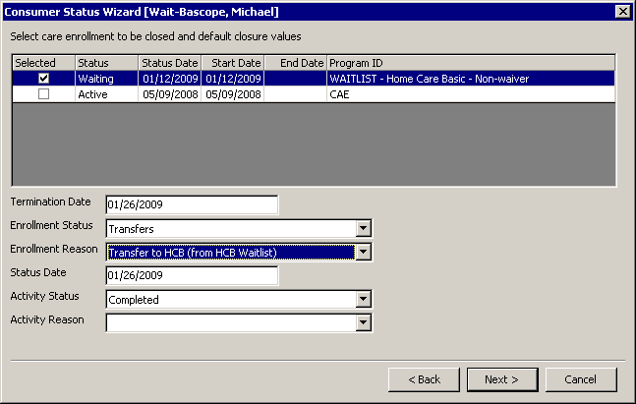
- On Screen 2, validate that all settings are correct from Screen 1. Make sure that the reason code entered on Screen 1 has carried over to screen 2. The reason code in the update column (as entered on the previous screen) may not display in some situations due to a known issue with SAMS.
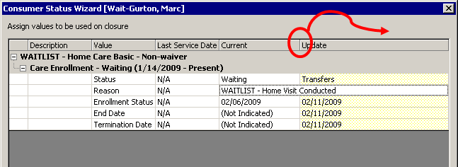
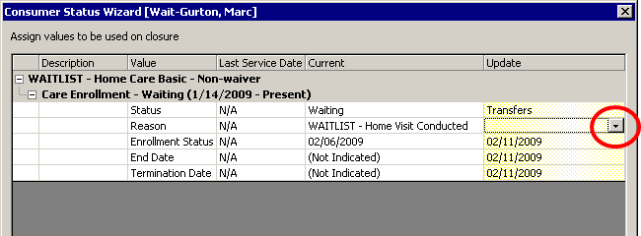
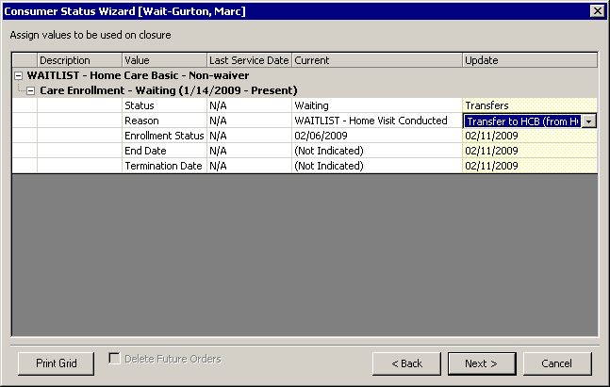
If the new reason code has not carried over, then adjust the column width of the "current" column until all of the current reason is displayed as indicated in the screenshot above). Once the current column width is wide enough to display all of the current reason, the update reason cell will turn yellow and the reason code may be selected again.
This is a known issue with the Status Wizard and will be fixed with SAMS 2.1 (currently scheduled for June 2009).
- As prompted by the Wizard, create Enrollment to Home Care Basic-Non-Waiver. Set the elements as follows:

  - Care program Name = Home Care Basic Non-Waiver
  - Application Date and Received Date: <the date the intake process began>, or in accord with agency process. Do not delete: these elements cannot be left blank, and the dates must be on or before the Start Date. Suggested: use the corresponding dates from the WAITLIST Enrollment.
  - Status = ACTIVE
  - Reason = Transfer from WAITLIST (Home Care Basic -Non-Waiver)
  - Status Date = <date of transfer>
  - Start Date = <first date in program>. Note: this should be the day *after* the consumer's last date in the waitlist.
  - End Date = BLANK
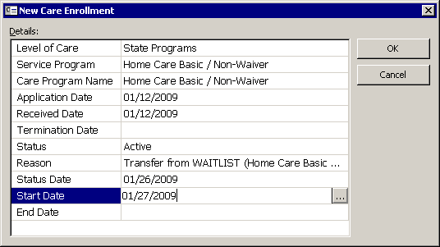

- Add / Edit Co-pay as needed. Validate that existing co-pay record, if any, has the correct Co-Pay Care Program to match the new enrollment.

- Status Wizard ends.

- Document activities in Journal Entries as appropriate.

- Create consumer Care Plan.

- The consumer's care enrollment history tells the story. The client was on the HCB Waitlist from Jan 12 - 26, and started in the actual Home Care Basic - Non-Waiver on January 27, 2009.
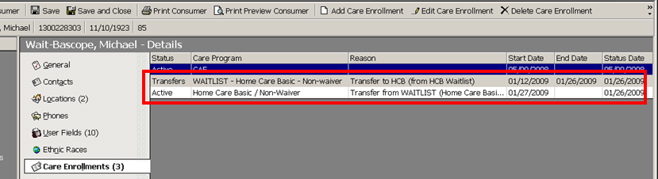

Promote Consumer from Waitlist - Enroll in Different Program
Occasionally, a consumer will be placed on a wait list for a particular program, but will actually be enrolled into a different program.

Reason Codes have been added to SIMS to reflect the various scenarios for waitlist and actual Home Care programs. See section New Waitlist-specific Reason Codes for Care Enrollments, above. Use these reason codes to reflect appropriate reasons and the actual destination programs for:
- the Termination reason for the Waitlist enrollment
- the Active reason for the actual Home Care Program enrollment

Follow the procedure Promote Consumer from Waitlist - Enroll in Same Program, above, filling in the correct reason codes for the terminated waitlist enrollment and the new active Home Care Program enrollment.

Example: client was on Home Care Basic Waitlist but actually enrolled in ECOP-NW.
After using the Status Wizard and setting the reason codes correctly, the consumer's enrollment history tells the story.
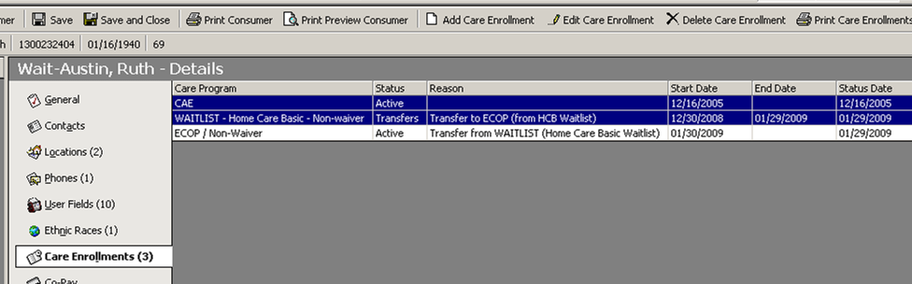

Remove Consumer from Waitlist - without Enrollment
Use status wizard to close consumer enrollment.

- Use the Status Wizard - Close Consumer Enrollment. From the Consumer Summary screen, select Status Wizard - Close Consumer Enrollment.

- Screen 1: select the Waitlist Program to close. Set the data elements as follows:
  - Termination Date = <date the agency learned of client's withdrawal from waitlist>. Make sure this date corresponds to any related journal entries.
  - Enrollment Status = TERMINATED
  - Enrollment Reason = <select appropriate reason>. Important: All waitlist-related termination codes begin with the text "Withdrawn from WAITLIST"
  - Status Date = <today's date: date of data entry>
  - Activity Status and Activity Reason may be ignored. The Status Wizard will only change Activities/Referrals whose Activity Care Program data element matches the Waitlist program being modified.
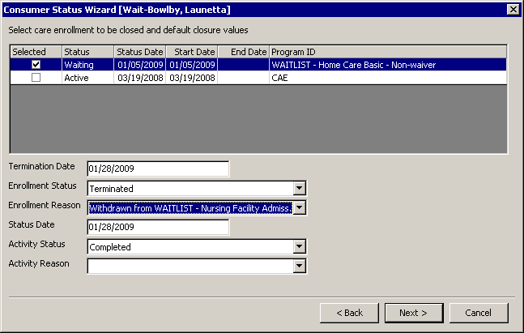

- Screen 2: confirm the dates and settings for the closure. Make sure that the reason code entered on Screen 1 has carried over to screen 2. The reason code in the update column (as entered on the previous screen) may not display in some situations due to a known issue with SAMS.
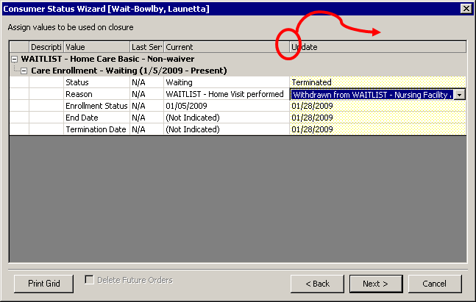
If the new reason code has not carried over, then adjust the column width of the "current" column until all of the current reason is displayed (as indicated in screenshot above). Once the column is wide enough to display all of the current reason, the update column's reason cell will turn yellow and the reason code may be selected again. See discussion above in section Promote Consumer from Waitlist - Enroll in Same Program (step 3 on page 6 of 17) for screenshots illustrating this operation.
This is a known issue with the Status Wizard and will be fixed with SAMS 2.1 (currently scheduled for June 2009).

- Status Wizard ends.

- Document activities in Journal Entries as appropriate.

- The consumer's Care enrollment history tells the story: This consumer was on the HCB waitlist from 1-5-2009 to 1-28-2009, terminated for reason of Nursing Facility admission.
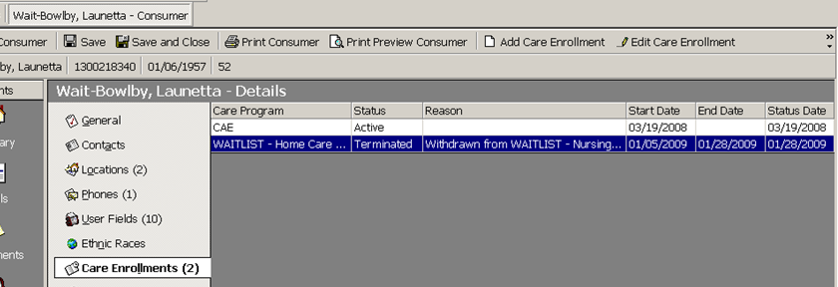

Reports - current and historical Waitlists
This section lists sample report names and filter/grouping criteria. ASAPs should create their own report definitions to match staff preferences.

Report: Show Current Waitlists for SHC Programs
Use the Consumer Listing Report, located in Reports > Consumers. This report, as defined below, shows all consumers for the default agency with an enrollment into a Waitlist program and a status of WAITING.

The report is grouped by Reason Code, so consumers are separated into those with and without a completed Home Visit.

The report is sorted by Status Date, so within a group, consumers at the bottom of the list have been contacted most recently by Agency staff to confirm waitlist interest.
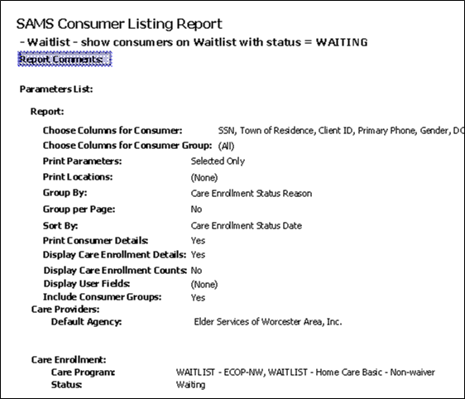

Note location of key data elements on Consumer Listing report.

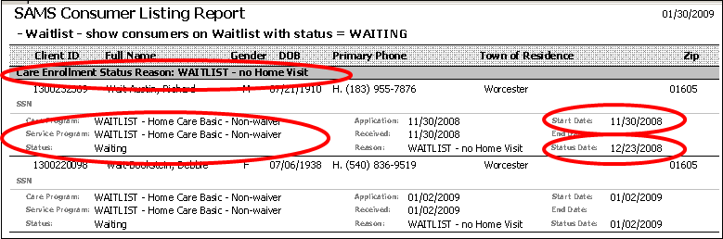

Report: Show Historical Waitlist
Use the Consumer Listing Report, located in Reports > Consumers. This report, as defined below, displays clients who are either (1) transferred from the Waitlist to a Home Care program, or (2) terminated from the waitlist.
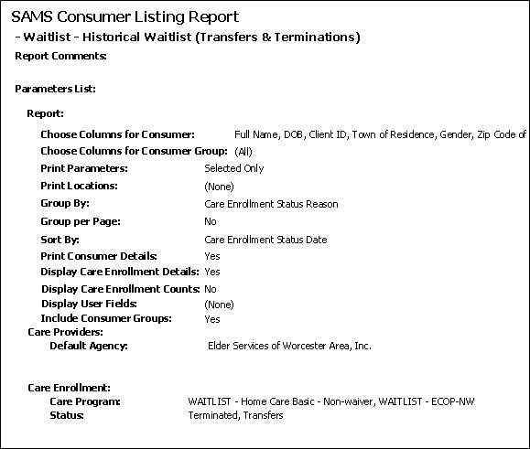

Report: Show Length-of-Stay (LOS) on Waitlist
Use the EOEA Consumer Length-of-Stay report, located in Reports > Consumers. This report, as defined below, shows the length-of-stay (LOS) of consumers on the HCB and ECOP waitlists.

It tracks clients who are both (1) currently waiting, with end date blank, and (2) terminated or transferred from the waitlist (with non-blank termination or end date). Specifically, if a consumer is counted who is active at least one day in the reporting period.

Consumers with an open end date or end-date greater than the end of the reporting period have an LOS set to the reporting period end-date minus their enrollment start date.

The report as set with these filter criteria does *not* track clients with incorrect enrollment status.

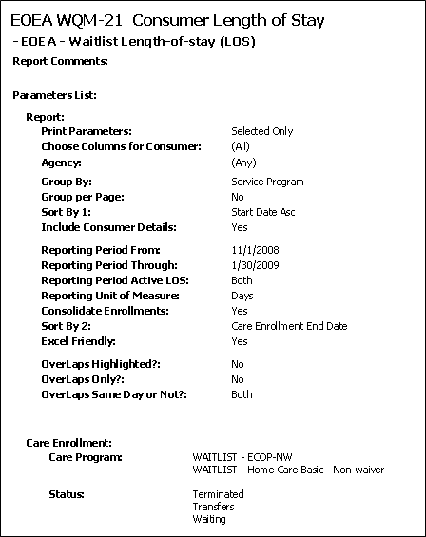

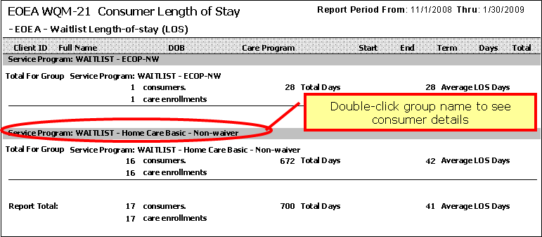

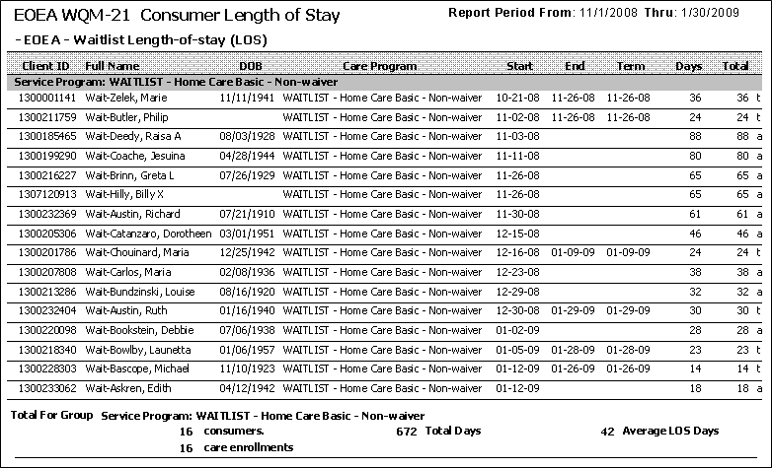

Reports: Data validation to show consumers with incorrect data
These reports are suggested for use to identify consumers incorrectly added to waitlists.

- When consumers appear on these reports, their data elements should be corrected, in line with the Job Aid above.
- If these reports are run and zero consumers are displayed, then the data are correct.

Report 1: Incorrect reason codes for Waitlist enrollments
Use the Consumer Listing Report, located in Reports > Consumers. This report, as defined below, show consumers with incorrect reason codes on their Waitlist enrollments.

WAITLIST programs should show only the statuses TRANSFERS, TERMINATED, or WAITING.
All other statuses are in error: consumers should NOT be enrolled in a waitlist for a home care program with status of Active, Inactive, Received, or Rejected. This report shows enrollments bearing incorrect status. All of the consumers displayed on this report should be corrected by Agency staff as soon as possible.

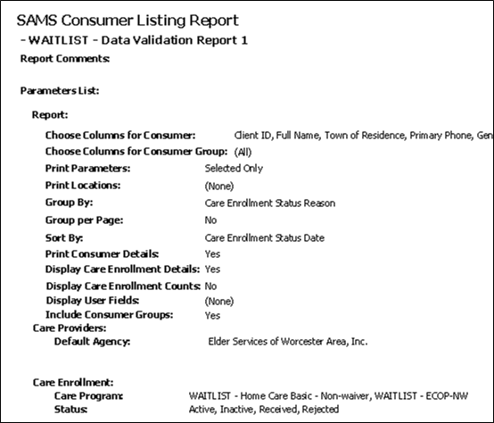

Screenshot showing sample output is not supplied.

Report 2: Incorrect enrollment status for Home Care program enrollments
Use the Consumer Listing Report, located in Reports > Consumers. This report, as defined below, show consumers with enrolled in Home Care Programs with an incorrect status, which indicate a user may have incorrectly attempted to add the consumer to a Waitlist.

Consumers should NOT be enrolled in a Home Care Program with status of WAITING. As soon as possible, all of the consumers displayed on this report should be corrected by Agency staff as follows:
- The consumer's Home Care Program enrollment should be terminated immediately.
- If the consumer remains potentially eligible for a home care program, then the consumer should be added to the appropriate HCP Waitlist as described in section Adding Consumer to Waitlist, above. The Start Date and Status Date of the consumer's enrollment should reflect the consumer's addition to the agency's waitlist and date of most recent check-in with the client or family to confirm waitlist interest.
- Describe the action taken in a Journal Entry.

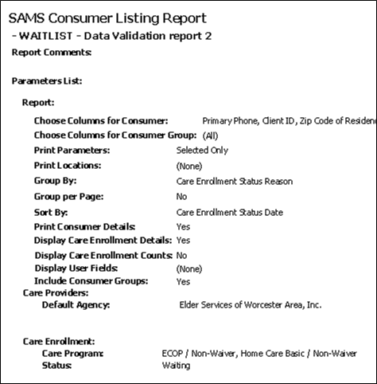

Screenshot showing sample output is *not* supplied.

End Job Aid.

