Overview
This document describes how to use the SAMS Administrator to update existing and add new ‘I&R Program Only’ providers. Starting July 20, 2009, users who have access to the SAMS Administrator with the “I&R Provider Editor – SIE” user role will be able to add and update ‘I&R Program Only’ providers in the SAMS Administrator. All provider additions and updates will be regularly exported to the new www.800ageinfo.com website, scheduled to be released in August 2009.

Table of Contents
Overview 1
Table of Contents 1
Revision History 1
Searching Providers in SAMS 1
Steps to Search for a Provider using the Search for Services in SAMS 2
Interpreting Search Results 3
Scenarios 6
Editing an Existing Provider 9
Adding a New ‘I&R Program Only’ Provider 13
How to Deactivate a I&R Program Only Provider 16
Steps to Deactivate a Provider in SAMS Administrator. 17
Logging into the Sandbox to Practice Using New Functionality 18
FORM TO REQUEST TO ADD/UPDATE A PROVIDER IN SAMS 19

Revision History
Date | Version | Description | Author
06-26-09 | 1.0 | Created for webinars to be held on July 1st, 7th, and 9th, 2009. | SIMS Project Team
07/01/09 | 2.0 | Updated Job Aid to include:  - Areas Served  - How to Deactivate a Provider  - Logging into the Sandbox to Practice Using New Functionality | SIMS Project Team

Searching Providers in SAMS
Before adding or editing a provider in the SAMS Administrator you should always first conduct a search in SAMS using the “Search for Services” button to determine if the provider already exists.

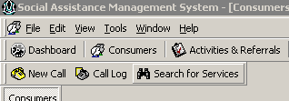

You must conduct the search in SAMS instead of SAMS Administrator, because a search in SAMS Administrator will only show providers with which your agency is associated. By searching for providers in SAMS first, you will be able to gather three (3) important pieces of information:

- Does the provider already exist in SAMS?
- Is your agency associated with this provider?
- Is the provider an ‘I&R Program Only’ provider or a SAMS Contracted provider?

The information gathered in the SAMS provider search determines how you will proceed.

Steps to Search for a Provider using the Search for Services in SAMS

- Log into SAMS.

- Click on Search for Services.

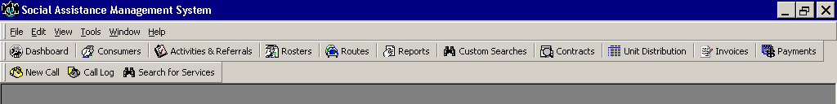

- Enter provider Name in the Search field. Please note that some providers are known by alternative names. For example, Center Street Cleaners may also be known as Joe’s Laundry. For best results, try a couple of search attempts using different spellings and names.
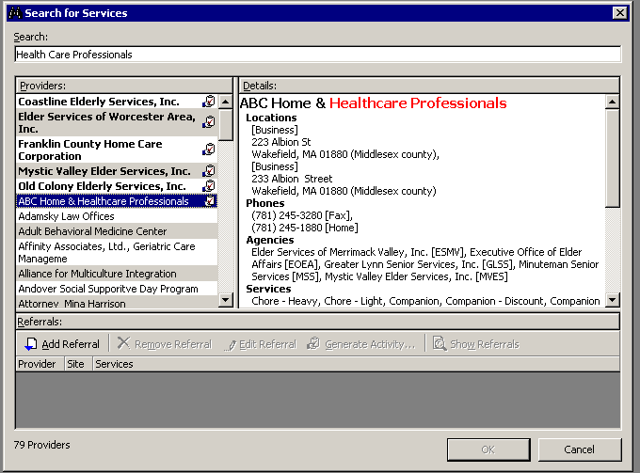

- A list will appear in the ‘Providers’ window on the left, of all providers whose records contain the text that you entered. If the provider you’re searching for doesn’t exist in SAMS, then you can proceed to SAMS Administrator to add a new I&R Program Only provider. Please see the Adding a New I&R Program Only Provider section on page 13 for step-by-step instructions on how enter a new I&R Program Only provider in the SAMS Administrator.

Interpreting Search Results
# | Provider Type | Characteristics
1 | Agency Service Provider | - Appears bolded.  - Displays at top of the results list, if it  meets search criteria.  - Clipboard icon will display to the right of the provider name. The icon indicates that it is a contracted provider.  - All updates need to be submitted to SIMS Support using the Provider Request Form.
2 | I & R Program and Service Provider | - Clipboard icon will display to the right of the provider name. The icon indicates that it is a contracted provider.  - All updates need to be submitted to SIMS Support using the Provider Request Form.
3 | I & R Program Only | - Agencies associated with I&R Program Only providers can update provider information in SAMS administrator.

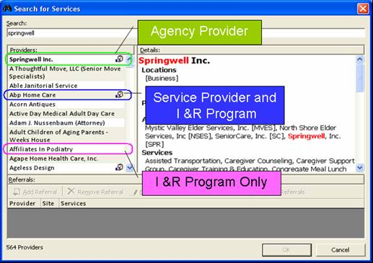

- Scroll through the list to find and highlight the desired provider.

- In the ‘Details’ window, scroll down to the section titled ‘Agency’ and note whether this provider is associated with your Agency. If the provider is not associated with your agency, please contact the associated agency and request they make the necessary updates.
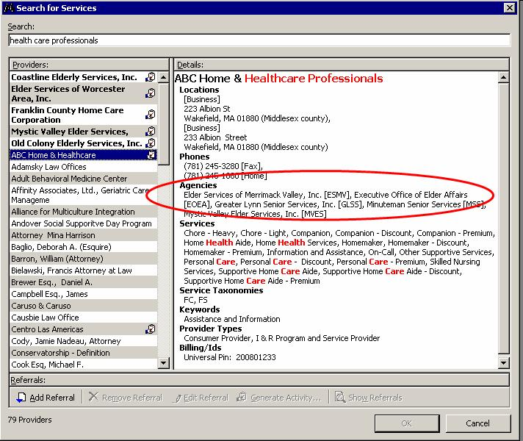

- In the ‘Details’ window, scroll down to the section titled ‘Provider Types’ and note whether this provider is marked as ‘I & R Program Only’. If so, proceed to the Editing an Existing Provider section on Page 9. If the provider is marked as an “Agency Provider” or “I&R Program and Service Provider” have your fiscal department submit a Provider Request Form to SIMS Support.
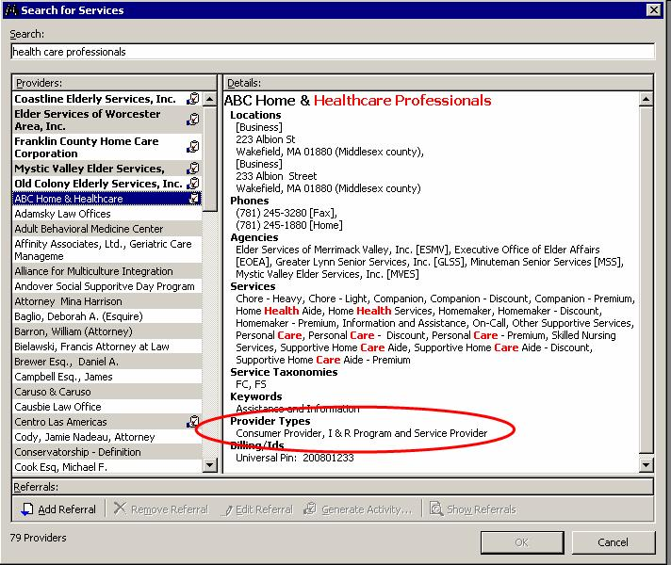

Users will be able to add a new (I&R Program Only) provider, if:
- the provider does not already exist in SAMS.

Users will only be able to edit an existing provider record, if:
- the provider exists in SAMS.
- the provider is associated with their agency.
- the provider type is I&R Program Only.

Users will need to submit a Provider Update Form, if:
- the provider type is “Agency Provider” or “I&R Program and Service Provider”

Users will need to contact the provider’s associated agency to request that their agency update the provider’s information, if:
- the provider type is “I&R Program Only” and the provider is not associated with their agency.

Scenarios
A) You are a Boston Elder Info user wanting to update Blackstone Valley Community Action Program. You do a search and see that the provider exists in SAMS, Boston Elder Info is associated with this provider and the provider is listed as an “I&R Program Only” provider. Therefore, you, the Boston Elder Info user, can go to SAMS Administrator and proceed with editing the provider record.
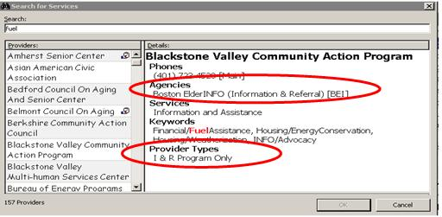

B) You are a Springwell user wanting to update Canine Companions for Independence. The provider exists in SAMS, however, your agency is not associated with the provider which is an “I&R Program Only” provider. Therefore, Springwell will contact the agency listed in the provider record (Boston Elder Info) and make a request to edit the provider record in the SAMS Administrator.

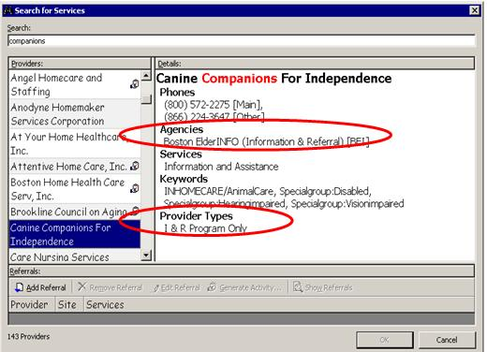

C) You are an Elder Services of Worcester Area user wanting to update Seven Hills Occupational & Rehabilitation Inc. The provider exists in SAMS and your agency is associated with it, but it’s an “I&R Program and Service Provider” provider. Therefore, you will need to have your fiscal department submit a Provider Request Form to SIMS Support.
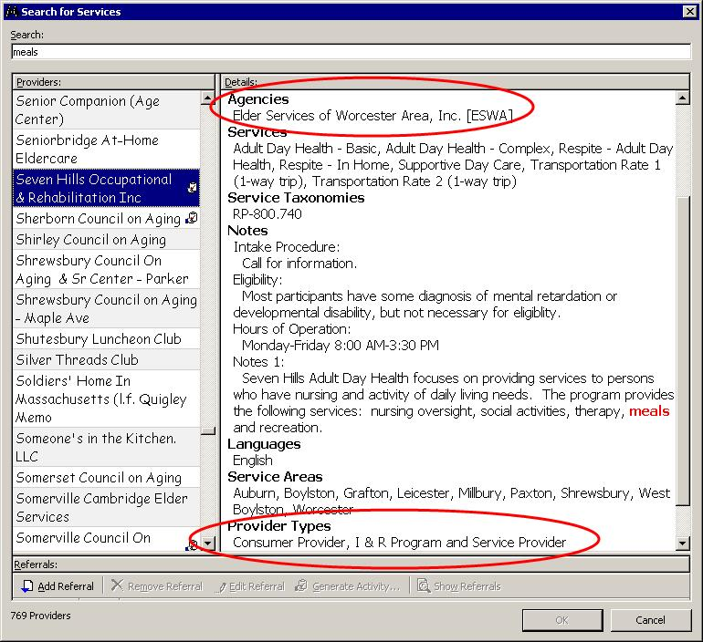

D) You are an Elder Services of Berkshire County user and you want to add North Adams YMCA as a provider in SAMS for informational purposes only. A search in SAMS reveals that North Adams YMCA does not exist as a provider in SAMS. Therefore, because the provider does not exist in SAMS and it’s only going to be used for informational purposes only, you can go into SAMS Administrator and add North Adams YMCA as an I&R Program Only provider. Note: If a new provider will be used to order and deliver services in SAMS, then a Provider Request Form needs to be submitted by your fiscal department to SIMS Support instead.

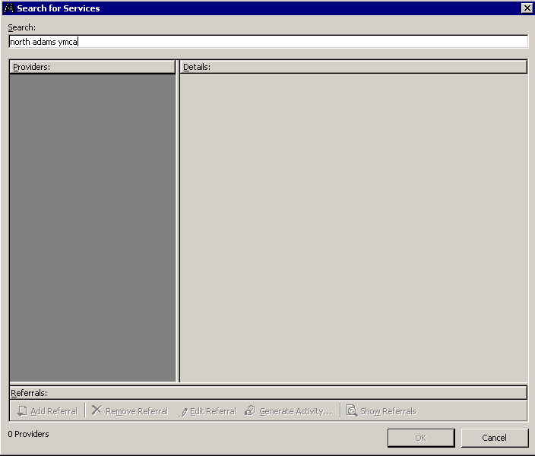

Editing an Existing Provider
You searched SAMS and the provider exists, they are associated with your agency, and they are an “I&R Program Only” provider.

- Log into SAMS Administrator.

- Click on Organization >> Providers
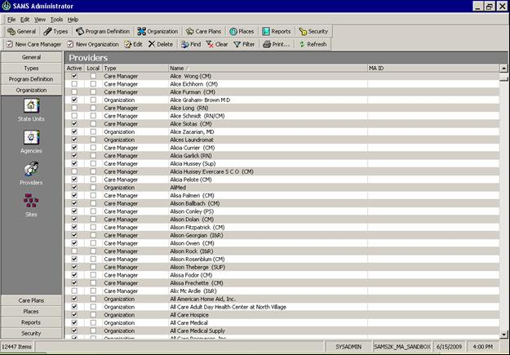
- Sort the list by provider name by clicking the header titled “Name”.

- Find the desired provider by single clicking in the column that lists all of the provider names, and start typing the name of the desired provider.

- Double click the provider record to open it.

- Click on the links in the navigation pane along the left side of the provider record to access the different sections and enter any info you have:
  - You can use the arrows to access each section in the navigation pane
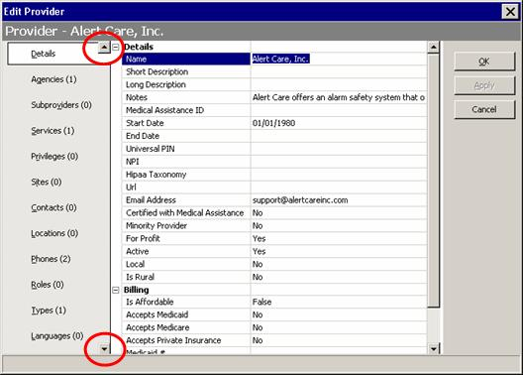

    - In the Details section you will find fields in which to enter:
        - Name of the provider (required field)
        - Descriptions
        - Notes (Any notes typed here will appear on new www.800ageinfo.com) (required field)
        - Start Date (should be equal to the date you are adding the new I&R Program Only provider) and End Date
        - URL - Website address for the provider (required field)
        - Email address for the provider (required field)
        - Active – the default on this field is Yes
        - Types of billing that are accepted by the provider (Medicaid, Medicare, Private Insurance)
        - Hours of Operation

    - Click on Services to add, edit or delete services that the provider provides.
        - Click New to add a new service.
        - Click Edit to edit an existing service.
        - Click Delete to delete an existing service.

    - Click on Contacts to add, edit or delete a Contact at the provider.
        - Click New to add a new contact.
        - Click Edit to edit an existing contact.
        - Click Delete to delete an existing contact.

    - Click on Locations to add, edit or delete an address for the provider.
        - Click New to add a new address.
        - Click Edit to edit an existing address.
        - Click Delete to delete an existing address.

    - Click on Phones to add, edit or delete a phone number for the provider. (required field)
        - Click New to add a new phone number.
        - Click Edit to edit an existing phone number.
        - Click Delete to delete an existing phone number.

    - Click on Languages to add, edit or delete languages that are spoken and understood at the provider.
        - Click New to add a new language.
        - Click Edit to edit an existing language.
        - Click Delete to delete an existing language.

    - Click on Accessibilities to add, edit or delete accessibilities, such as: handicap accessible, bathrooms on all floors, ramps at all doors, etc.
        - Click New to add a new accessibility.
        - Click Edit to edit an existing accessibility.
        - Click Delete to delete an existing accessibility.

    - Click on Keywords if you wish to associate this record with certain keywords that will assist users to search on this provider in SAMS
        - Click New to add a new keyword.
        - Click Edit to edit an existing keyword.
        - Click Delete to delete an existing keyword.

    - Click on Areas Served to add, edit, or delete towns, counties, municipalities, zip codes, states, or regions.
- Click New to add a new area served.
- Click Edit to edit an existing area served.
- Click Delete to delete an existing area served.

Note: If the provider serves all towns throughout the state, we recommend that you select Statewide under the Region section of Areas Served.

- When you are finished, click OK.

Note: As with all SAMS Admin changes, if a user is logged into SAMS, they must log out and back in to see any changes that were made in SAMS Administrator since they last logged in.

Adding a New ‘I&R Program Only’ Provider
A search in SAMS determines the provider does not exist. This provider is for informational purposes only, your agency will not be using this provider to order or deliver services in SAMS. If this provider will be used to order and deliver services in SAMS, then a Provider Request Form needs to submitted by your fiscal department to SIMS Support.

- Log into SAMS Administrator.

- Click on Organization >> Providers
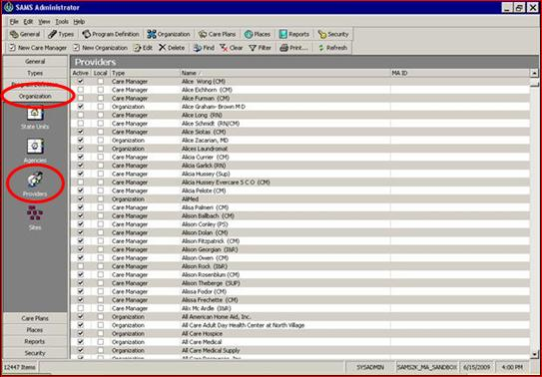

- Click New Organization.
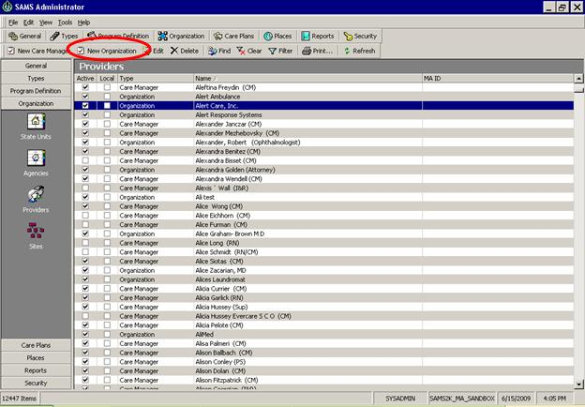

- Click on the links in the navigation pane along the left side of the provider record to access the different sections, and enter any info you have:

    - You can use the arrows to access each section in the navigation pane.
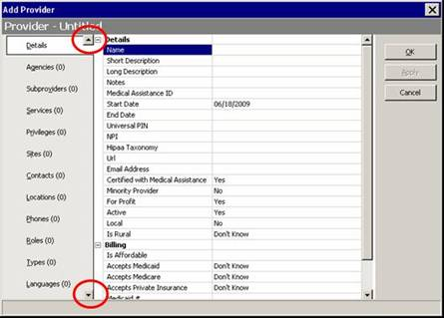

    - In the Details section you will find fields in which to enter:
        - Name of the provider (required field)
        - Descriptions
        - Notes (Any notes typed here will appear on new www.800ageinfo.com) (required field)
        - Start Date (should be equal to the date you are adding the new I&R Program Only provider) and End Date
        - URL - Website address for the provider (required field)
        - Email address for the provider (required field)
        - Active – the default on this field is Yes.
        - Types of billing that are accepted by the provider (Medicaid, Medicare, Private Insurance)
        - Hours of Operation
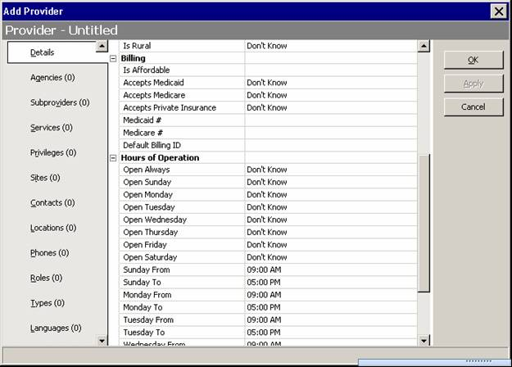

    - Click on Agencies to associate your Agency with this provider. Then click New and choose your Agency from the list.

    - Click on Services to add or edit services that the provider provides.
        - Click New to add a new service.

    - Click on Contacts to add a Contact at the provider. Then click New and enter Contact info.

    - Click on Locations to add an address for the provider. Then click New and enter Location info. (required field)

    - Click on ‘Phones’ to enter a phone number for the provider. Then click New and enter phone number(s). (required field).

    - Click on Types, click New and select ‘I & R Program Only’ from the drop-down list. (required field)

    - Click on Languages if you wish to indicate which languages are spoken and understood at the provider.

    - Click on Accessibilities if you wish to add any, such as: handicap accessible, bathrooms on all floors, ramps at all doors, etc.

    - Click on Keywords if you wish to associate this record with certain keywords that will assist users to search on this provider in SAMS.

    - Click on Areas Served to add, edit, or delete towns, counties, municipalities, zip codes, states, or regions.
- Click New to add a new area served.
- Click Edit to edit an existing area served.
- Click Delete to delete an existing area served.

Note: If the provider serves all towns throughout the state, we recommend that you select Statewide under the Region section of Areas Served.

- When you are finished click OK.

Note: As with all SAMS Admin changes, if a user is logged into SAMS, they must log out and back in to see any changes that were made in SAMS Administrator since they last logged in.

How to Deactivate a I&R Program Only Provider
Providers cannot be deleted in SAMS Administrator, therefore, users will need to end date and deactivate a provider that is no longer in business.

Steps to Deactivate a Provider in SAMS Administrator.

- Open Provider record you would like to deactivate.

- Enter an End Date.

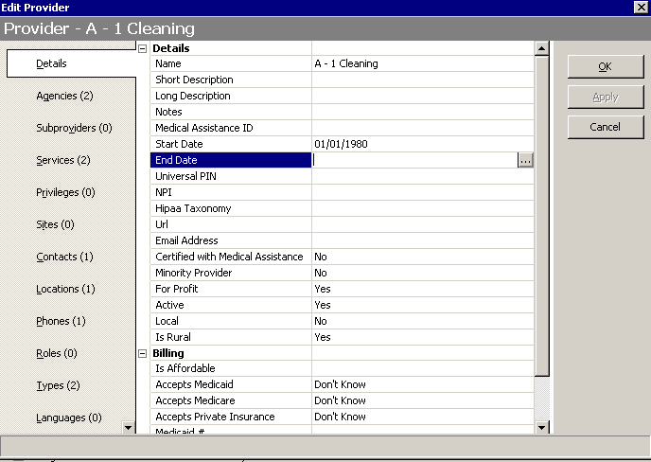

- Change Active field to No.

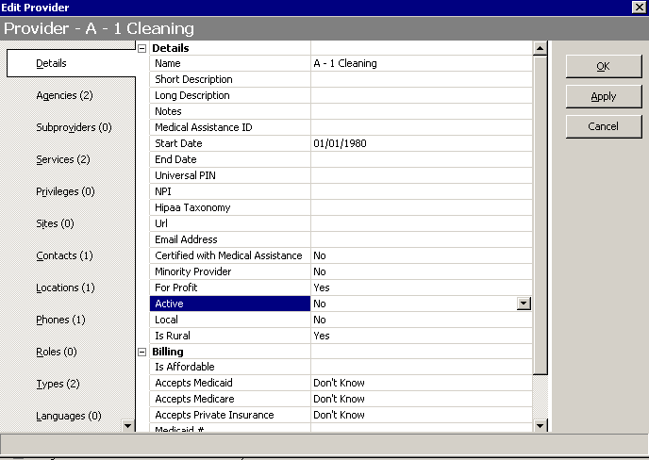

- Click OK.

Logging into the Sandbox to Practice Using New Functionality
We have created a generic login for users that would like to practice using this new functionality in the Sandbox. Please note that the login is associated with the login of Springwell, so you will only see providers that are associated with the Agency Springwell. The following login will allow you to login into SAMS and SAMS Administrator.

- Go to www.agingnetwork.com

- Login to one of your agency’s sandbox accounts using the username and password kept by your agency (i.e. Mastudent1). Sandbox passwords are maintained by each individual agency, SIMS Support does not have a list of these passwords.

- Click on SAMS Administrator icon.

- Enter in the following SAMS username & password:
  - Username: IRProgramOnly
  - Password: IRProgramOnly

FORM TO REQUEST TO ADD/UPDATE A PROVIDER IN SAMS

Please fill out this form with as much information as you can on each provider and email to sims.support@state.ma.us. All additions and edits of SAMS contracted providers should be submitted through fiscal staff so that they can provide the necessary information for all the required fields marked with an asterisk (*).

* These items are required for contracted providers in SAMS.

Please check one:
Create New SAMS Contracted Provider
Edit Existing SAMS Contracted Provider
Create New I&R Program Only Provider

Note: If adding a new SAMS contracted provider or a new I&R Program Only provider, I certify that I have searched existing SAMS providers and verify that this provider does not already exist.

Provider Details
Agency Name:
Provider Name:
* Legal Name:
* Federal Tax ID Number:
Address 1:
Address 2:
City:
State:
Zip Code:
* Billing Address 1:
* Billing Address 2:
* Billing City:
* Billing State:
* Billing Zip Code:
Business Phone 1:
Business Phone 2:
Fax:
Website:
Email:
Contact Name:
Contact Title:
Contact Phone:
Contact Email:
Hours of Operation:

Eligibility Requirements
Check all that apply.
Abused/neglected
Below Poverty
Homeless
Jewish
Recent Immigrant
Single Parent
Unemployed
Veteran

Methods of Payments Accepted
Check all that apply.
Accepts Medicaid
Accepts Medicare
Accepts Private Insurance

Languages Spoken
List out all languages spoken by provider.
Areas Served
List out all towns and cities the provider serves.

Services
List out all the services offered by this provider. Please refer to listing of SAMS Services to provide the exact name of the service as it appears in SAMS. Please note: only services that are available in SAMS will be entered by SIMS Support.

Keywords
List out all the keywords applicable to this provider. Please refer to listing of SAMS Keywords. Please note: only keywords that are available in SAMS will be entered by SIMS Support.

Notes
Type any additional information on the provider here. These notes will appear on the provider record in SAMS and on www.800ageinfo.com.

