Exercises in Report Building
These following are actual report requests from end users. We will use these as examples from which to demonstrate the thought process behind building a report in SAMS based on a specific request or need.
Along with each example you will find a screenshot of the preview and definition following by a
Example 1:
The Request: “I need a care manager active consumer list that includes the consumer street address.”
The Report: Consumer Listing Report
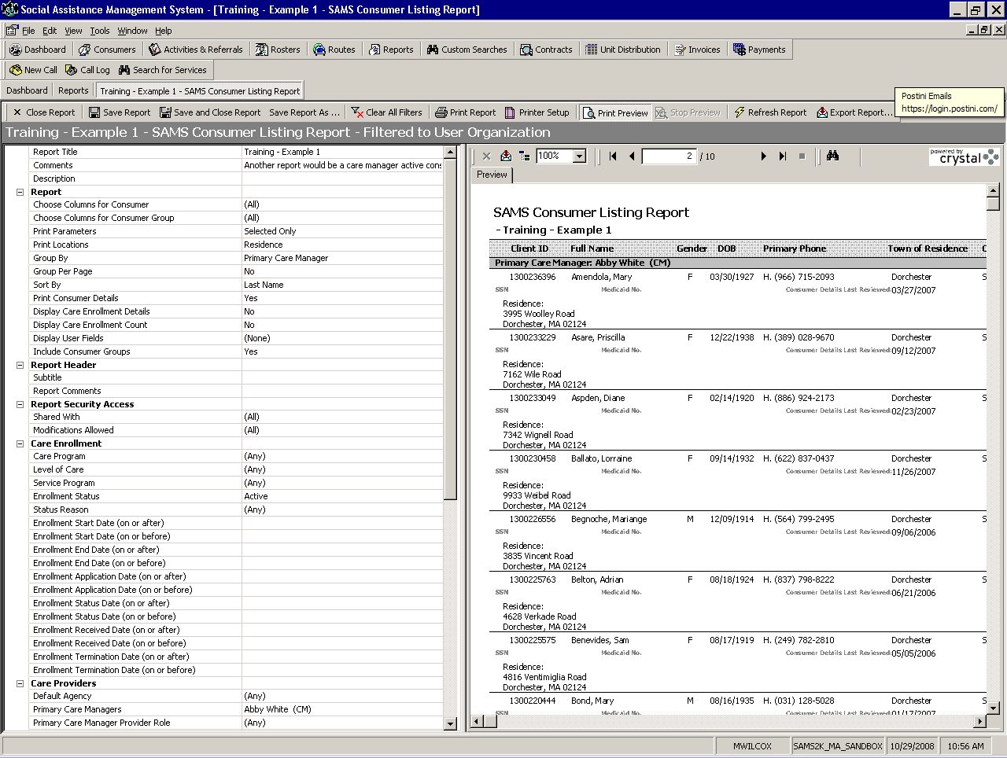

The Report Parameters:
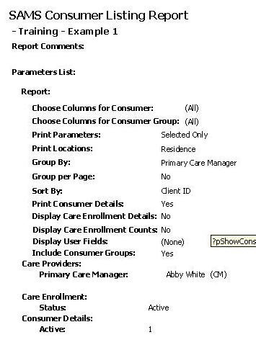
Notes:
__________________________________________________________________________________________________________________________________________________________________________________________________________________________________________________________________________________________________________________________________________________________________________________________________________________________________________________________________________________________________________________________________________________________________

Example 2:
The Request: “We are looking for a list of consumers with an Active SCO – Evercare Care Program with a specified User Field. We would like to be able to print a list of consumers for a specific care manager with a User Field SCO Rating Category 2 and a separate list for User Field SCO Rating Category 3.”
[A second report could be created for Category 3 by using the “save as” button then adjusting the User Field Filter such that SCO Rating Category = 3]
The Report: Consumer Listing Report
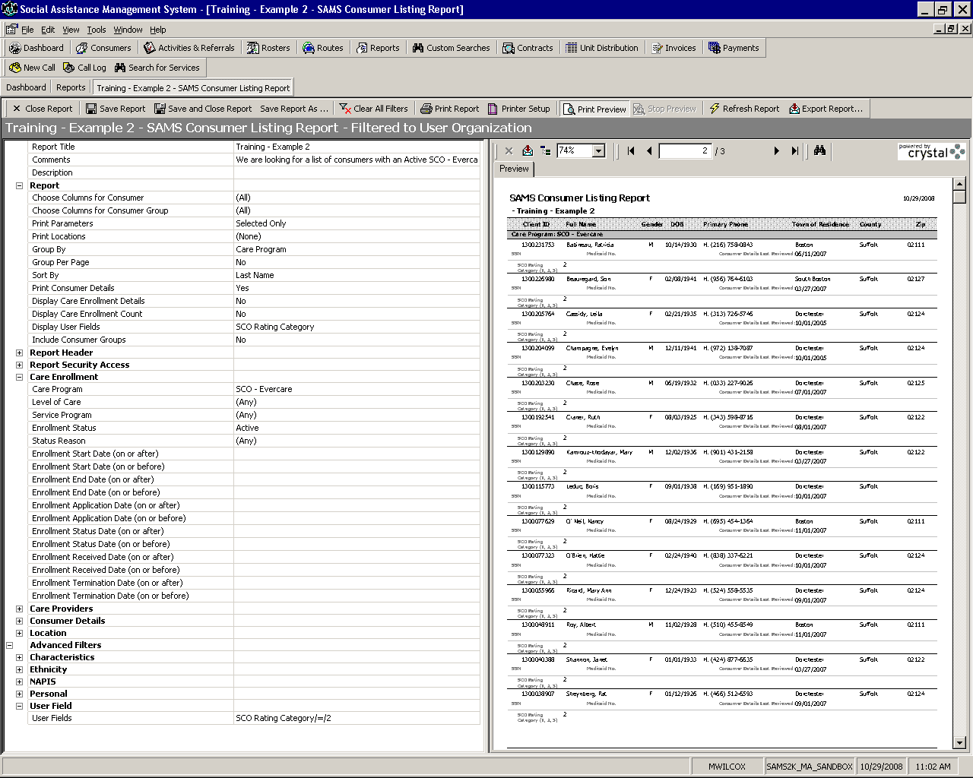

The Report Parameters:
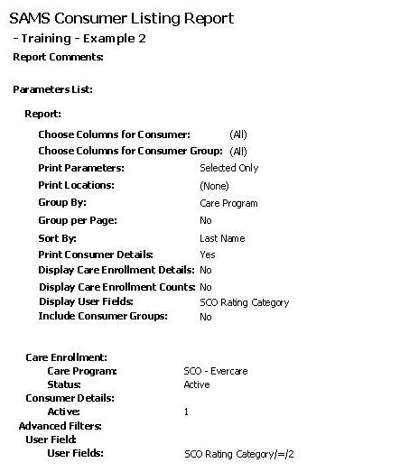
Notes:
______________________________________________________________________________________________________________________________________________________________________________________________________________________________________________________________________________________________________________________________________________________________________________________________________
Example 3:
The Request: “Our executive director needs a board report showing all the services that our Agency delivered in January including the number of consumer served, units, and cost, broken down by program.”
The Report: Agency Summary Report (Total Only)
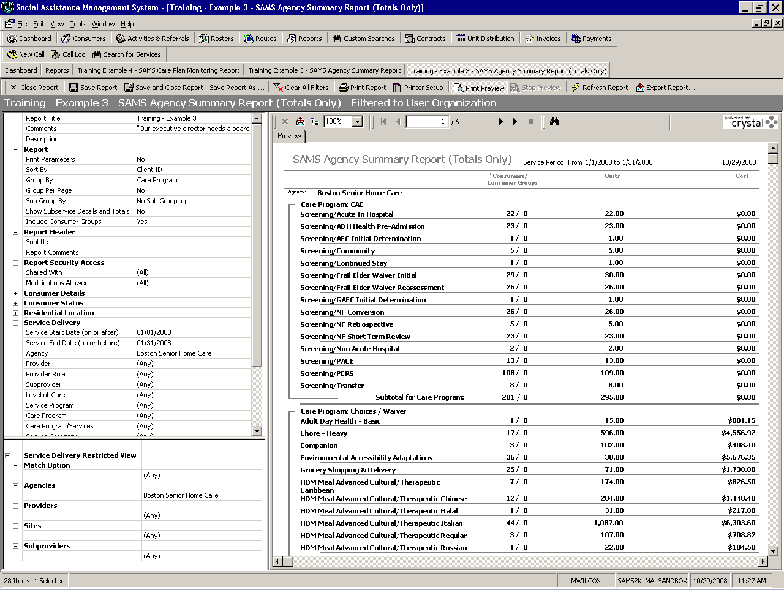

The Report Parameters:
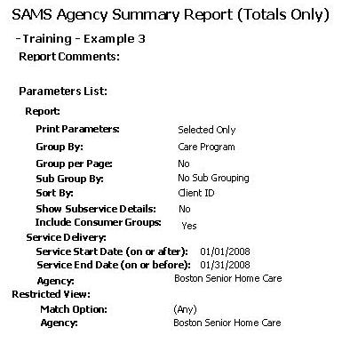

Notes:
__________________________________________________________________________________________________________________________________________________________________________________________________________________________________________________________________________________________________________________________________________________________________________________________________________________________________________________________________________________________________________________________________________________________________

Example 4:
The Request: “Is there a report that will show all the Services that our Agency delivered in January under CAE along with a list of the consumers and totals for each service.”
The Report: Agency Summary Report
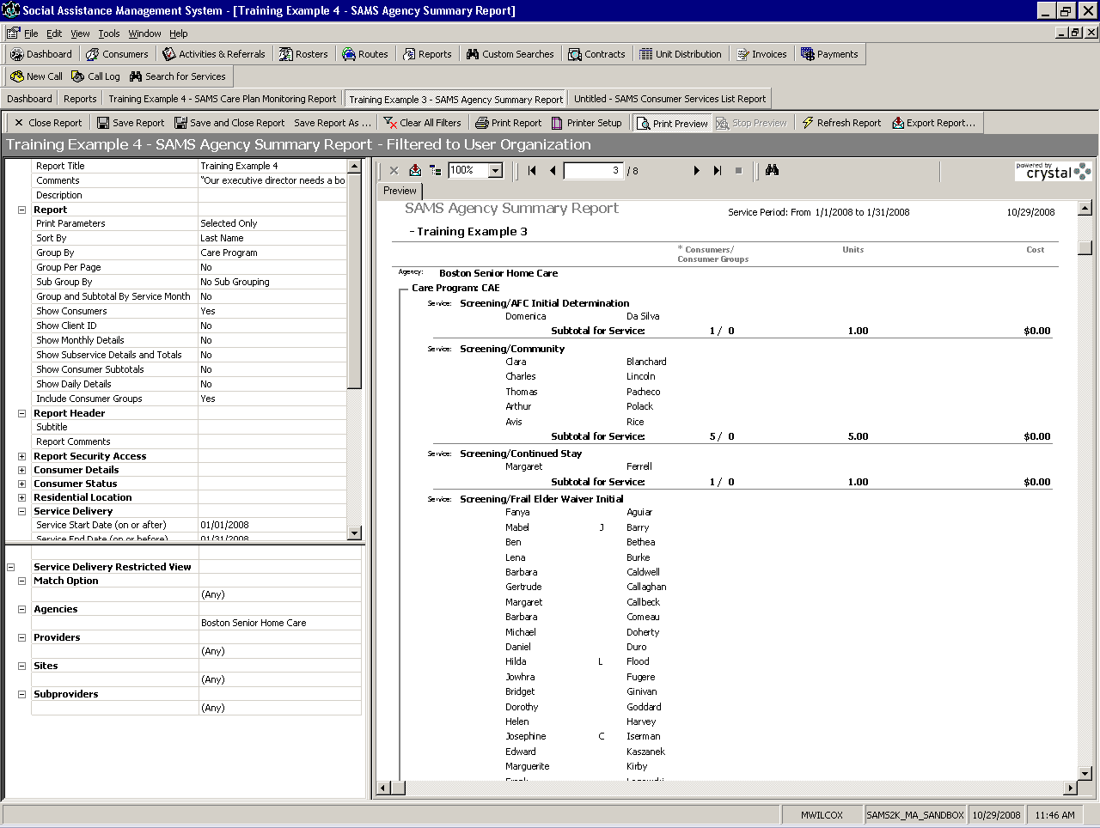

The Report Parameters:
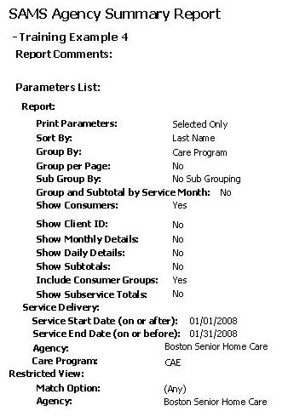

Notes:
__________________________________________________________________________________________________________________________________________________________________________________________________________________________________________________________________________________________________________________________________________________________________________________________________________________________________________________________________________________________________________________________________________________________________
Example 5:
The Request: “I need a listing of all care plans that are expiring this month for each of our Care Managers.”
The Report: Care Plan Monitoring Report
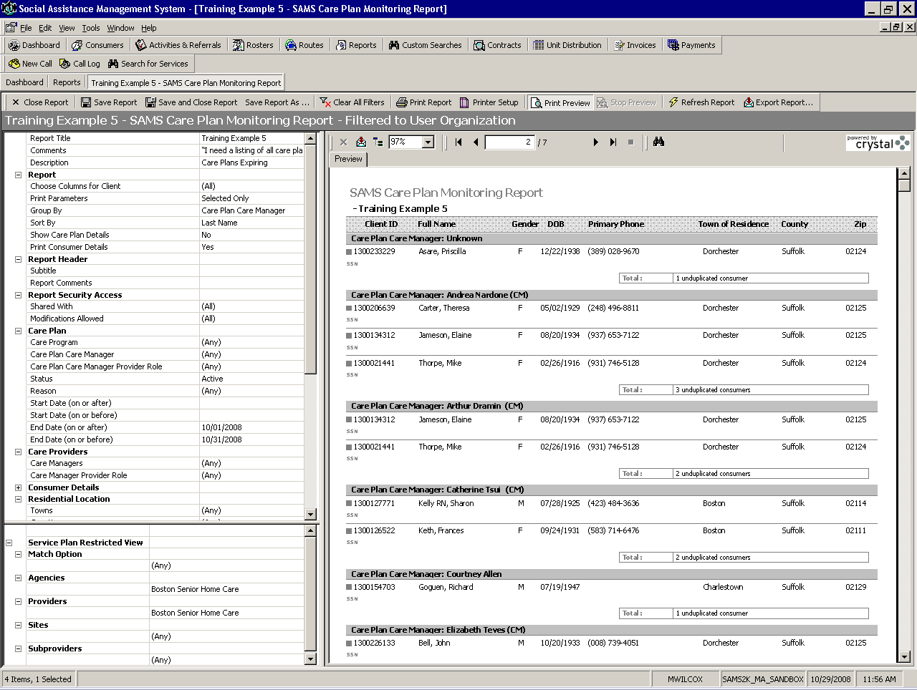

The Report Parameters:
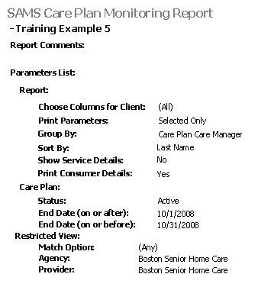

Notes:
__________________________________________________________________________________________________________________________________________________________________________________________________________________________________________________________________________________________________________________________________________________________________________________________________________________________________________________________________________________________________________________________________________________________________

Example 6:
The Request: “I need a list of all the Caregiver Referrals our agency has completed so far this year.”
The Report: Activities and Referrals Report
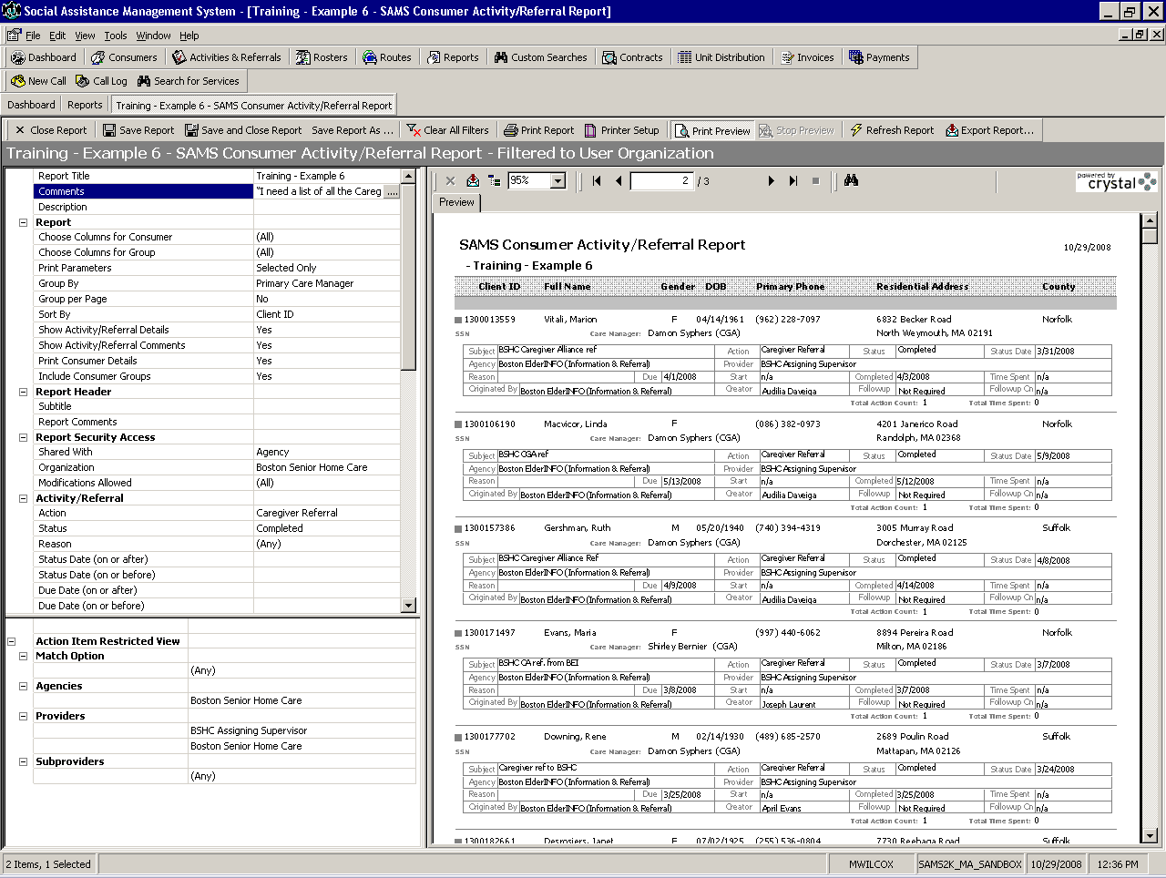

The Report Parameters:
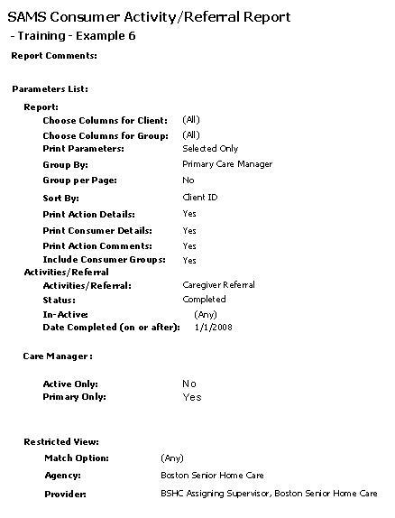

Notes:
__________________________________________________________________________________________________________________________________________________________________________________________________________________________________________________________________________________________________________________________________________________________________________________________________________________________________________________________________________________________________________________________________________________________________

