**Tracking Advocacy & Navigating Care in the Home with Ongoing Risks (ANCHOR) in SAMS:**

EOEA has initiated an Advocacy & Navigating Care in the Home with Ongoing Risks (ANCHOR) pilot program, as of 2/1/2019.

ANCHOR enrolled consumers receive highly focused care management and coordination level that provides more frequent, intense and time intensive delivery of advocacy and other support to elders with behavioral health needs, who are at risk of institutionalization or homelessness due to their inability to accept or retain services. This higher level of care management would allow for the provision of contact with the consumer at a minimum of every other week either by telephone or home visit with a minimum monthly home visit, a high number of phone calls and multiple consultations, all requiring documentation.

This business rule communicates required procedures and instructions for data entry for consumers enrolling in ANCHOR.

A new Care Enrollment “ANCHOR” is entered into SAMS for all consumers identified for the ANCHOR program regardless of enrollment in other Home Care programs. Two types of service delivery exist for ANCHOR:

* + - 1. ANCHOR Only
      2. ANCHOR Supplement

Service deliveries do not need to be entered on the last day of the month since reimbursement will be through E-invoicing and not through the Payment Voucher. A service delivery of “ANCHOR Only” is entered for each month a consumer is enrolled in ANCHOR **AND** no other Home Care Program. A service delivery of “ANCHOR Supplement” is entered for each month a consumer is concurrently enrolled in ANCHOR **AND** another Home Care Program. The new “ANCHOR Supplement” service delivery is available for the following programs:

* Home Care Basic/Non-Waiver (HCB/NW)
* Home Care Basic/Waiver (HCB/W)
* Home Care Over-Income (HCOI)
* Respite Over Income (ROI)

Specific ANCHOR **Journal Types** have been created in SAMS to track related activities during the ANCHOR enrollment timeframe and are required to be used.

* **ANCHOR Initial Contact** *(utilize when first opening a consumer in ANCHOR)*
* **ANCHOR Goals** *(utilize when first opening a consumer in ANCHOR for what goal or focus the CM and consumer will be working on together)*
* **ANCHOR Termination** *(utilize when terminating a consumer from ANCHOR)*
* **ANCHOR Extend Duration** *(utilize when requesting extended duration from EOEA for the consumer to stay open in ANCHOR longer than 9 months)*

When documenting monthly home visits during ANCHOR enrollment existing on-site journal types shall be utilized to reflect the Home Visit.

* **On Site Reassessment**
* **On Site Assessment**
* **Annual Re-Determination**
* **Face to Face Meeting**

The following **Activity and Referrals** (A&Rs) have also been created in SAMS for tracking convenience, and are required to be used during ANCHOR enrollment. Use of Status Date, Due Date, And Date of Completion is required according to ASAP Business Practice.

* **ANCHOR Initial Contact**
* **ANCHOR Home Visit**

HCB/NW, HCB/W, HCOI, ROI A&R action items for Home Visit, Reassessment, and Annual Re-determination shall be used for ANCHOR Supplement enrolled consumers when the ANCHOR monthly home visit is completed along with scheduled Home Care Program Home Visit. ASAPs are not required to data enter two A&R home visits in the same month (ANCHOR A/R Home Visit and Program visit A&R). ASAPs are expected to data enter an ANCHOR A/R Home Visit for the months in which a Program visit A&R is not planned. Example: If the consumer is due to have a 6 month reassessment in March, ASAPs will use the Home Care Program Reassessment action type as their ANCHOR Home Visit A&R without an additional data entered unique ANCHOR Home Visit A&R. The CM will address ANCHOR related goals and interventions during the regularly scheduled visit.

SAMS data entry for **ANCHOR** Care Enrollment:

* Enter an ANCHOR Care Enrollment in the consumer record.
* When entering the ANCHOR care enrollment, the application date cannot be after the start date.
* Enter the same date for the Application Date, Received Date, Status Date and Start Date.
* The ANCHOR Care Enrollment will not appear as a **Service Program** option if the Application date is prior to 2/1/2019.

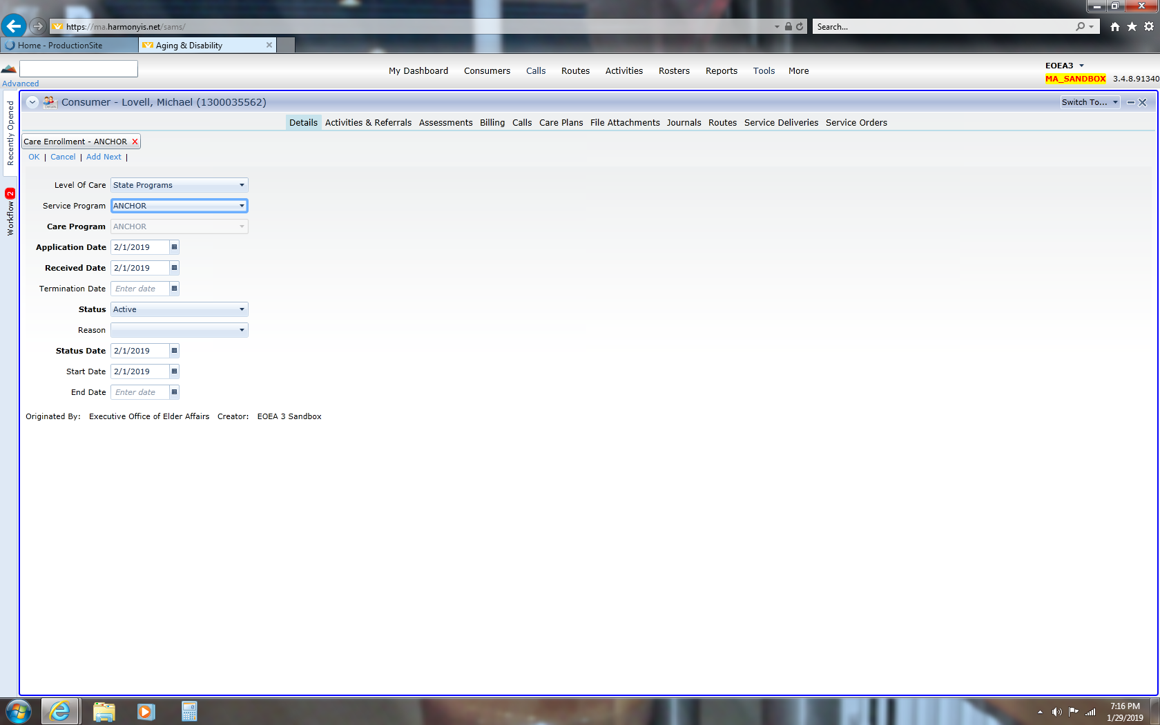

* An ANCHOR Service Delivery is required to be entered into the consumer record each month for every month that the consumer is open and active in ANCHOR at least one day in the month.
* When a consumer is enrolled exclusively in ANCHOR (without a concurrent Home Care Program enrollment) the ANCHOR Only Service Delivery shall be entered monthly, for every month the consumer is open and active in ANCHOR at least one day. The Service Delivery shall be recorded on the any day of the month, for each month the consumer is open and active in ANCHOR at least one day in the month.

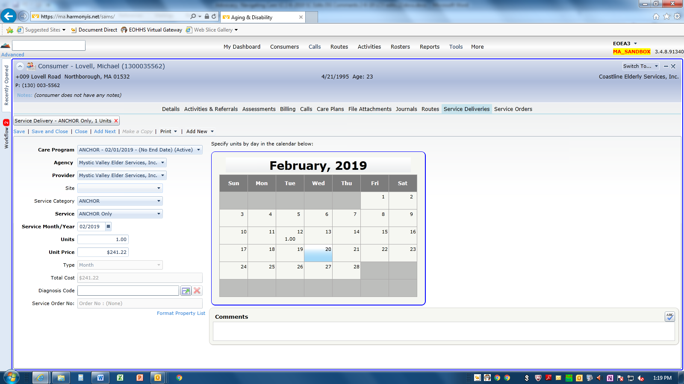

* When a consumer is concurrently enrolled in both ANCHOR and a Home Care Program, the ANCHOR Supplement Service Delivery shall be entered monthly, for every month the consumer is open and active in ANCHOR at least one day. The Service Delivery shall be recorded on the any day of the month, for each month the consumer is open and active in ANCHOR at least one day in the month.
* When a consumer transitions from ANCHOR Only to ANCHOR Supplement within the same month of being open and active, only record the ANCHOR Supplement Service Delivery for the consumer for that month.

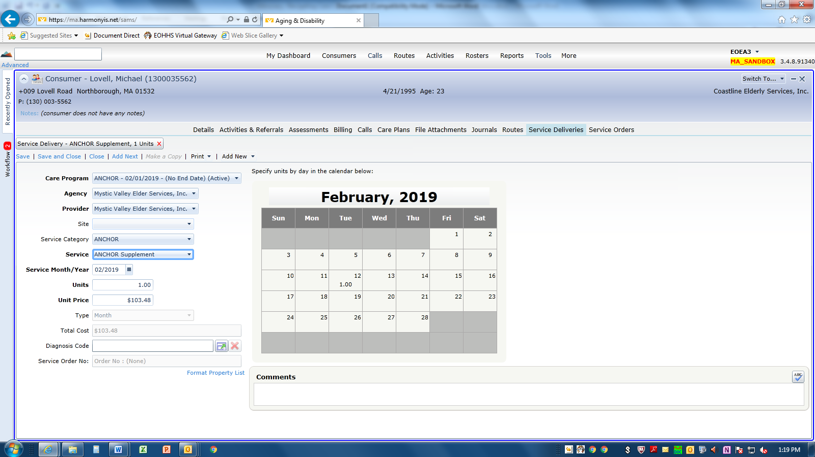

Terminating the **ANCHOR** Care Enrollment:

* Enter the appropriate Termination Date and End Date, as well as the appropriate Care Enrollment Termination Reason. The same date should be the utilized for both Termination and End Date.
* For example: the consumer may enroll in a Home Care Program and be accepting of services, enter code “Transfer to (Appropriate Home Care Program)” for the Termination Reason.

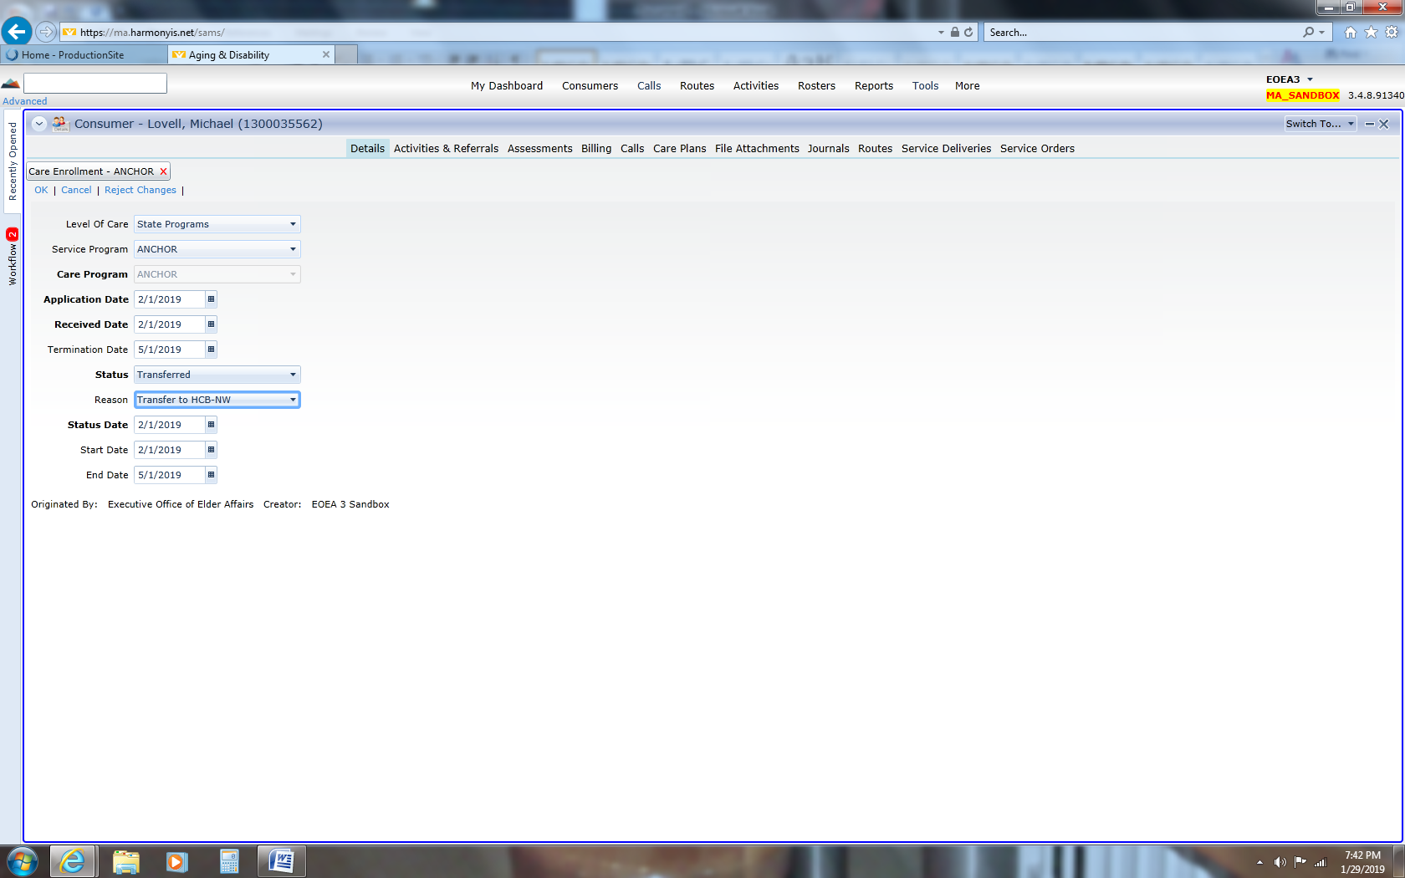

* For example: If the consumer refuses to continue to participate in ANCHOR, enter code “Client Refused” for the Termination Reason.

