Nutrition Best Practices Document
Version 1.1.0

Massachusetts Recommended Procedures for Nutrition Practices in SAMS

Introduction
The Massachusetts Elderly Nutrition Program provides close to 9 million meals and other nutrition services such as group education and individual counseling to approximately 75,000 elders (age 60 or older) each year. The Program addresses multiple issues faced by elders – ranging from poor nutrition, food insecurity, and acute and chronic disease to social isolation. Nutrition services and meals are a vital support that enables many elders to live in the community independently. Throughout the state, a wide range of nutrition services are available such as ethnic, therapeutic, and weekend meals to meet the varying needs of seniors. For many seniors, the meal provided through the program is their main meal of the day and provides a significant portion of their daily nutrient intake.

Overview
This job aide outlines recommended procedures for using SIMS (Senior Information Management System) in Massachusetts to process common Nutrition Program related functions using SAMS (Social Assistance Management System) and Omnia. Please note that agencies may operate differently and there is often more than one way to perform functions within the system. It is up to each agency to determine the most efficient method based on their unique business practices. Specific questions regarding recommended procedures should be directed to the Nutrition Business Analyst or the EOEA Nutrition Program.
This document is meant to be used with the “SAMS Nutrition Training Manual,” version 1.80.x, published in May, 2007.

Other documents referenced in this job aide include “SAMS Case Management Training Manual,” version 1.10.x, published June, 2008, “Job Aide – How to add Consumer Provider for Client Sharing,” version 1.1, published February, 2008 and “Job Aide: Bulk Service Order Generation” published February, 2008.

Table of Contents
Introduction 1
Overview 1
Table of Contents 1
Revision History 2
SAMS Client Records 2
Searching for Clients 2
Editing Existing SAMS Clients 4
Creating New SAMS Clients 4
NSIP Meals Eligible 4
Assessments 7
Performing Assessments 7
Home Delivered Meals 9
Care Enrollments, Care Plans and Service Plans 10
Planning Services for Holiday, Emergency Meals, and Weekend Meals 12
Service Order Generation 13
Generating Service Orders from a Service Plan 13
Bulk Generating Service Orders (Monthly) 13
Routes 14
Routes and Municipalities 14
Creating a Route and Generating a Route List 14
Modifying a Route List 21
Refreshing a Route List 21
Printing a Route Sheet 23
Bulk Printing Route Sheets 23
Service Suspensions 24
Service Deliveries 25
Service Delivery Confirmation Wizard 25
Rosters 31
Electronic Vendor Invoices (EVI) 31
Congregate Meals 32
Adding Congregate Consumers 32
Consumer Groups for Congregate Meals 33
Routes for Congregate Meals 33
Using Rosters for Congregate Meals (Service Deliveries) 35
Printing Rosters as a Tool for Recording Meals at Congregate Meal Sites 38
Nutrition Education 38
Nutrition Counseling 41
Nutrition Reports in SAMS 43
Report Security Access 44
Exporting Report Results 45
Reports at a Glance 48
SAMS Kitchen Report (Category: Services) 50
EOEA HDM Meal Donation Letter (Category: Services) 51
Other Features 61
User Fields 61
Activities 62

Revision History
Date | Version | Description | Author
4-15-2009 | 1.0 | Adapted from Best Practices Document | SIMS Support & EOEA Nutrition Program
03-01-2010 | 1.1 | Updated to include sections on NSIP Meals Eligible, Service Suspensions, Nutrition Education, Nutrition Counseling and Nutrition Reports | SIMS Support & EOEA Nutrition Program

SAMS Client Records
SAMS is a shared database that is used by multiple organizations in Massachusetts for the tracking and planning of services for elder clients (also referred to as consumers). A SAMS user’s ability to view and edit a client’s data in SAMS is based on their user role and their organizational association.

Searching for Clients

Before adding a new client record to SAMS, users should first search the SAMS database for existing clients as this will prevent the creation of duplicate client records. A client may very well have received services from another organization in Massachusetts prior to moving to the user’s area.

Select the SEARCH BUTTON on the SAMS tool bar, which has binoculars on it, as seen in the screen shot below.

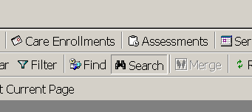

A SEARCH CONSUMERS box will appear with several options for searching. The simplest search criteria are by the first letters of the client’s last and first name.

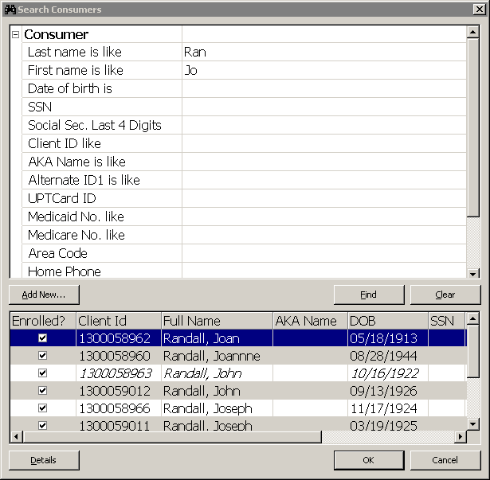
The SAMS Search function looks for specific data. If a user searched for a client by the First Name “Joseph” the software would not show results for consumers who have a first name of “Joe.” If a user searched for a client by the First Name “Jo,” however, the software would show results for consumers whose first names start with those two letters, including both Joseph and Joe.

Editing Existing SAMS Clients
As SAMS is a shared database, client records from all elder agencies in the state of Massachusetts are stored in SAMS. SAMS Users, however, are only able to view, edit and create specific client records based on their organizational access rights.
In most cases, SAMS organizational access rights in Massachusetts is based on the following data elements, where one of the following elements must match the user’s organization in order for the user to be able to access and update the client record:
- Default Agency
- Consumer Provider
- Service Agency

If a user should find that they are unable to update an existing SAMS client, they should work with their senior staff to request a transfer from the client’s existing care management agency.

For further details on the process to share clients between agencies, please see the document titled “Job Aide – How to add Consumer Provider for Client Sharing,” version 1.1, that was published February, 2008.

Creating New SAMS Clients
For further details on the process of creating new clients in SAMS, please see the “SAMS Case Management Training Manual,” version 1.10.x, published June, 2008.

Note: Before Creating a New Consumer Record in SAMS, users should first Search for the Consumer. See the section “Searching for Consumers” above.

In most cases, when creating new consumer records in SAMS, users will need to set the client’s default agency to match their organization. Users who work for free-standing nutrition programs will need to understand their organization’s privileges in conjunction with their oversight agency.

NSIP Meals Eligible
In SAMS, there is a field “NSIP Meals Eligible” under Consumer Details, under Characteristics. This field exists for Consumer and for Consumer Groups. Setting this field to Yes indicates that the client is eligible for meals under NAPIS Title III. In addition to setting the field for NSIP Eligible to Yes, the user must also indicate the Eligibility Type.
Available choices for Eligibility Type are as follows:

Age (60 or Over)
Disabled in Elderly Housing
Disabled Living with Elderly Person
Other
Spouse
Volunteer

Both fields will be updated automatically when a Date of Birth is entered for a Consumer and the consumer is over 60 years old, but must be manually changed for Consumers who meet other eligibility requirements besides age.

The field for “NSIP Meals Eligible” defaults to “no” for Consumer Groups and must be changed for eligible meals to be counted on the NAPIS report.

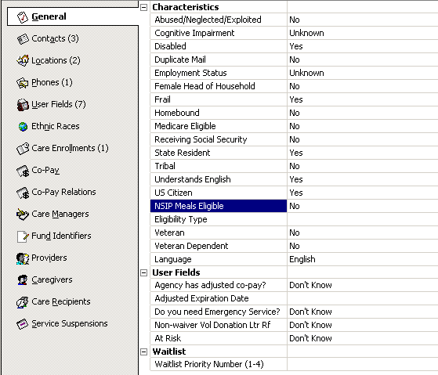

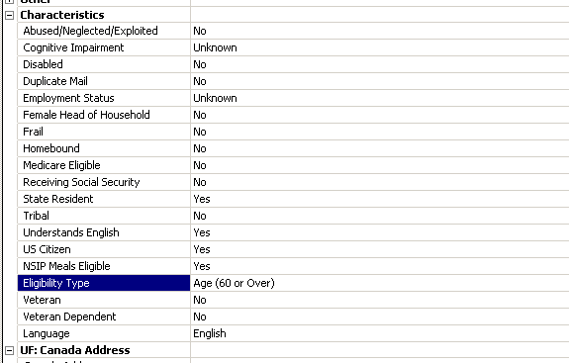

In addition, many SAMS Consumer Reports like the Consumer Listing Report allow users to filter consumers by NSIP Meals Eligible and by Eligibility Type (these filters are found under Advanced filters).

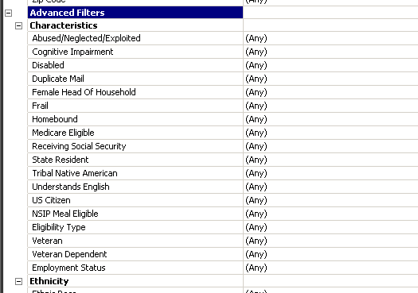

The Older American’s Act (OAA) Nutrition Programs are administered by the U.S. Department of Health and Human Service’s (DHHS) Administration on Aging (AoA). Under Section 311 of the OAA, the Nutrition Services Incentive Program (NSIP) rewards State Agencies on Aging and Indian Tribal Organizations that efficiently deliver nutritious meals to old adults.

http://www.fns.usda.gov/fdd/PolicyMemo/pmfd003_NSIP-MealEligibility.pdf

Eligibility for Congregate Meals:
Services are available to individuals who are age 60 or over. Services are available to the spouse of an older individual regardless of age. Services may be available to a limited number of individuals who are under age 60 if they are: individual with disabilities who reside with older individuals (their caregiver), individual with disabilities who reside in housing facilities primarily occupied by older individuals at which congregate nutrition services are provided.

Eligibility for Home Delivered Meals:
Services are available to individual who are age 60 or over and homebound. Services are also available to the spouse of an older individual regardless of age. Services may be available to individuals who are under age 60 with disabilities if they reside with the homebound older individual (their caregiver).

Assessments
Users can perform assessments in SAMS for clients that they have access rights for. Please see the section “Editing an Existing SAMS Client” above.

The Nutrition Intake Assessment is a tool used for intake for new nutrition clients or for reassessments. The form gathers information regarding demographics, nutrition risk (Nutrition Screening Initiative or NSI), ADL’s and IADL’s, emergency risk and food insecurity. Much of this information is also contained in the CDS assessment used by home care case managers. The Nutrition Intake Assessment may also be used to enter NSI and other data for congregate meal clients.

Assessments are created in SAMS and in the SIMS module called Omnia Interviewer. Omnia Interviewer is often installed locally on user’s laptops so that the user may perform an assessment on a client during a home visit. Please see the Omnia Interviewer (Mobile Assessment) Training Manual, published May 14, 2006.

In order to run reports based on information in assessments, the SIMS module Omnia Analyzer should be used. Please see the Omnia Analyzer Training Manual, version 2.5.6, published June 24, 2008.

Certain reports in SAMS, however, automatically pull Omnia data and do not require the use of Omnia Analyzer.

Performing Assessments

In the left hand pane of the client record, click on “Assessments.”

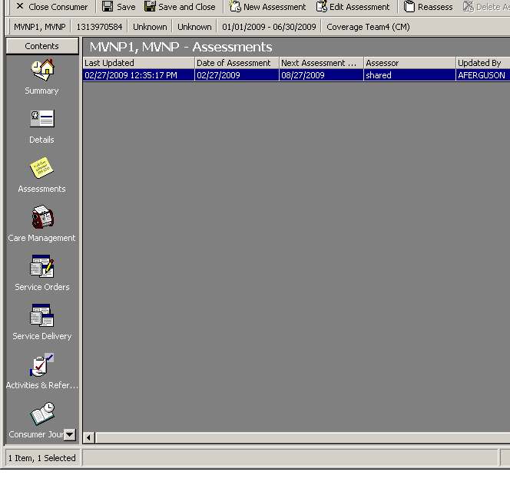

The user can click on “New Assessment” to create a new assessment. If an assessment already exists, the user can highlight the existing assessment and then click on “Reassess” to create a new assessment based on the earlier assessment.

When creating the assessment, the user will want to select the Filename for S:\Omnia\Assessment Forms\Nutrition Intake Assessment.afm.

Data from previous assessments will pre-fill subsequent assessments when the user reassesses the client. Users can reassess from another assessment form (such as the Intake assessment form or the CDS assessment form into the Nutrition assessment form) and responses that were captured in the original assessment will be carried into the new assessment, as long as both assessment forms use the same questions. It is important to review this data for any changes to the client’s status (e.g. ADL’s, nutrition risk, etc.).

When creating an assessment the user will need to enter both the agency and provider.

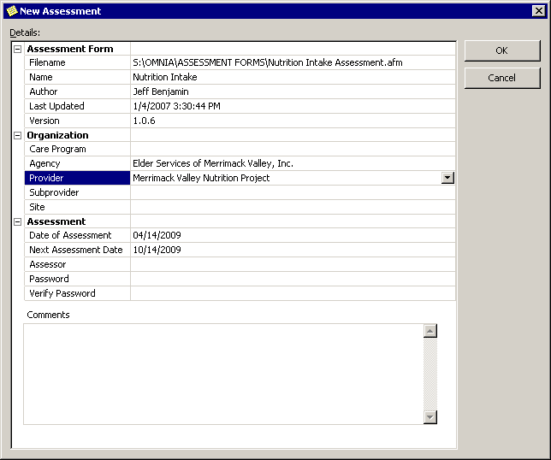

Contact information from the client including emergency contact and physician will flow from the client record in SAMS to the assessment and from the assessment to the client record in SAMS. For example, if the residential address is updated in an assessment, the software will update the client’s residential address in SAMS.

Home Delivered Meals
Home Delivered Meals (HDMs) are meals that are delivered to the client’s home. Currently in SAMS, there are many unique service names for various types of HDMs which identify the day of week, time of day, or special ethnic meal types. Examples include HDM Meal Lunch Weekday Hot, HDM Meal Supper Weekday Frozen, and HDM Meal Hot Cultural Weekday Kosher.

Services are used in conjunction with subservices to distinguish a regular meal from those with therapeutic diet modifications such as modified, renal, or cardiac. For example, one client may receive “HDM Meal Supper Weekday Frozen – Regular” and a second client may receive “HDM Meal Supper Weekday Frozen – Modified” where ‘Regular’ and ‘Modified’ are indicated through the use of subservices.

When creating service plans for Home Delivered Meals in SAMS, users should always remember to include subservice data in the service schedule (in the right hand pane). If the subservice is not indicated in the service schedule, the client may not appear as expected on a route list.

Care Enrollments, Care Plans and Service Plans
Please see the SAMS Case Management Training Manual for details on further details on Care Enrollments and Care Plans.

In Massachusetts, most state and home and community based (waiver) care programs require service plans and service orders for Home Delivered Meals (HDMs). This means that, in SAMS, users can not post service deliveries to clients unless corresponding service plans and service orders already exist for the clients.

It is recommended that service plans be created for ALL home delivered meal services regardless of care program in order for these clients to appear on the route sheets used by drivers for meal deliveries. Planning services also allows your agency to post service deliveries using the Service Delivery Confirmation Wizard.

To create a service plan, the user must confirm that the client is enrolled in a care program and that a care plan exists for the care program.

Both Home Care and Nutrition staff may have responsibility for creating care plans for HDM clients depending on the funding source. Typically, there are Home Care Case Managers who manage care plans for Home Care clients and Title 3 Case Managers (Nutrition Staff) who manage care plans for Title 3 clients within the same agency. Each user should understand their organization’s policies on care management. This document assumes that users have been trained to understand case management practices at their organization.

Organizational access rights also apply when creating care enrollments and care plans. Please see the section “SAMS Client Records” above for details of client access rights.

Reminder: When creating service plans for Home Delivered Meals in SAMS, users should always remember to include subservice data in the service schedule (in the right hand pane). If the subservice is not indicated in the service schedule, the client may not appear as expected on a route list.

In addition, selecting Weekly Detail in the right hand pane allows a user to select the specific meal delivery days.

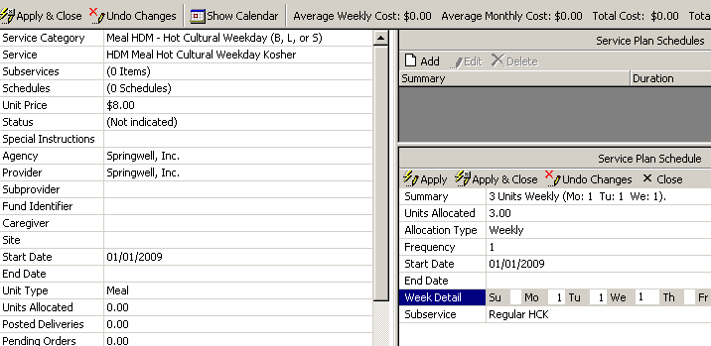

Nutrition staff can set their Care Plans to default to the Weekly Allocation Type by clicking on Tools>Options on the SAMS toolbar.

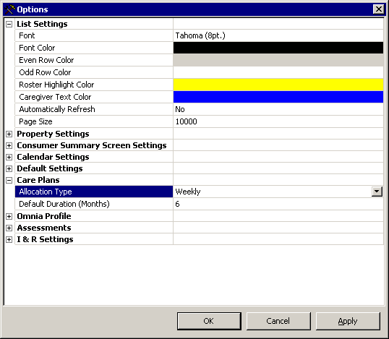

Planning Services for Holiday, Emergency Meals, and Weekend Meals
It is recommended that users create a service plan for each client for the appropriate holiday or emergency meal type. Specify a weekly service schedule for one unit a day, Monday through Friday. This will allow the meal to be delivered at any time. Note that service orders will not be generated for these meals.

In the case that emergency meals are distributed to ALL clients and therefore are not needed to appear on the route sheets and/or the kitchen report (provides total meal counts for the caterer), a consumer group may be used to enter bulk meal numbers. Please note that consumer groups are counted by NAPIS as one single client. Therefore use of Consumer Groups may result in incorrect NAPIS numbers for clients served by your agency and should only be used with approval from your organization.

Weekend meals should follow the same procedures as those for planning weekday meals. The appropriate weekend meal service and subservice should be selected. Using the weekly service plan schedule users enter the day of the week that the meal will be delivered.

Service Order Generation
Please see the Case Management Training Manual for detailed explanation of service orders.

Service Orders in SAMS are monthly authorizations of services. There are two ways to generate service orders in SAMS. Service Orders can be created for individual consumers for the length of the service plan or they can be generated in bulk for all clients at an organization for one month.
Note: In Massachusetts, users should not generate service orders for either Holiday or Emergency Meals.

Generating Service Orders from a Service Plan
Service Orders can be generated for individual clients through the client’s service plan. This process is explained in the Case Management Training Manual, but is generally not used in Massachusetts. When a user generates Service Orders from a service plan it is a lot of work for the case management staff. It also results in many future service orders being generated which can be cumbersome to manage.

Bulk Generating Service Orders (Monthly)
In Massachusetts, many organizations prefer to Bulk Generate Service Orders on a monthly basis. Please see the document “Job Aide: Bulk Service Order Generation” published February, 2008 for detailed explanation of the Bulk Service Order Generation process.

Bulk Generating Service Orders greatly reduces the work load on case management staff. It also allows for more current and up-to-date service orders.

Note: When Bulk Generating Service Orders, the system will not update service orders that have already been associated with service deliveries. For this reason, most organizations will post service deliveries on a monthly basis. Generally speaking, organizations will generate service orders for a month at a time prior to the end of the previous month. Organizations will then re-generate service orders for that same month at the end of the month, prior to posting service deliveries. By following this method of generating orders at the start of the month and then again at the end of the month, organizations will be sure to capture any changes to service orders, if, for example, a client were to change from receiving a home delivered meal four days a week to receiving a home delivered meal five days a week.
Note: Users should not generate service orders for Holiday or Emergency Meals. These services are typically planned but not ordered. This is because holiday and emergency meals may be delivered to clients on any day in a month. By not ordering these meals, the organizations are then free to deliver them on the appropriate day.

Routes
Please see the SAMS Nutrition Training Manual for detailed information on Routes.

Routes are organized lists of consumers, most commonly used to record clients who are scheduled to receive Home Delivered Meals, often based on common data such as residential address. Route Sheets are often printed out and given to the drivers when making deliveries.

Routes and Municipalities
In Massachusetts, the clients who appear on a route are usually determined by the client’s residential address (Town and Municipality fields). Each Massachusetts town is associated with 50 separate Municipalities to allow nutrition staff to create up to 50 different routes for each town.

Creating a Route and Generating a Route List
In SAMS, route lists are generated based on the route definition. The route definition is a set of filters that identify both the services that will be provided to a group of consumers and the common traits that are shared by all of the consumers who receive meals on that route. Route definitions work in a similar manner to report definitions in that the software will display consumers on a route list who meet the criteria of the route definition.
In the Route Definition area, the user will see three separate sections:
Route, General Filters, Service Filters.
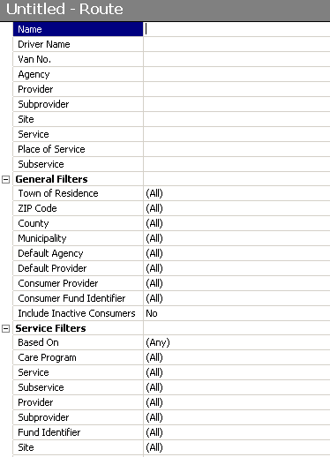

The top most section of the route definition determines what services will show on the route sheet when it is generated. Please note that if the user is printing the route sheets using the Compact Route Sheet methods the selected service at the top of the route definition will not be the only service to show on the route sheet. Most users in Massachusetts will print route sheets using the Compact Route sheet methods, therefore the service field at the top of the route definition is not important (although it still needs to be entered). Please see the section “Compact Route Sheets (Daily and Weekly)” below for further information on printing route sheets.

The second and third sections of the route definition (General Filters and Service Filters) determine which clients will be shown on the route list when the route list is generated in the system.
In Massachusetts, most route sheets for Home Delivered Meals are filtered based on client residential Town and Municipality. Please see the screen shot examples displaying municipality and routes below.

Routes can also be filtered based on Service Filters. For example, if a route is based on Care Plans, only clients who have a matching care plan will show on the route.

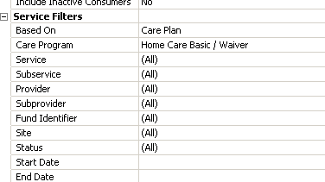

If a route is based on Service Deliveries, only clients who have received past matching service deliveries will show on the route.

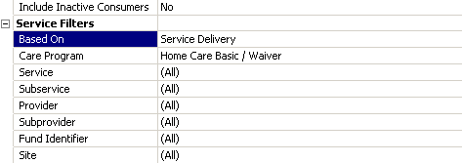

Users are not required to filter the route based on Care Plans or Service Deliveries. In Massachusetts, routes are often based on Care Plans with specific meal services indicated. This allows an organization to create specific route sheets for regular meals and separate route sheets for regular meals plus holiday meals (to be used on days when holiday meals are delivered with the regular meals).
Once the route definition has been created, the user can click on the button “Generate Route List” and the software will create a list of consumers who meet the criteria of the route list.

Note: If a client does not appear on the route list as expected, it may indicate that the client does not meet the route definition criteria, and it may indicate that the subservice for the meal was not properly added to the client’s service schedule. Please see the section on “Home Delivered Meals” above.

In the screenshots below, we see two clients who both have a residential address where the town is listed as Boston and the Municipality is listed as 10 - Route.

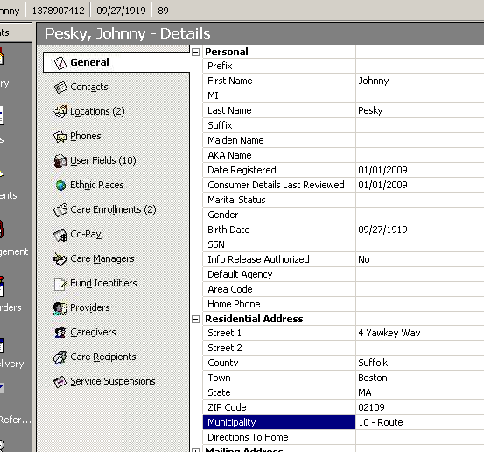

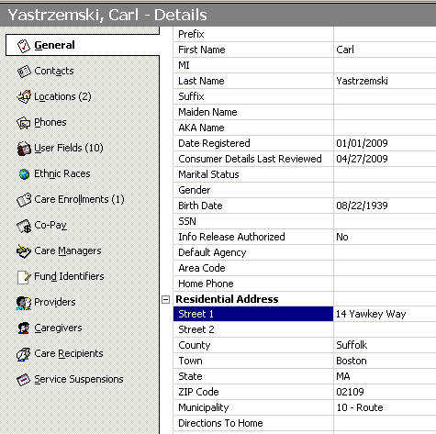

In the next screenshot, we see a route for Boston – Route 10 where both of the clients from the screenshots above are listed. This route is filtered based on Town of Residence = Boston and Municipality = 10 – Route.
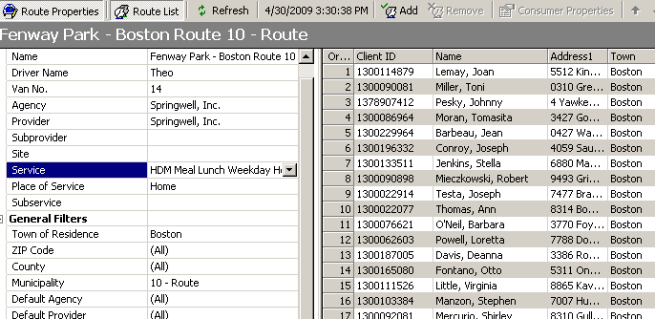

Note: As the route lists are based on both the client’s Residential Town & Municipality, an organization can use the same municipality information for different towns. In other words, there may be a route for “Canton – Route 12” and there maybe be a route for “Milton – Route 12” where the clients from both routes are associated with the Residential Municipality of “12 – Route” but the Residential Town differs.

Note: In the route definition, more than one town can be associated with the same route. For example, in Massachusetts, the village of Waban is a section of the town of Newton. In SAMS, Newton and Waban are both listed as towns, but it may make sense to have a driver deliver meals to clients who live in both towns on the same route. A user can create a route definition with more than one town.

In the screenshot below, we see one route for two towns, Newton and Waban, where the driver will be delivering meals to clients who live in both towns.
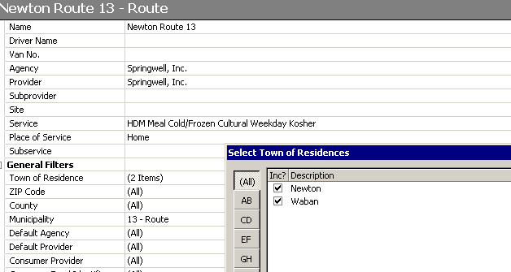
Note: The Route will also display on the consumer summary page and in the consumer details page.
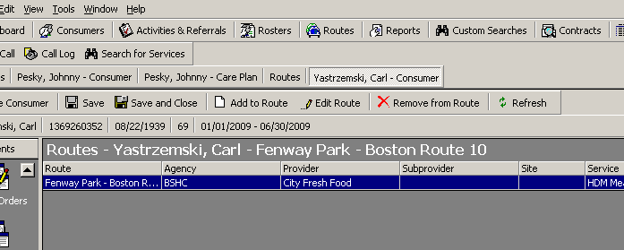

In the sections below “Modifying a Route List” and “Refreshing a Route List” we document two separate methods to update route lists. For Route Lists for Home Delivered Meals in Massachusetts, most users use the tools explained in the Modifying a Route List section below to change the order of clients on the route list. To add and remove consumers from a route list for Home Delivered Meals, however, most users edit the client residential address (municipality and/or city/town) and then refresh the route list as this represents a more permanent change.

For Route Lists for Congregate Meals in Massachusetts, most users use the tools to modify the route list when changing the order of the clients and when adding and removing clients from the route list. This is to account for clients who may exist on multiple route lists (if a client receives Home Delivered Meals and also attends Congregate Meal sites).

Modifying a Route List
Once the Route Definition has been created and a route list has been generated, users can manually edit the route list, by adding and removing clients to the route list and by changing the order of the clients on route list. These steps are detailed in the Nutrition Training Manual. Also, it should be noted that users can now manually add or remove a client from a route directly from the consumer record.

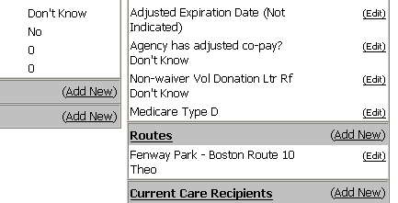

Note: Manually adding or removing clients from the route list will not update the client’s residential address (municipality and/or city/town). When a route is refreshed the software will update the route list based on the clients who meet the criteria of the route definition. In other words, a user may manually remove a client from a route list only to see that client reappear on the route when the route list is refreshed, or a user may manually add a client to a route list only to see the client get removed from the route when the route list is refreshed.

For example, if a route exists for clients whose residential addresses include the Town of ‘Newton’ and the Municipality of ‘2 – Route’ and a client exists with both of these elements in their client record, even if someone removes that client from the route list, the next time the route list is refreshed the client could be added back to the route list. To permanently add or remove a client from a route list, the recommendation is to edit the client record directly to either have them meet the criteria of the route definition or not (most likely by editing the client’s residential address).

Refreshing a Route List
Once the Route Definition has been created and a route list has been generated, users can use the Refresh button to re-generate the route list. The steps to refresh a route list are explained in the Nutrition Training Manual.
When a user goes to refresh a route, the software will provide the user with three options:

- Adding and removing clients from the route list
- Adding new clients to the route list (without removing clients)
- Regenerating the route list entirely

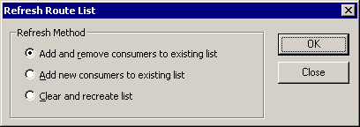

If the user selects the option to “Add and remove consumers to existing list” new clients who meet the route definition criteria will be added to the route list and clients who no longer meet the route definition criteria will be removed from the route list. The software will also provide the user with a list of consumers who have been added or removed from the route list. New clients are added to the bottom of the route list. Users can then manually move the client up or down the route list order (please see the SAMS Nutrition Training Manual).
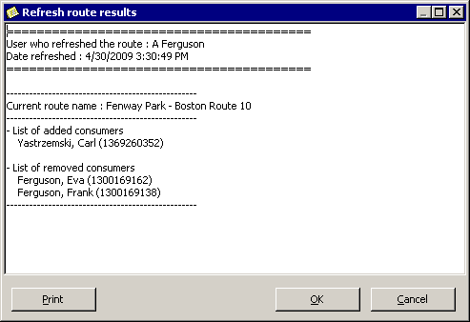

Note: If a user clicks on the “Cancel” button displayed in the list of clients who are being removed or added to a route, it will not cancel the changes from being made. The changes will still be made, however, the changes will not be saved until the user clicks either “Save” or “Save and Close.” If the user closes the route without saving their changes, the clients will not be added or removed from the route.

If the user selects the option to “Add new consumers to existing list” new clients who meet the route definition criteria will be added to the route list, but no clients are removed from the route list. The software will also provide the user with a list of consumers who have been added to the route list. New clients are added to the bottom of the route list. Users can then manually move the client up or down the route list order (please see the SAMS Nutrition Training Manual).

If the user selects the option to “Clear and recreate list” the entire route list will be regenerated based on the route definition. Any changes to the order of the consumer route list will be lost, as will any driver notes that have been added to the route sheet. This method of refreshing the route list is only recommended when the user has completely changed the route definition and is, in effect, starting from scratch.

Note: With any of these methods of refreshing a route list, the changes are not made until the user clicks on either “Save” or “Save and Close.” In other words, if the user is not happy with the changes to the route list based on the refresh attempt, they can simply click on “Close” and the route list will remain as it was before the refresh attempt.

Printing a Route Sheet
The SAMS Nutrition Training Manual details how to print individual route sheets for each route.

Compact route sheets allow clients with varying meal services to appear on the route sheet. Note you need to click on the tab to select the services. In Massachusetts, most organizations prefer to print many route sheets at the same time using Compact Route Sheet reports. This is also referred to as bulk-printing route sheets. See below for more information on printing bulk route sheets.

Bulk Printing Route Sheets
To bulk print route sheets, the user can create and save report definitions. The great benefit of bulk printing route sheets with report definitions is that the definitions can be saved and re-run without requiring the users to manually select all of the appropriate services each time.

Note it may be helpful to save a daily report definition as well as separate report definitions with holiday or emergency meals also included.

A choice of font size may be selected in the filter for the route sheet print-out.

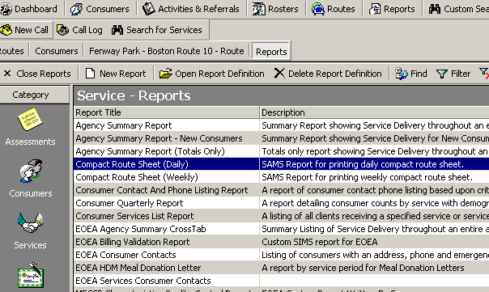

Service Suspensions
Please see the SAMS Case Management Training Manual for details on further details on Suspensions.

Service suspensions allow users to temporarily suspend consumer service deliveries and routes in SAMS. Suspensions should be used to prevent services from being delivered when a client is away from home or unavailable to receive services (if they are in the hospital, for example).

Users can still create service plans, schedules and orders during a suspension. A suspension is in effect from the start date through the end date, including both the start and end date.
When entering a new suspension, the user will have the option to “Show Planned Service Only.” Users are able to suspend unplanned services, but the option to limit the displayed services to only show the planned services was added at the request of Massachusetts Nutrition users to filter out old services that the client no longer receives.

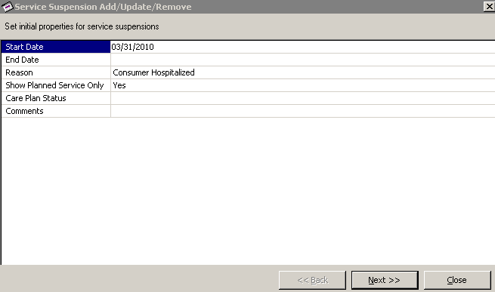

Note: There is also an option to filter the Displayed Services based on Care Plan Status. Care Plan Status is not required in Massachusetts, and it is not uncommon to see care plans with a blank status. When entering a suspension, the user can leave Care Plan Status blank and they will only see services that exist in plans based on the Start and End Dates of the suspension.

Service Deliveries
There are three different methods of posting service deliveries in SAMS to multiple clients at once. Users can also manually add service deliveries, individually, to each client directly in SAMS. In Massachusetts, for Home Delivered Meals and Congregate Meals, service deliveries are typically posted to multiple clients at the same time using one of the methods described below. Home delivered meals are typically posted through either the Service Delivery Confirmation Wizard or Electronic Vendor Invoicing depending upon your agencies business process. Rosters are typically used to post deliveries for congregate meals.

Service Delivery Confirmation Wizard
The Service Delivery Confirmation Wizard is a tool that allows users to post Service Deliveries in Bulk based on Planned Weekly Services for each provider. Please see the Service Delivery Confirmation Wizard (SAMS 1.8 Training Reference) for further details on running the Service Delivery Confirmation Wizard.

The Service Delivery Wizard can be run to show either Weekly Planned Services with Service Orders or Weekly Planned Services. In most cases, users will run the confirmation wizard for Weekly Planned Services with Service Orders. If the agency has not generated service orders for Holiday and Emergency Meals, as explained in the section above “Service Order Generation,” then when the user runs the Service Delivery Confirmation Wizard based for Weekly Planned Services with Service Orders, deliveries will not be posted for Holiday and Emergency Meals.

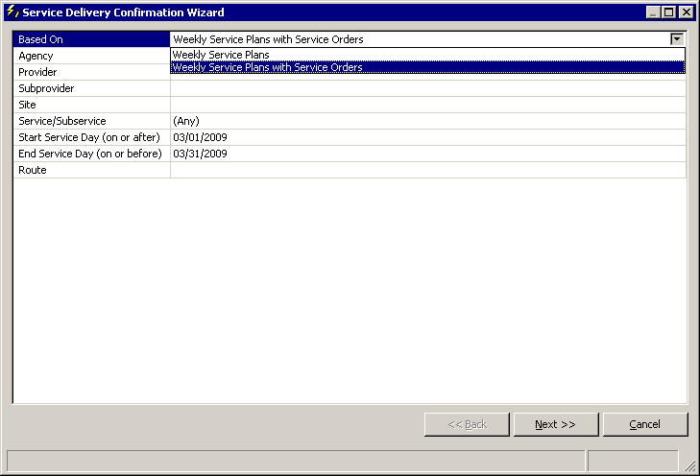

Note: The Confirmation Wizard shows planned units. Users can run the wizard and elect not to deliver services to a client (by zeroing the planned units out), but if the user re-runs the wizard for the same day, the planned units will continue to show. Many users are confused by this aspect of the tool as they expect the system to build a history of services that were not delivered. This is not the case. The confirmation wizard simply posts deliveries.

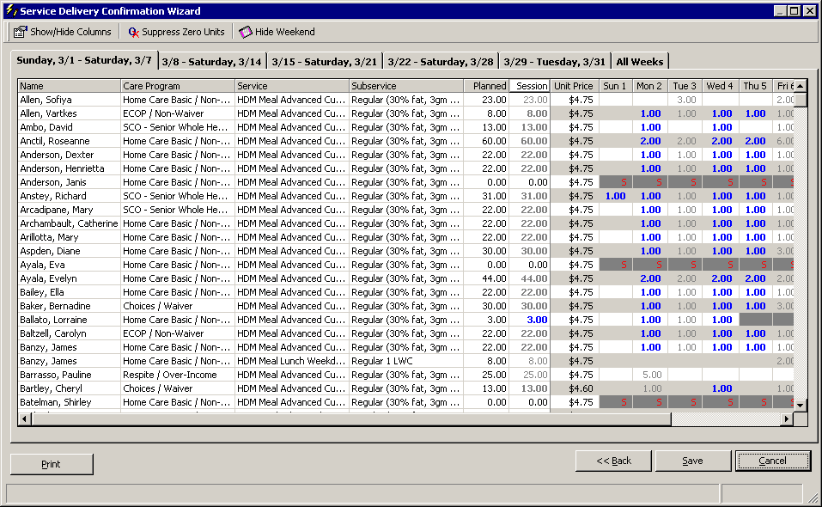

In the screenshot above, the units in gray represent services that have already been delivered. The clients with a red S have suspensions in place on those days. The units in Blue represent services that are planned and that will be delivered if the user clicks on the “Save” button. The user can manually zero out the units for a client so that the deliveries are not posted (see the image below).

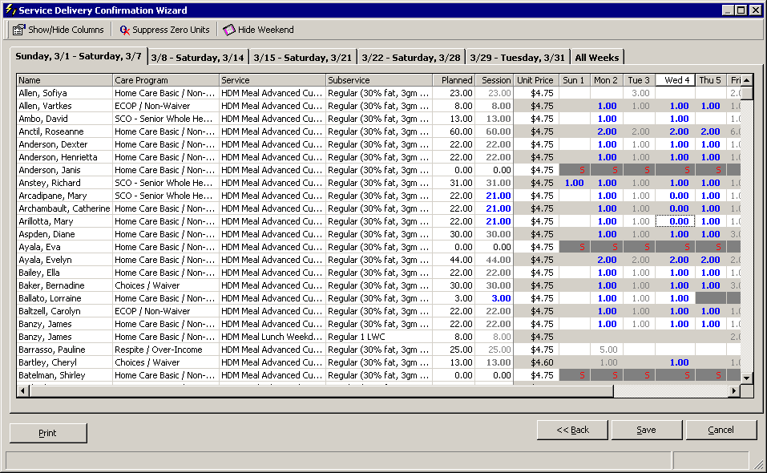

Note: If your agency uses the Service Delivery Confirmation Wizard to post service deliveries, you need to create plans for services. This is why congregate meals are typically not posted through this method.

Running the Service Delivery Confirmation Wizard by Route
Users can run the Service Delivery Confirmation Wizard by Route. Selecting this method will require the tool to be re-run multiple times (once for each route). In addition, when running the confirmation wizard by route, the software will only show clients who are currently associated with that route. If a client has transferred from one route (Route 1) to another route (Route 12) in the middle of the month, when running the confirmation wizard for that month, the client will not show up for the first route as they are now associated with the second route, even though the first part of the month was delivered from the first route. For clients who have transferred from one route to another, this does not represent a major problem as the client will be listed when running the wizard for the second route.

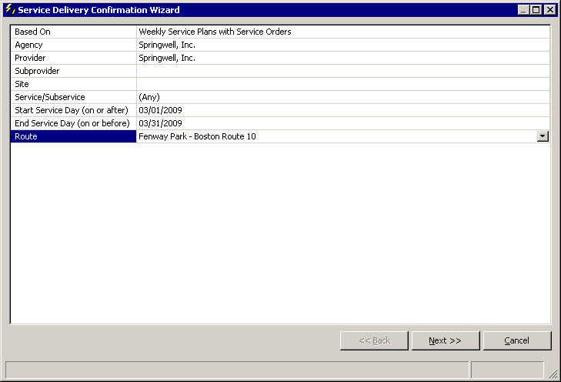
Note: If running the service delivery confirmation wizard by route, users should post deliveries for clients who are removed from a route mid-month by opening the client record for each individual and posting the delivery. For clients who have stopped receiving meals services in the middle of the month, the recommended process is to manually post all service deliveries for that client for that month prior to removing the client from the route. Otherwise, when running the confirmation wizard for that route, service deliveries will not be posted for that client (as they are no longer on the selected route).

Managing Holidays and Snow Days with the Service Delivery Confirmation Wizard
In the case that meals are not able to be delivered for a planned delivery date, the Service Delivery Confirmation Wizard does not allow users to zero out an entire day of meals for all clients. If there was a snow day or a holiday, for example, where no clients were delivered meals, users would need to zero out deliveries one-by-one for every client that day.
An easier method would be to run separate instances of the Confirmation Wizard skipping the day where no deliveries were posted. For example, if March 14th was a bad snow storm where no meals were delivered, the user could run the Confirmation Wizard from March 1st through March 13th and then run the Confirmation Wizard from March 15th through March 31st. By following this method, no deliveries would be posted on March 14th.

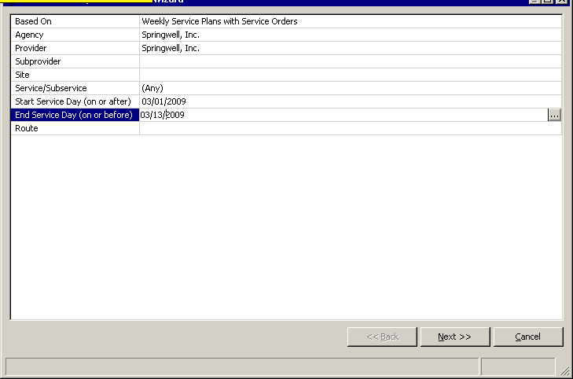

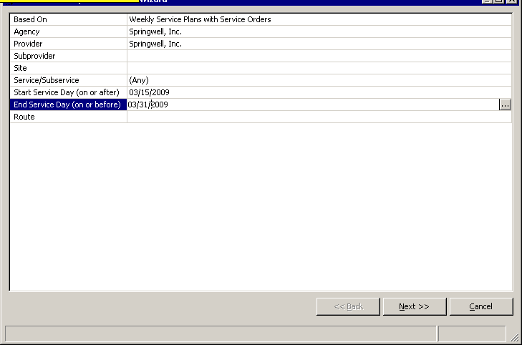

Posting Deliveries for Holiday and Emergency Meals
In order to post the delivery of holiday or emergency meals, it is recommended to run the Service Delivery Confirmation Wizard separate from regular meal deliveries based on Weekly Service Plans without Orders. Select only the appropriate service (holiday or emergency meal) and enter the date of delivery as the date range (with the same start and end service date).

Rosters
Please see the SAMS Nutrition Training Manual for detailed information on Rosters.

Rosters are pre-defined groups of consumers in SAMS that allow users to post service deliveries for multiple consumers at the same time. Unfortunately, rosters can only be associated with one care program. So, to post deliveries for home delivered meals through a roster, a user would need to create one roster for Home Care Basic/Non-Waiver, another roster for Home Care Basic/Waiver, another for ECOP/Non-Waiver, etc.
In Massachusetts, users typically only use rosters to post service deliveries for Congregate Meals under the NAPIS-Title III program. Please see the section below “Congregate Meals.”

Note: Rosters can also be used to delete service deliveries that were posted incorrectly. Service deliveries can not be removed if they have already been invoiced. For this reason, service deliveries that were posted incorrectly should be corrected as soon as possible.

Electronic Vendor Invoices (EVI)
Electronic Vendor Invoices (EVI) are a method that some agencies use to communicate planned services with vendors and also to post service deliveries. EVI is typically managed by either Fiscal staff or IT staff at the agency level. For further information on EVI, Nutrition staff should meet with Fiscal and IT staff at their organization to discuss in greater detail.

In the EVI process, agency staff exports a report on service plans from SAMS in excel. This excel file is then processed through EVI software to create a vendor specific excel file. This file is sent to the vendor. The vendor then updates the excel file to count the services that have been delivered to the client.

The vendor returns the excel file to the agency. The agency processes the excel file through the EVI software which produces an xml file. The agency then imports the xml file into the SAMS network using the Import/Export Utility.

Some agencies have incorporated the EVI process to post nutrition service deliveries, where the nutrition program would be entered in the system as the meals provider (vendor). In other words, either the fiscal staff or the IT staff at the agency runs the report and processes the data using the EVI software, the Nutrition staff updates the excel file to count service delivers and either the Fiscal or IT staff imports the deliveries to the network.
Using the EVI process for Nutrition would require interaction between the nutrition staff and either the Fiscal staff and/or IT staff at the agency level.

Note: Services must be planned to use the EVI process to post service deliveries.

Congregate Meals
Congregate Meals are meals that are delivered to a group of consumers at a congregate meal site, where the elder client lives at or travels to the site to receive the meal.

In addition to the typical hot weekday lunch, currently in SAMS, there are other services available for various types of Congregate meals such as Congregate Meal Lunch Basic Cold, Congregate Meal Supper Cultural Kosher, and Congregate Meal Weekend Hot. Much like home delivered meals, congregate meals are used in conjunction with subservices to indicate the different types of meals the user will receive. Subservices also allow users to distinguish between meals provided.

Congregate meals operate through a reservation process whereby an elder client requests a meal a day in advance. Due to the potential variability in the service schedule, it is not required to create service plans for client’s receiving congregate meals. Instead, the specific meal services are documented in SAMS and associated with client’s names during the delivery process.

In Massachusetts, users typically only use rosters to post service deliveries for Congregate Meals.

Adding Congregate Consumers
As described previously in this document, before adding a new client record to SAMS, users should first search the SAMS database for existing clients as this will prevent the creation of duplicate client records. Individual consumer records for all congregate participants should be created with demographic and contact information, birthday, and NAPIS required fields (e.g. NSI for nutrition risk).

In Residential Address, enter the appropriate Municipality for the consumers most frequently attended meal-site. Please see the section below “Routes for Congregate Meals”.

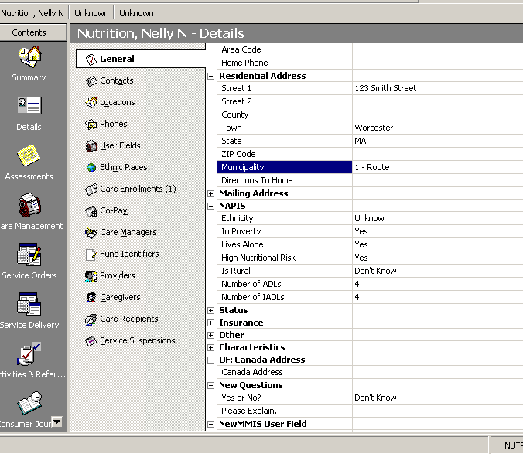

Consumer Groups for Congregate Meals
Please see the SAMS Case Management Training Manual for details on further details on Consumer Groups. Please also see the section “NSIP Meals Eligible” above.

Consumer Groups in SAMS are used to track services provided to groups of clients where the clients share basic data. In Massachusetts, organizations should be tracking and recording the individual client data for consumers who receive congregate meals. Consumer Groups should only be used for Congregate Meals in limited situations where individual client data cannot be collected (e.g. homeless shelter meals). Consumer groups can be used for guests at a meal site, guests under 60 should have a separate consumer group (note there is a NSIP meals eligible option). The consumer group is used to enter aggregate numbers and does not associate meals with individual’s names.

Deliveries for consumer groups need to be entered manually by opening the consumer group as they will not appear on the roster.
Please contact the EOEA Nutrition Program for questions regarding which instances are appropriate to use consumer groups for congregate meals.

Routes for Congregate Meals
Please see the section “Routes” above for further details on bulk-printing route sheets.

Many organizations will create routes specifically for each congregate meal site based on infrequently used municipalities, such as “50 – Route” and “49 – Route.” Routes then provide an easy way to list the congregate clients that attend specific sites and to post deliveries using rosters. At the top of the route filter screen you may give the route the name of the congregate site.

It is possible that a client may receive home delivered meals on a different route or that a client may attend two different congregate meal sites. Due to the common overlapping of clients for congregate meal sites, most agencies will manually add and remove clients to the route lists for congregate meal sites. These organizations never refresh route lists for Congregate Meal sites. Please see the section “Modifying a Route List” above for further details on manually adding and removing clients from route lists.

Let’s say that client “Erin Lambert” receives home delivered meals three days a week. She also regularly attends a congregate meal site every Friday. To receive the home delivered meal, her residential address was set to Town: Framingham and Municipality: 3 - Route.

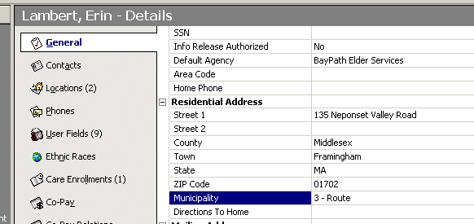

Based on the client’s residential address, she shows up on the route list for the route named “BPES Framingham A3.” This route is used for home delivered meals. The route definition for “BPES Framingham A3” is set to include clients where the town is listed as Framingham and the Municipality is listed as “3 – Route.”

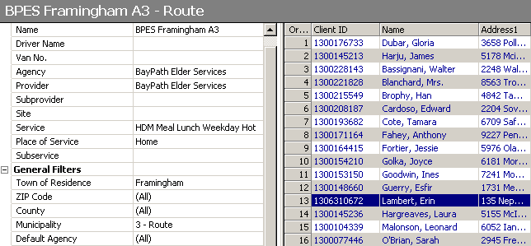

This client, Erin Lambert, also belongs on the Congregate Meal route “BPES Framingham Congregate.” The route list for the congregate meal route, however, may be initially created on residential address data, such as Municipality “50 – Route.” As consumers travel to the congregate meal site from many locations, however, and as some consumer may exist on HDM Route Lists (using other municipalities), clients are manually added and removed to the route list. Because this route is managed manually, the route list is never refreshed.

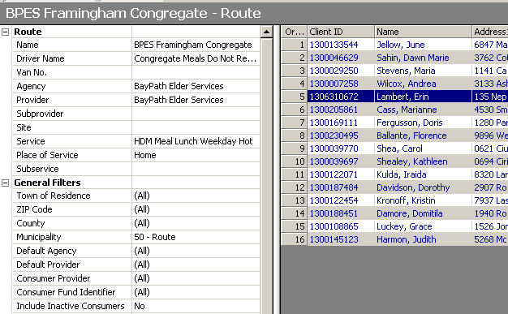

The client details list both routes that the client is on.

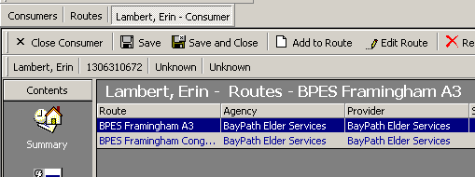

Using Rosters for Congregate Meals (Service Deliveries)
Please see pages 39 through 55 of the SAMS Nutrition Training Manual for detailed information on Rosters. Please see the section “Rosters” above for additional details.

In Massachusetts, Rosters are typically created to allow for management of Congregate Meal sites.
In the section above, “Routes for Congregate Meals,” we explained the process by which a route list can be created manually for congregate meal sites.
A roster can be created based on a specific route list. By following this method, the user can manage the list of clients through the route list and then post deliveries to those clients using an associated roster.

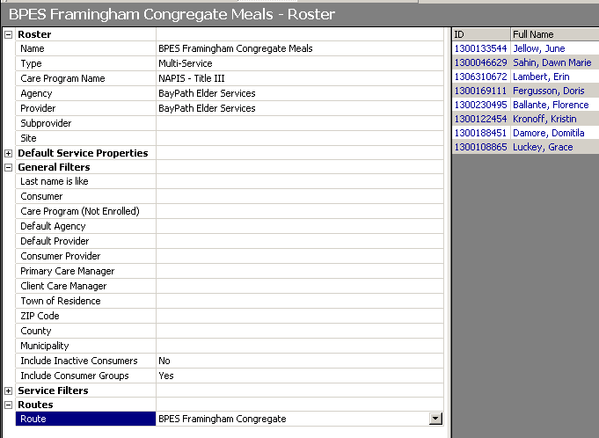

Once the roster has been created, users can use it to post service deliveries to those clients by highlighting the roster, clicking the button “Record Service Data” and selecting the appropriate month.

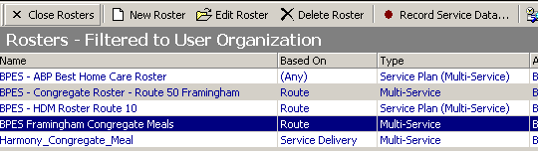

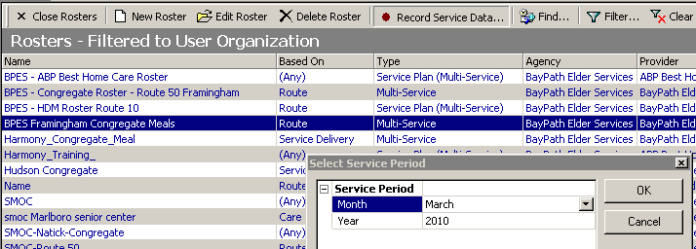

Unlike the Service Delivery Confirmation Wizard, when posting deliveries to a group of clients using a roster, the user can multi-select and manage deliveries for multiple clients at once.

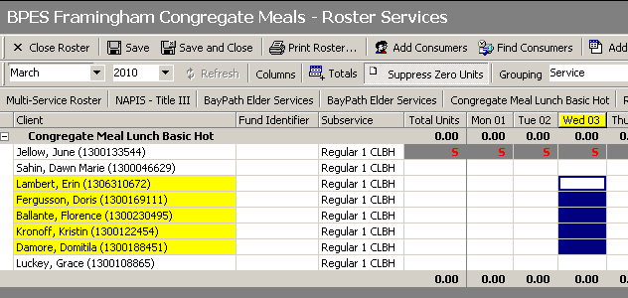

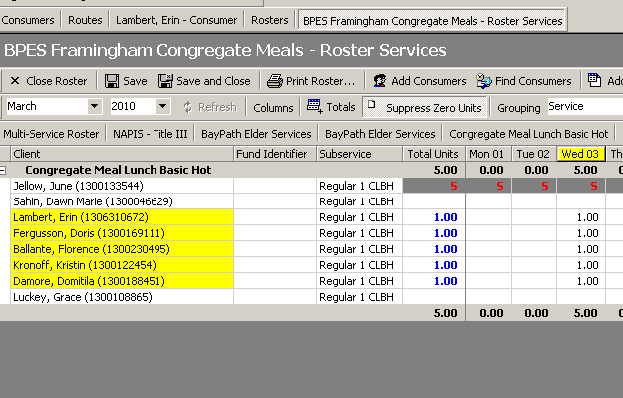

Congregate meal deliveries may be posted daily, weekly, or monthly, depending upon the agencies business process. Many choose to simply enter a monthly total for the number of congregate meals served to each individual client. It is possible to highlight an entire column and enter the most common number of meals and then change the number for the clients who received more or less total meals.
In Massachusetts, users typically only use rosters to post service deliveries for Congregate Meals under the NAPIS-Title III program. Agencies that choose to create care plans may use the delivery confirmation wizard to post deliveries.

Printing Rosters as a Tool for Recording Meals at Congregate Meal Sites
Printing the congregate meal roster list provides a tool for sites to record congregate meal services provided to each client. Weekly or monthly service rosters may be printed in order to record the number of daily meals served to each client. Users may also add extra rows to the roster print out to add any new clients who start the service during that time. The site manager can then provide these sheets back to the nutrition program to use for the posting of deliveries.

Nutrition Education
Nutrition Education is a service provided at Congregate Meal sites twice a year.

The AoA NAPIS Reporting Requirements defines Nutrition Education as the following: A program to promote better health by providing accurate and culturally sensitive nutrition, physical fitness or health (as it relates to nutrition) information and instruction to participants, caregivers, or participants and caregivers in a group or individual setting overseen by a dietitian or individual of comparable expertise. Note: in a group presentation, each participant is counted as having received the service.

As Nutrition Education is provided at congregate meal sites, the recommended process to record “Nutrition Education” service deliveries in SAMS is through an established congregate meal site roster or route list.
In the section above, “Using Rosters for Congregate Meals,” we had created a roster for congregate meals. As the service for “Nutrition Education” is provided to the clients at the congregate meal site, it is a simple process to use the existing congregate meal roster to record service deliveries for Nutrition Education.

The user highlights the appropriate roster, clicks the button “Record Service Data,” and enters the appropriate month.
The roster opens for the congregate meal services as expected, but the user clicks on the button “Add Service” to add a new service for the indicated clients.

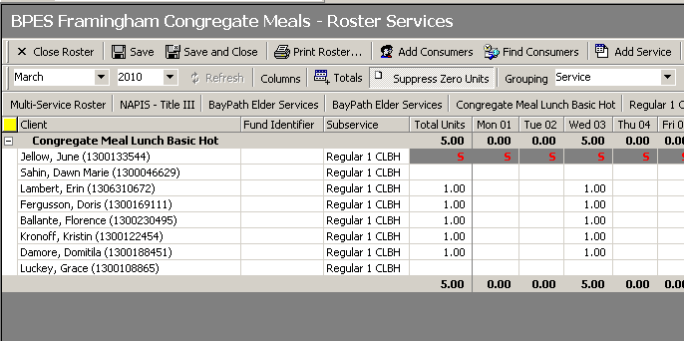

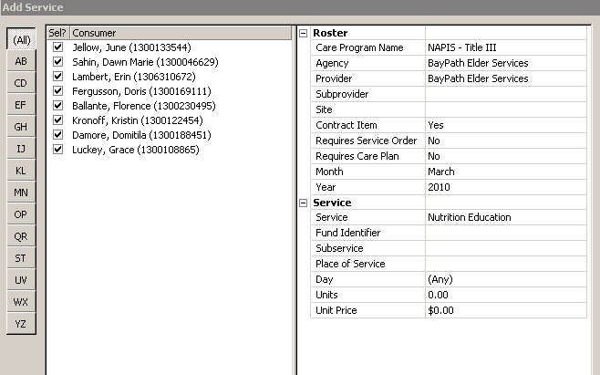

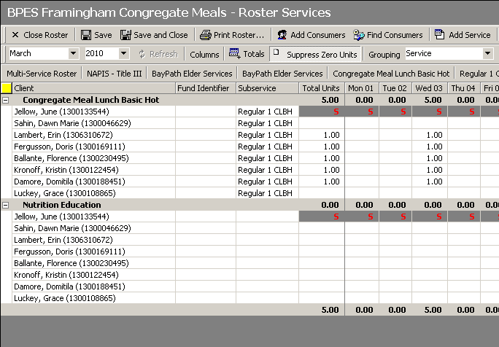
Note: This service will need to be associated with the provider through your contracts manager.

Nutrition Counseling
Please see the SAMS Nutrition Training Manual for details on further details on posting service deliveries to an individual client.

The AoA NAPIS Reporting Requirements defines Nutrition Counseling as the following: Individualized guidance to individuals who are at nutritional risk because of their health or nutrition history, dietary intake, chronic illnesses, or medication use, or to caregivers. Counseling is provided one-to-one by a Registered Dietitian, and addresses the options and methods for improving nutrition status.
As indicated above, Nutrition Counseling is provided on a one-to-one basis.

As Nutrition Counseling is usually provided at the client’s home, on a one-by-one basis, it is recommended that the service deliveries be manually posted to each client as they are served. We would not recommend entering the deliveries to groups of consumers at the same time as we do for Nutrition Education as the clients are generally not served at the same time.

Note: This service will need to be associated with the provider through your contracts manager.
When creating service plans for Nutrition Counseling, the recommendation is to start and end date the plan in the same month, during the week that the service will be provided.

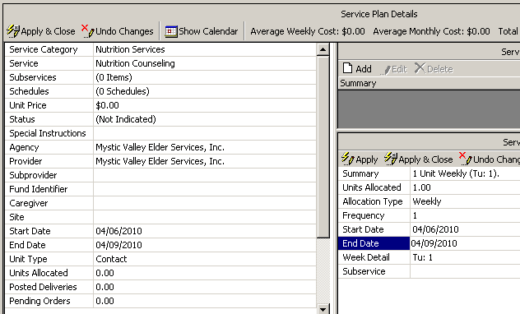
A service plan/service schedule set to start and end within the same month and week will allow for a single, uniform service order to be generated. Once the service plan/service schedule is set up correctly, a service order can then be generated through the bulk service order generation process, or individual users may generate a single service order themselves.

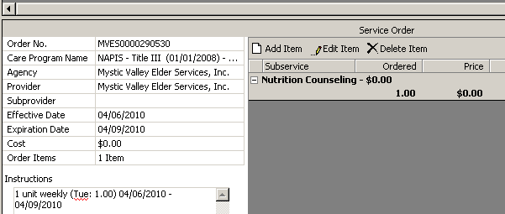

Nutrition Reports in SAMS
Please see the document “SAMS Reports At a Glance” published November 14, 2008 for a general description of each report found in SAMS.

SAMS includes many customizable reports broken out by category. SAMS reports allow users to view, export and compare SAMS data based on specific criteria. Users can click on “Reports” to see the report listing page. Report Categories include Assessments, Consumers, Services, Contracts, Care Plans, Billing, Activities & Referrals, Administrative, and I &R Reports.
The report results will depend on the organizational access privileges for the user who is running the report. For example, a user from Springwell will not see report results on service deliveries that were provided by Mystic Valley Elder Services regardless of the report filters.

Under each report category, users will find many standard report templates. Generally speaking, users should consider what data they are looking the report to produce. Users should then look in the appropriate report category for standard report templates that may produce the requested results.

If a user is looking for consumer data, for example, they will most likely be looking at reports under the category of Consumers. If a user is looking for data on service deliveries, however, the user should probably be looking at reports under the category of Services.

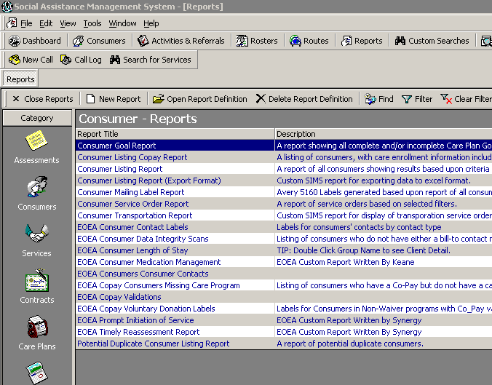

Once a user has opened a standard report template, the user will be able to customize the report output using report filters. Users can also save the customized reports as report definitions. When saving a report definition, we suggest naming the report definition using the abbreviation for your organization and a description of the report usage such as “SPR – Monthly Meals Delivered” for a report that shows meals delivered by Springwell.

Note About Saving Reports: Caution should be used when saving reports. If a user should change the name of a report definition, or if a user should modify the report parameters for an existing report definition, it is recommended that the user should click on the “Save Report As” button to save the updated report definition by a different name. This will create a second report definition by a new name while also retaining the original report definition. If the user should modify the report definition and then click on the “Save” button, the original report definition will be lost.

Report Security Access
Users can restrict access to report definitions that they have created using the filters for Report Security Access. These filters allow users to set a report to only display for users at one particular organization. These filters can also be used to prevent users from editing a saved report definition, by setting Modifications Allowed to (None). Please note that the creator of a report definition will always be able to edit the report even if Modifications Allowed is set to None.

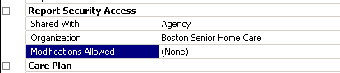

Exporting Report Results
Once a user has run a report in SAMS, the user can print or export the report results. Exporting a report allows the data in the report to be formatted in documents that can then be shared and archived.

Once the report filters have been set, users can click on the “Print Preview” button to review the report results.

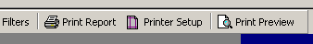

The preview results will display in the right hand panel. If the results do not match the user’s expectations, the user can continue to edit the report filters in the left hand pane and “Refresh” the preview results.

Once the report preview matches the user’s expectations, the user can click on the Export Report button (the icon looks like a small envelope with a red down-pointing arrow.

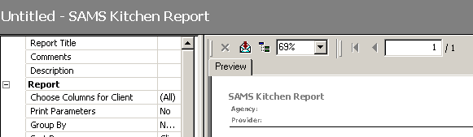
During the export process, the user can select the file format and export location.

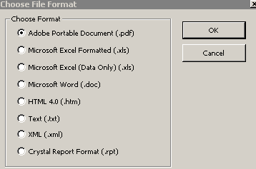

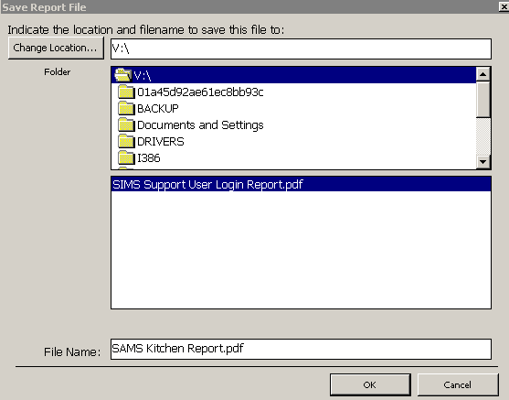

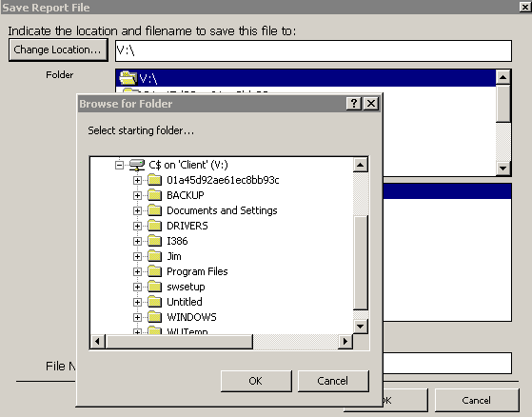

During the export process, the V:\ drive represents the user’s C:\ drive on their computer.

Note: if a user is having difficult getting a report to show the correct data, they should set the report filter for “Print Parameters” to Yes or Selected Only and then preview, export and submit the exported report to SIMS Support for review as the report output will now include the report filters that the user had selected when running the report.

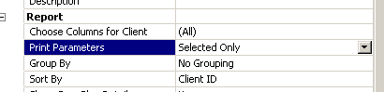

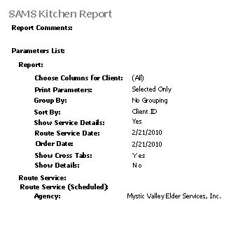

Reports at a Glance
Below please find some common SAMS reports that may be useful for Nutrition staff.
Consumers
Consumer Listing Report – A listing of consumers displays demographic information with extensive filtering capability. Additional display options are available for grouping, sorting, Location filtering, and including various consumer-related details.
- When to use: Likely the most common report for basic consumer listings. Run anytime you want to return a list of consumers that meet a certain criteria, such as anyone living in a certain town, or if a Case Manager wants a list of all of their clients sorted by Last Name.
Services
Agency Summary Report – A summary listing displays service delivery information across agencies, allowing for robust filtering, grouping and sorting options. Additional options available to include multiple levels of information for the consumers served.
- When to use: Likely the most common service-level report utilized for monthly reporting of clients served. Run anytime you wish to see an unduplicated list of clients served and the total counts based on a certain criteria, such as consumers that have received a Home Delivered Meal this month grouped by provider.
Agency Summary Report (Totals Only) – A variation of the Agency Summary Report (see above) only allowing for total counts to be displayed for service delivery data.
- When to use: Commonly used as a monthly or annual report by state units or agencies to report totals for clients served, service units and costs. This is an optimized report when individual consumer detail is not necessary in the results.
Compact Route Sheet (Daily) – Allows for printing one or more daily compact route sheets with additional filtering options for the services or subservices in the routes.
- When to use: You want to generate daily compact route sheets for a group of routes at once. If the report is created and saved, then the route printing is simple and consistent without having to set the options every day.
Compact Route Sheet (Weekly) – Allows for printing one or more weekly compact route sheets with additional filtering options for the services or subservices in the routes.
- When to use: You want to generate weekly compact route sheets for a group of routes at once. If the report is created and saved, then the route printing is simple and consistent without having to set the options at the start of each week.
NAPIS Consumer Listing – A listing of all consumers that have received services displays columns for existing and missing NAPIS information. Extensive filtering options are available to limit the resulting data.
- When to use: You want to check the demographic detail that has been captured for your clients while preparing the federal NAPIS report. This powerful report will show where the holes in the data collection are for the clients that receive services.
NSIP Meal Reports Tab – A cross-tab report of all home delivered and congregate meals (NSIP meals) delivered grouped by agency and listed by provider, sub-provider or site. Filters are available to limit the results by service and/or NAPIS demographics. A reimbursement rate can be entered to display the reimbursement cost for the NSIP meals.
- When to use: You want to create a report to show how many meals were provided to clients based on a certain criteria, such as a time period. Entering a reimbursement rate will display the NSIP cost for the services provided.
NSIP Meals Recipient List – A listing displays all consumers that have received home delivered or congregate meals (NSIP meals). Filters are available to limit the results by service and/or NAPIS demographics, and grouping and sorting options are available to customize result display.
- When to use: You want to see a listing of all clients that have received NSIP meals based on a certain criteria, such as a time period. The list will be grouped by agency, and you can select the grouping for the consumer results, such as by provider.
SAMS Kitchen Report – A listing of all meals displays consumer, service detail, and meal counts that have been planned by route. An additional option is available to display a cross-tab summary of the total count of meals by route, and limited filtering is available to limit the results based on route definitions and service plan status.
- When to use: Typically used by meal sites that need to prepare the meals or to order meals prior to delivery. This list will result in the total counts of the types of meals based on the routes previously set.
Service Delivery Consumer Listing – A detailed listing of consumers displays demographics as well as service and provider information for the service deliveries entered. Extensive filtering options are available to limit the resulting data, and grouping and sorting options are available to customize result display.
- When to use: You want to return a list of client-level detail, such as address information, for clients that have received services based on a certain criteria, such as a given date range or from a certain provider or service. Display options give the flexibility to show or hide additional levels of details for consumers, services, and providers.
Care Plans
Care Plan Monitoring Report – A summary listing of consumers displays demographics and detailed information on care plans that exist in the criteria selected. Extensive filtering options are available to limit the resulting data, and grouping and sorting options are available to customize result display.
- When to use: You want to see a list of clients and their care plan details. Additional filters can be added to limit the results such as a case manager who only wants to see their clients or filtering by a certain provider or service plan date range.
SAMS Suspended Service Plan Report – A listing of consumers displays the service suspensions entered. Extensive filtering options are available to limit the resulting data.
- When to use: You want to see a list of the consumers that have suspended services meeting a certain criteria. Additional filters can be added to limit the results such as a case manager who only wants to see their clients or filtering by a certain provider or suspension date range.
Activities & Referrals
Consumer Activity/Referral Report – A listing of consumers displays the details for activities entered based on criteria selected. Extensive filtering options are available to limit the resulting data, and grouping and sorting options are available to customize result display.
- When to use: You want see a list for consumers that have activities entered meeting a certain criteria such as activities of a specific type that are due in a certain time period. A case manager may want to see home visits that are due this week.

SAMS Kitchen Report (Category: Services)
The Kitchen Report provides a list of meals planned on a specific date by route and meal type. The SAMS Kitchen Report tells drivers the number of meals to pick up for a particular route. To be included on a Kitchen Report, consumers must be enrolled in a service plan and included on a route.

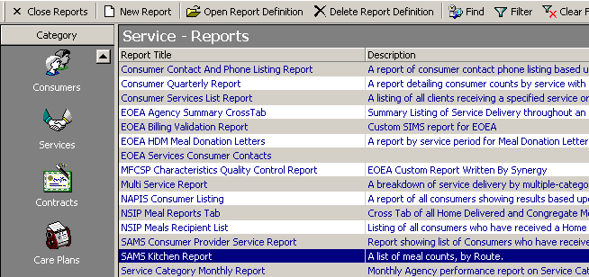

This information is typically submitted by the nutrition program to the caterer one day in advance. Due to the fact that congregate meals are based on reservations and are not planned, these meals will not appear on the kitchen report. It is possible to export the Kitchen Report as an excel file and then add in congregate reservation numbers to get the final total for the caterer.

EOEA HDM Meal Donation Letter (Category: Services)
This report automatically generates donation letters for elders who receive home delivered meals.
Language for the letter must follow guidelines. The recommended donation amount is set by each agency.

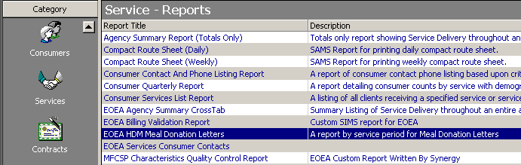

The report excludes clients who receive meals through waiver programs. A User Field (Donation Ltr Refused) may be used for clients who do not wish to receive a donation letter.

In the case that there is a different mailing address for the consumer than the residential address, the mailing address will print for the donation letter.

SIMS Meal Donation Letter Report Template

Donation letters are generated for a specific Agency and Service Month.

Donation letter select all consumers who received Home Delivered Meal Services under any service programs excluding consumers receiving meals within the following programs:

Choices / Waiver
ECOP / Waiver
GAFC
Home Care Basic / Waiver
SCO - Commonwealth Care Alliance
SCO - Evercare
SCO - Senior Whole Health

Agencies may also exclude any clients who have expressed a desire not to be sent a donation letter request by adding the following user field to the client’s record:

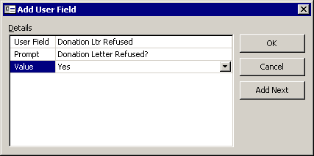

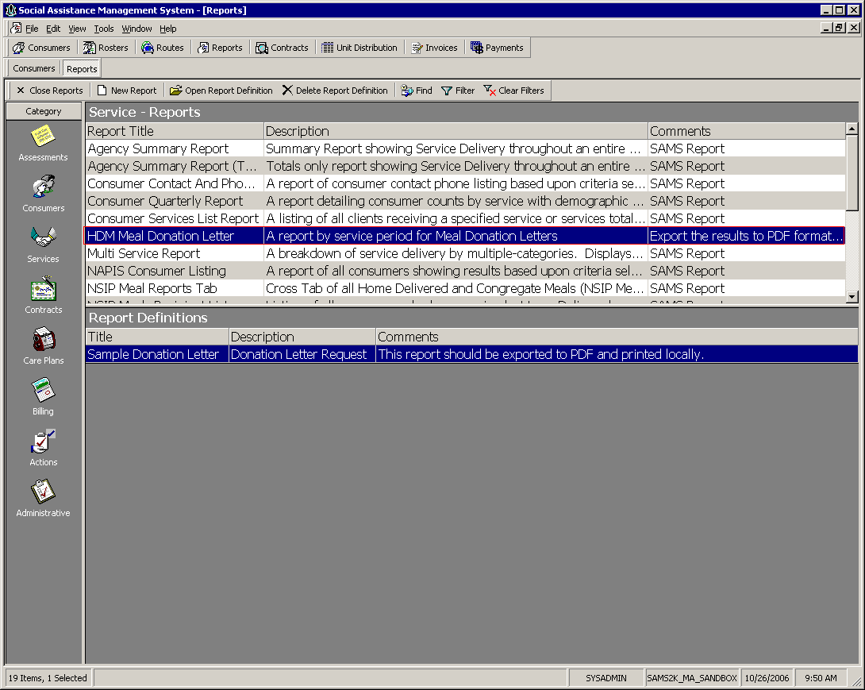

A new report template definition can be created by choosing the New Report option

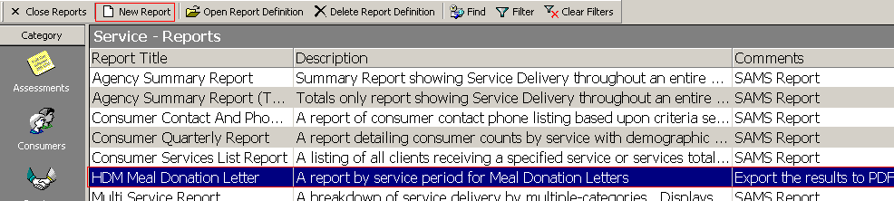

For each report parameter, fill in the necessary information. This information will be saved for future report runs.

Agency Name
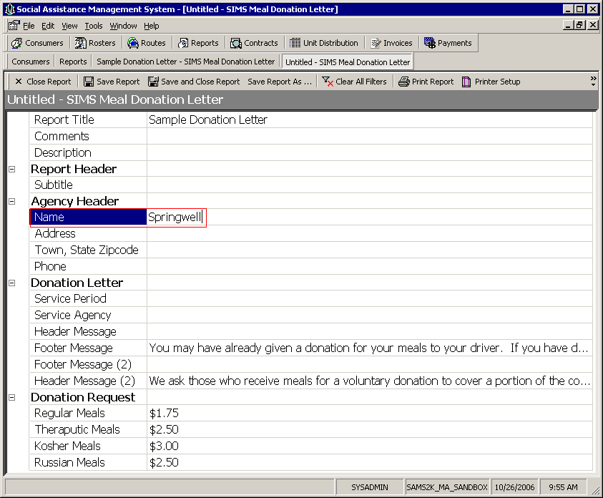

Address Line
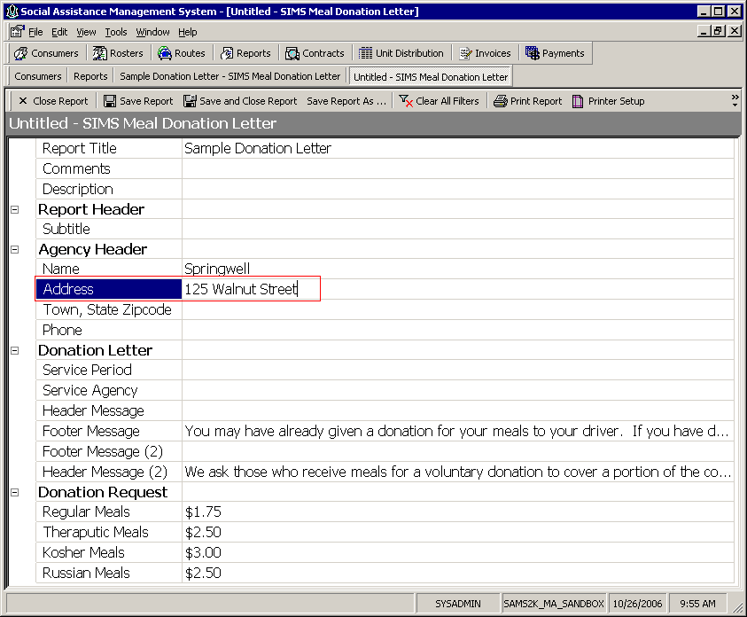

Town State and Zip Code
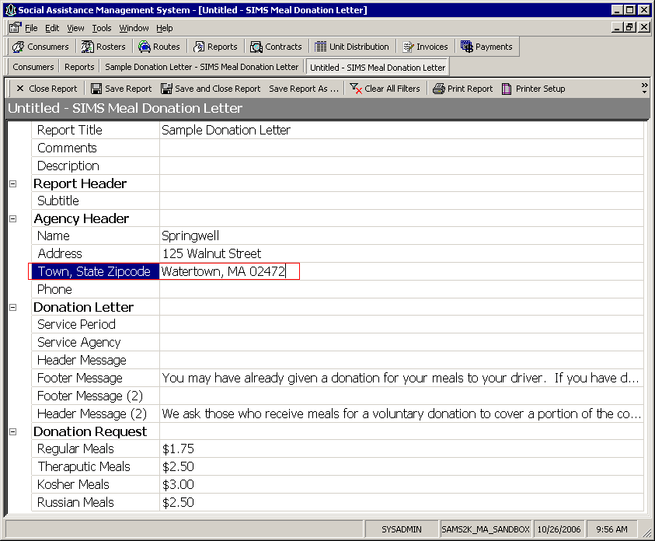

Phone
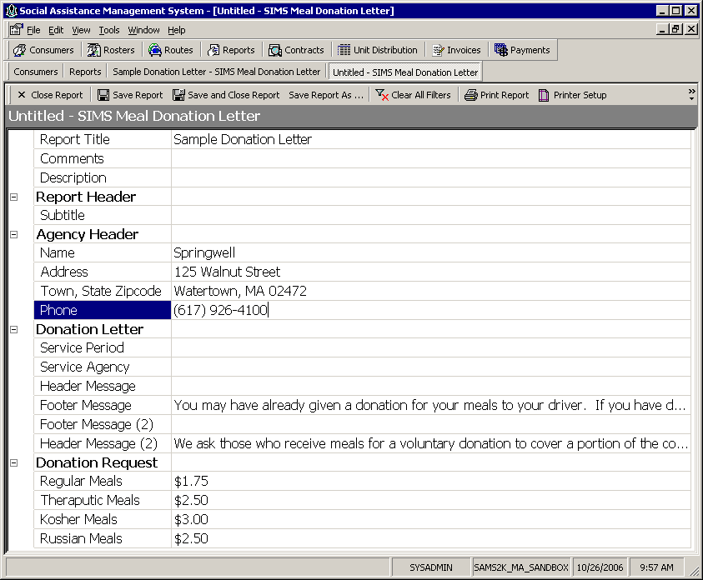

Service Delivery Period for each to report on.
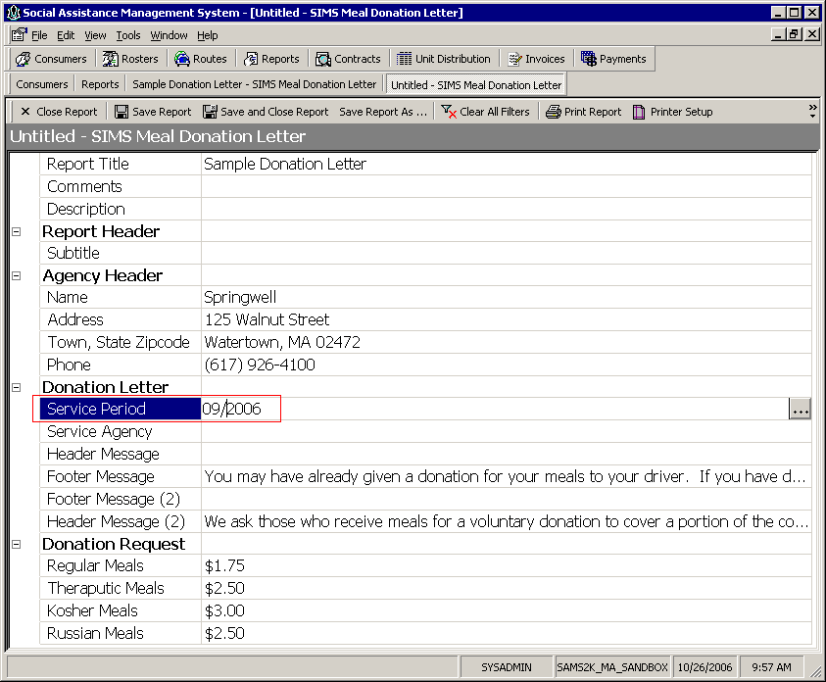

Service Agency

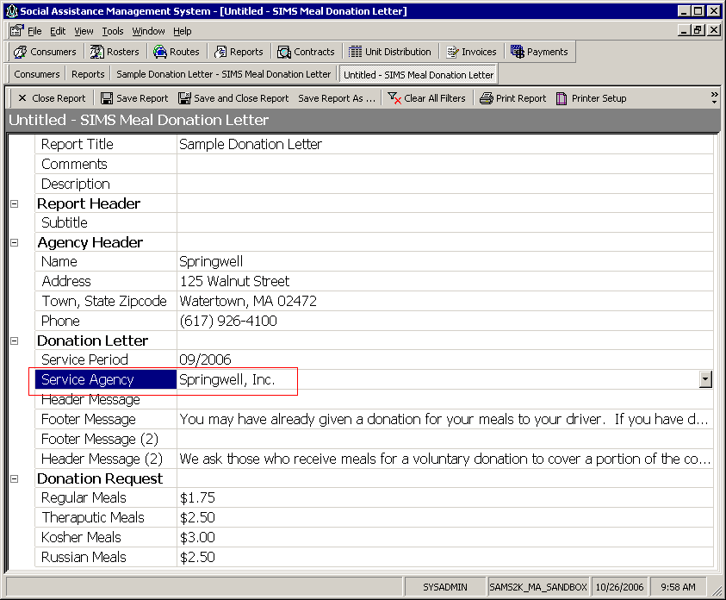

Customize the Messages to be printed on the donation letter request to your organization’s needs.

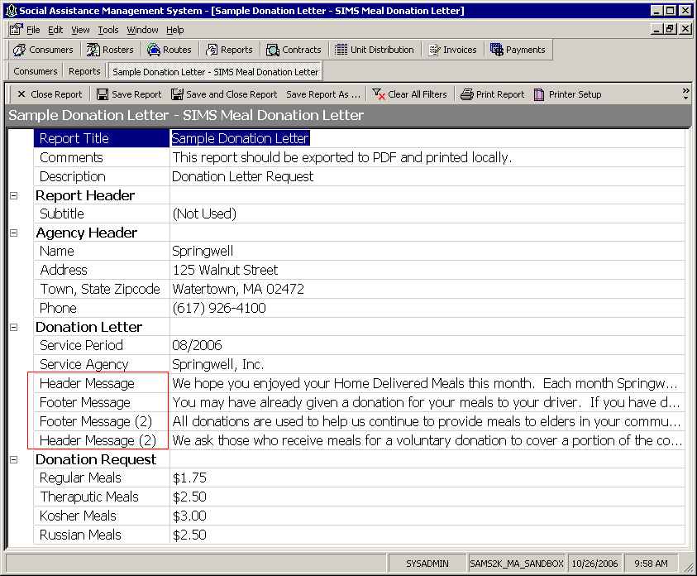

The donation request amounts come pre-populated, but can be updated to account for future price changes.

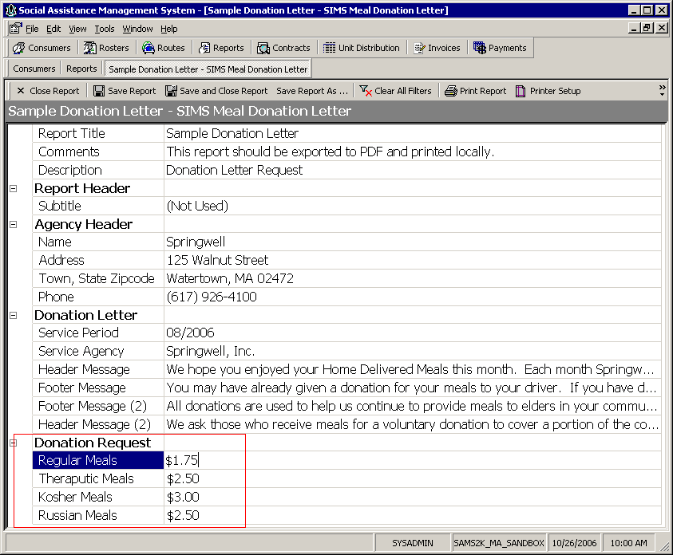

Once the definition is completed, click Print Preview.

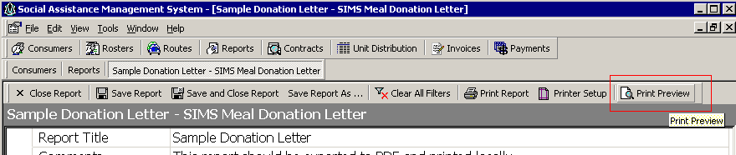

The final output will generate a combination of the consumer data in SIMS with the messages defined in the report template.

The To: Field is the consumer’s mailing address, or consumer’s bill-to contact.

The For: record is always the consumer’s name and their mailing address.
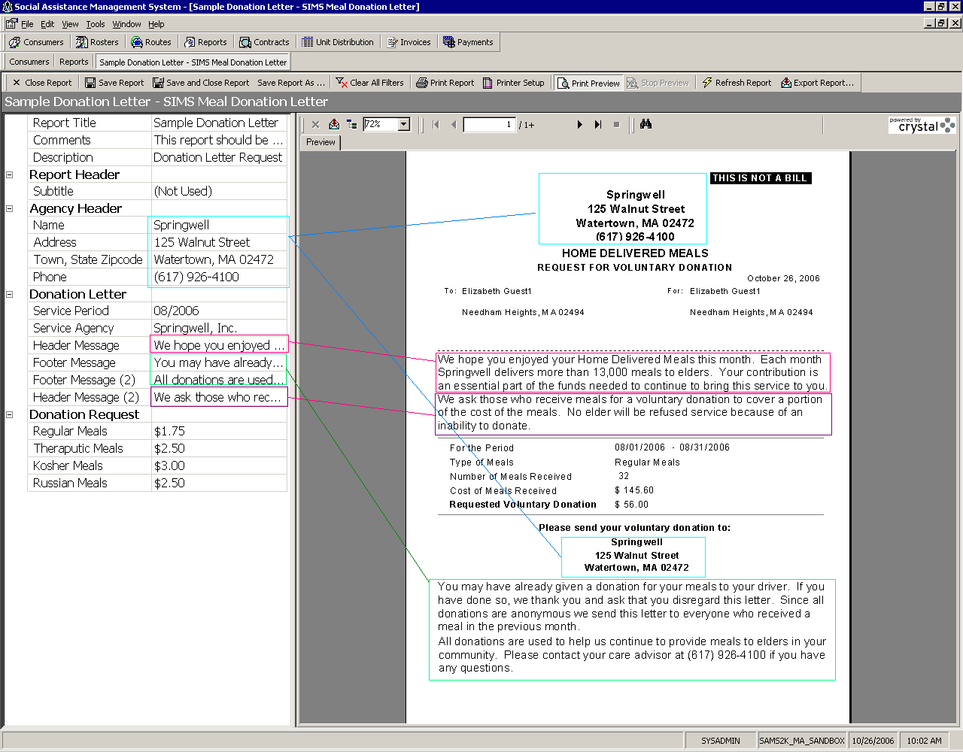

Upon successful preview, the report generated (which may be several hundred pages) should be exported to the local User’s hard drive before printing. This ensures that the large print job will not be interrupted or hindered by a sudden disconnect and provide maximum performance with the local printer.

To export the final report, choose Export Report..

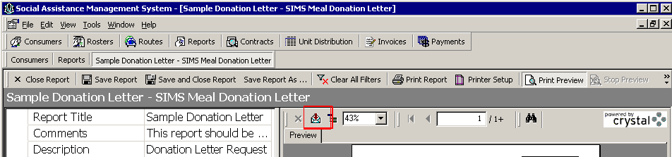

Choose Adobe Format (PDF)
Choose OK

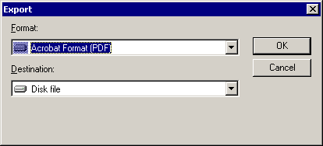

Choose OK for All
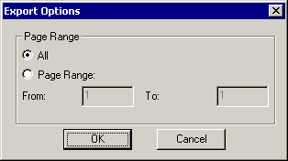

Drop down the Save In Folder Selection choice and choose the V:\ drive. This is the local C:\ drive on the user’s computer.
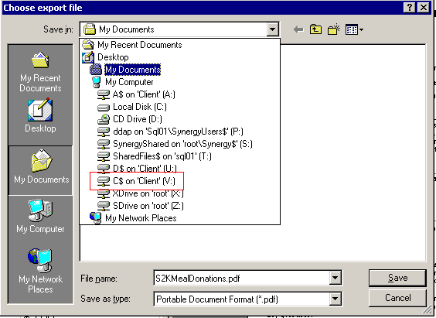

Choose Save

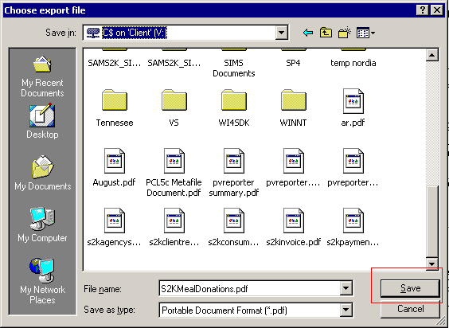

Once complete, the file can be located on your local PC from Windows Explorer and opened with Adobe Reader.

If you do not have Adobe Reader, a free download can be obtained here:
http://www.adobe.com/products/acrobat/readstep2.html

Alternatively, the Word Format can also be chosen for export format. This option would allow the user to further customize the layout and fonts prior to printing. Please note the Word Format is a larger export file and will take longer to download.

Other Features

User Fields
Please see the document “SIMS SAMS 2.0 User Guide – Massachusetts version” pages 185 through 189, published September 11, 2008 for more detail on User Fields.

User Fields are custom data fields that have been added to the Massachusetts version of SAMS to allow agencies to track and report on specific data elements. Requests for new user fields should be sent to ELD Nutrition Program and cc’ed to SIMS Support with a detailed description explaining the business need for the request.
Nutrition specific user fields are listed below:
- Does the Consumer get Holiday Meal
- Donation Letter Refused?
- Emergency Meal?
- Food & Fuel At Risk?
- Recommended for Food Stamps?
- Did the Client Cancel Meals?

Users can record responses for these user fields in SAMS which will then allow reports to be run on these specific data elements.
In the screenshot below, we see a client for whom a user field has been entered “Food & Fuel At Risk? Yes.”
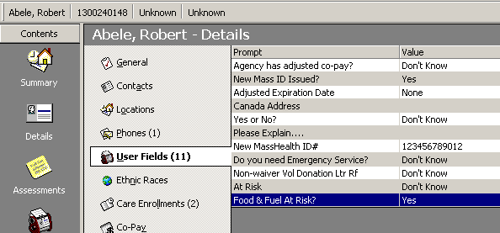

An agency could then create a report to show clients who are noted in a user field as being at risk for Food and Fuel. User Field report options are found under Advanced Fields.

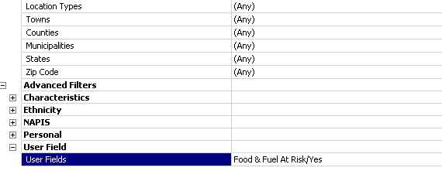

Activities
An Activity is a meeting, phone call, or similar event with or regarding a consumer. Please see the document “SIMS SAMS 2.0 User Guide – Massachusetts version” pages 453 through 466, published September 11, 2008 for more detail on User Fields.

Activities may be used to track and report on clients who were unavailable to receive a home delivered meal.

For example, when an elder is not home to receive a home delivered meal, nutrition staff can enter a new activity in the client record with an Action Type of “Follow Up,” a subject of “Not Home for HDM” and a status of “Completed.”

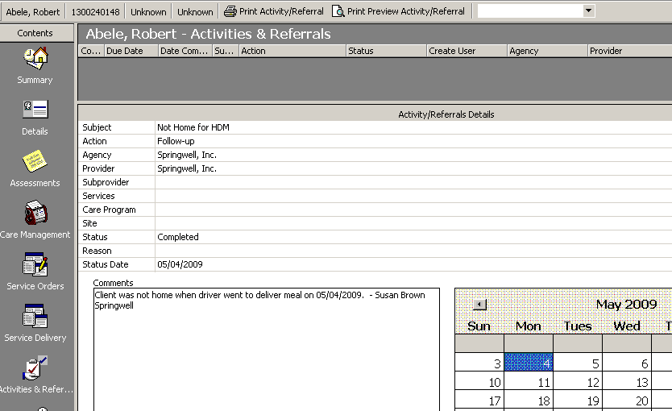

When an elder calls to cancel a home delivered meal, but calls too late (after the meal has already been ordered), nutrition staff can enter a new activity in the client record with an Action Type of “Cancelled Meal,” a subject of “Today - Cancelled HDM” and a status of “Completed.”

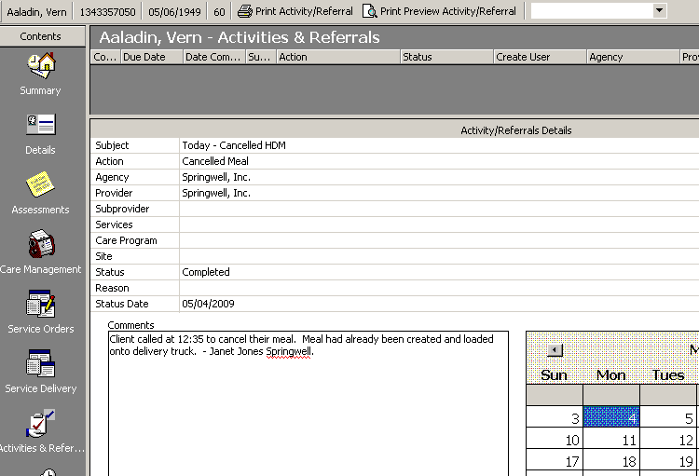

Users can also set Custom Searches to display consumers on their dashboard who have matching activities.

