ALR Dynamics –

FLU Vaccination Reporter Instructions

These instructions provide designated *ALR FLU Vaccination Reporters* (referred to as ***Vaccine Reporters*** from this point forward) with all the information they need to submit staff vaccination information to the Executive Office of Elder Affairs, as required by the MA Department of Public Health.

Contents

Important things to know before you begin: 1

Outline of Steps to Upload and Edit your FLU Vaccination Data 1

**STEP 1**: Prepare the FLU Vaccination data for your ALR on the provided Excel template 2

**STEP 2**: Import the Excel template to the ALR – Dynamics system (must be performed by a designated Vaccine Reporter) 3

**STEP 3**: Edit the information, if necessary, in the ALR – Dynamics system. (Editing will only be allowed up until Midnight, January 15, 2021.) 7

Technical Issues and Support 8

## Important things to know before you begin:

* The Vaccine Reporters for your facility must be existing, active users of the ALR – Dynamics system.
* Vaccine Reporters have additional privileges in the ALR – Dynamics system that other users do not have. ALRs were instructed to provide a list of requested Vaccine Reporters; these are the only users who can enter and access the FLU Vaccine data.
* If you wish to add/remove/change a Vaccine Reporter on your authorized list, please send in a user request form to [ALRincidentreport@MassMail.State.MA.US](mailto:ALRincidentreport@MassMail.State.MA.US).
* Submission of your FLU Vaccine data must be submitted by midnight January 15, 2021.
* This guide, and any updates, is posted to the ALR Help Blog: <https://alrir.800ageinfo.com/>
* For Vaccine Reporters with new accounts, you will be prompted to verify your identity using a phone number or email address. (Multi-factor authentication.)

## Outline of Steps to Upload and Edit your FLU Vaccination Data

Following this broad description of the process, each step will be explained in detail with relevant screenshots.

**STEP 1**: Prepare the FLU Vaccination data for your ALR on the provided Excel template

**STEP 2**: Import the Excel template to the ALR – Dynamics system (must be performed by a designated Vaccine Reporter)

**STEP 3**: Edit the information, if necessary, in the ALR – Dynamics system. (Editing will only be allowed up until Midnight, January 15, 2021.)

## **STEP 1**: Prepare the FLU Vaccination data for your ALR on the provided Excel template

1. Once you receive the Excel template for recording your staff FLU Vaccination data, be sure to save it on your computer and/or office network.

The template contains 7 columns:

**Staffname | Position | Start Date | Date of FLU Vaccination | Medical Exemption | Religious Exemption | ALR**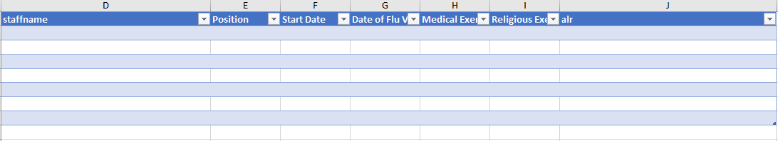

1. Starting with the first row, enter the information completely and accurately for all staff/volunteers/private aides at your ALR.

Important notes on entering data:

* *Position*, *Exemption,* and *ALR* fields are dropdown selections.
* Carefully select the correct ALR from the ALR dropdown field.
* To save data entry time, select your ALR from the ALR dropdown field on the first row, then click and drag lower right corner of selected cell down to copy below for as many rows as needed.

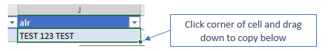

* *Medical Exemption* and *Religious Exemption* fields do not need to be entered manually ***unless*** the response is “YES”. Those fields if left blank will default to “NO” once imported to the system.
* Do not enter any information on other areas of the spreadsheet, and do not attempt to change the formatting or column headers. This will result in an import failure.
* There is a second tab (named “REF”) in the Excel workbook Do not change any data on this tab.
* If you are pasting names from a different spreadsheet or program, use the paste- **values** option to avoid formatting problems. It appears as shown below, typically with a ‘123’ label on it.

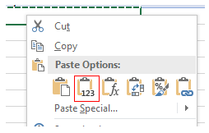

Example of a completed Vaccine Reporter template:

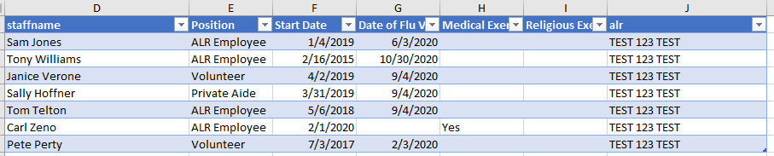

## **STEP 2**: Import the Excel template to the ALR – Dynamics system (must be performed by a designated Vaccine Reporter)

1. After staff information has been entered, save your Excel template to a location on your computer/network.
2. Log into the ALR – Dynamics system. (Must be a designated Vaccine Reporter for your ALR)
3. Near the top of the screen, click the dropdown arrow to the right of *ALRs and Individual and Facility-wide Reports.*

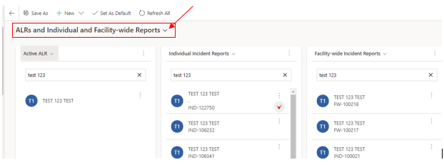

1. Click on the Selection for *Flu Vaccine*.

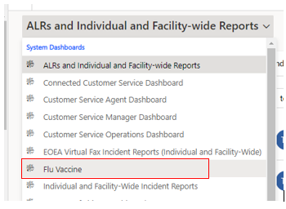

Before any data is imported, the *FluVaccines* page will look like this:

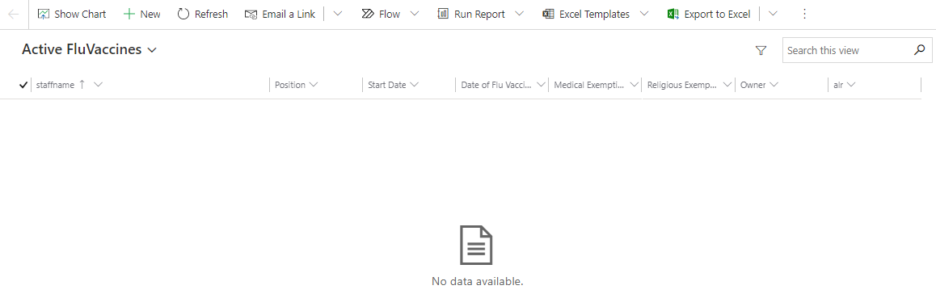

Along the top of the screen, you will see various Excel related options. You may need to click on the vertical ellipsis* on the far right to access *Import from Excel*.

*Vertical ellipsis: 

1. Click on *Import from Excel*.

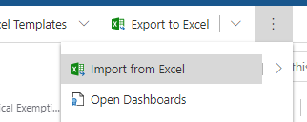

1. This will display the Import from Excel dialog box. Click *Choose File*.

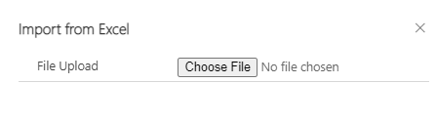

1. Navigate to the location on your computer/network where you saved the completed template. Select the file and click *Open*.

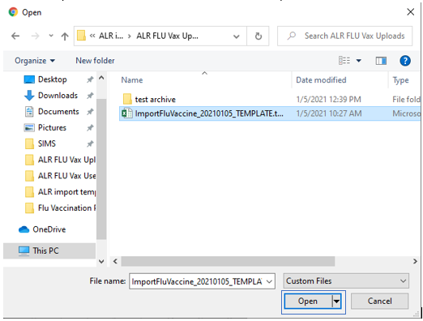

1. Click Next, near the bottom right of the screen.

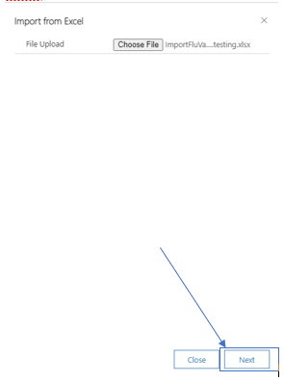

1. Click *Finish Import*. [In most situations you will not change the *Duplicate Data Settings*.]

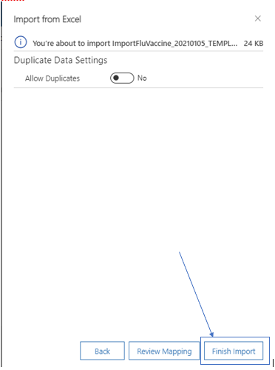

1. You should see the message below appear. Click the X to close.

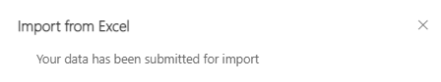

It may take a few minutes and several refreshes -  - for your imported data to appear.

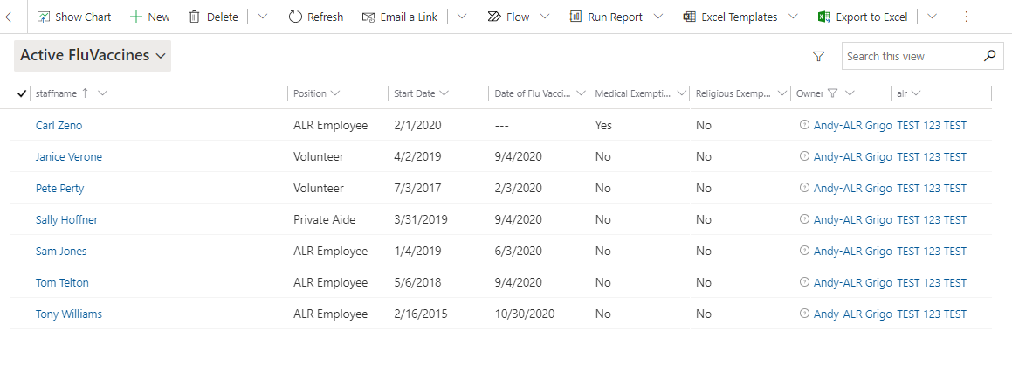

## **STEP 3**: Edit the information, if necessary, in the ALR – Dynamics system. (Editing will only be allowed up until Midnight, January 15, 2021.)

1. If you need to edit the imported information for a specific person, double-click the person’s row, or click on the name.

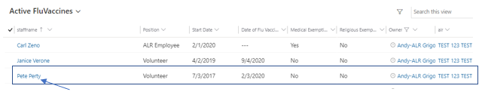

1. Make the change by editing the desired field and be sure to click *Save & Close* when complete.

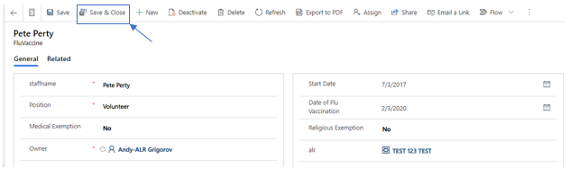

1. To add a new person to your FLU Vaccine list, Click on New -  - and complete all fields. Click Save & Close when complete.

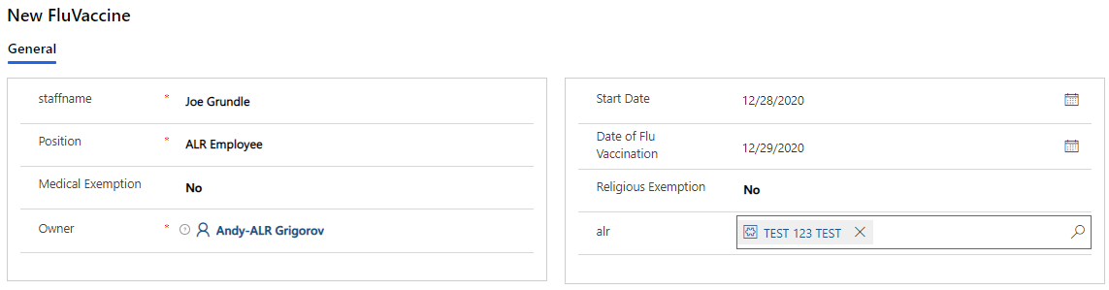

1. Wait a moment, and *refresh* to see your new entry.



1. Use the column headers to filter and sort your columns, if desired. Click the arrow to the right of the column name.

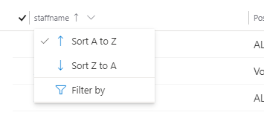

## Technical Issues and Support

If you encounter problems importing and accessing your FLU Vaccine data, please send an email with a complete description of your issue, including screenshots if available, to [ALRincidentreport@MassMail.State.MA.US](mailto:ALRincidentreport@MassMail.State.MA.US).

Include your name, and your complete facility name in the email.

Document History

|  |  |  |  |
| --- | --- | --- | --- |
| Version | Note | Author | Date |
| 1.0 | Final draft | Andy Grigorov | 1/6/2021 |
| 2.0 | Revised p. 3 instructions | Andy Grigorov | 1/12/2021 |
|  |  |  |  |
|  |  |  |  |