
The Commonwealth of Massachusetts
Executive Office of Elder Affairs

One Ashburton Place, 5th Floor

Boston, Massachusetts 02108

CHARLES D. BAKER
Governor

Tel: (617) 727-7750
Fax: (617) 727-9368
www.mass.gov/elders
KARYN E. POLITO
Lieutenant Governor

ALICE F. BONNER
Secretary

PROGRAM INSTRUCTION (PI)

EOEA PI -17 -01
TO: Aging Service Access Points (ASAPs)
Executive Directors
Program Managers
Nurse Managers

FROM: Alice F. Bonner, Secretary

DATE: January 6, 2017

RE: Falls protocol

Purpose:
Falls and fall-related injuries are a geriatric syndrome and a major threat to the independence and well-being of older adults. Falls are the leading cause of both fatal and nonfatal injuries in people over age 65, and are responsible for significant disability, hospitalization, loss of independence, and reduced quality of life. This Program Instruction (PI) has been issued by the Executive Office of Elder Affairs (EOEA) to provide Aging Service Access Points (ASAPs) with the tools necessary to identify and mitigate preventable fall-related injuries.

Background and Program Implications:
ASAP Care Managers (CMs) and Registered Nurses (RNs) may identify consumers who are at risk for falls through the screening and assessment process. Early identification may lead to earlier recommendations or interventions for consumers and caregivers that may reduce fall risk. Implementing a falls protocol ensures continuity of care for the consumer and the teams managing consumers who are at increased risk for falls.

The Department of Public Health via a Prevention and Wellness Trust Fund grant, established collaborations between Community Health Centers (CHCs), Aging Service Access Points (ASAPs), Visiting Nurse Associations (VNAs), Community Health Workers (CHWs) and Primary Care Physicians (PCPs) to identify risk factors leading to falls and evidence-based or evidence-informed interventions to reduce falls. Many agencies engaged in this effort utilize Community Health Workers to assist in Home Safety Assessments with consumers and their caregivers, as well as other interventions.

This PI serves to build upon these efforts, incorporating national protocols such as the National Council on Aging guidelines.

Causes and Fall Risk Factors
Fall risk factors are characteristics or situations that increase a person’s chance of falling. Risk factors can generally be grouped into three categories: biological, behavioral, and environmental. (Attachment 1)

Required Actions:
ASAPs shall implement a standardized Falls Protocol which includes a mechanism for identifying risk, strategies and interventions for the prevention of falls, person-centered teaching tools and/or evidenced-based programs focused on fall prevention.

There are two mechanisms for identifying which consumers may be at risk for falls. The first utilizes three questions from the Comprehensive Data Set (CDS). The three questions are:
- Falls frequency: Has the consumer fallen in the last 90 days or since the last assessment?
- Potential for falls: Does the consumer feel unsteady when standing or walking?
- Does the consumer worry about falling?
An affirmative answer to any of these questions will identify a consumer who may be at increased risk for falls.

The second mechanism for identifying and evaluating level of risk is using the HCBS Explorer Reporting Tool. This will be available for ASAPs in the future and utilizes a predictive modeling algorithm that categorizes consumers as either a low or high risk for falls based on their assessment findings in the CDS. ASAPs may utilize this report to prioritize targeted consumer interventions.

Once a consumer is identified as being at risk for falls, the ASAP must address the risk with the consumer and offer further evaluation and consideration for appropriate interventions. If the consumer declines further evaluation, the ASAP must document this in the consumer’s SIMS record. If the consumer wants to self-refer for any interventions, the ASAP must follow up within a week to ensure the consumer has made the self-referral. If the consumer is willing to engage in falls interventions, the ASAP should take the necessary steps to recommend evidence-informed interventions.

Interventions may include any combination of the following and should be documented in the consumer’s SIMS record:
- Notification to caregiver or family member designated as contact person
- Notification to the consumer’s designated medical provider
- Referral for Physical Therapy, Occupational Therapy or equipment evaluation
- Referral to Evidence-Based Falls Prevention Program (e.g. Matter of Balance, Tai Chi)
- Referral for medication review
- Referral/provision of falls prevention education, including recommended actions
- Referral for environmental modifications
- Referral for vision examination
- Explanation of the falls risk assessment (Attachment 2) that may be completed by the consumer or a family member on their own, if preferred.

Interventions should address the consumer’s risk factors for falling and take into account whether the risk factors are modifiable. It is strongly recommended that the designated medical provider is notified when a person is at risk for falls. The CDS addresses multiple causes of falls, such as cognitive impairment(s), continence issues (bowel and bladder), visual impairment(s), nutrition, substance abuse, and multiple medications. Attachment 3 provides examples of more interventions.

PLEASE NOTE: The ASAP care team should consider the possibility of elder abuse when a consumer presents with evidence of a fall, particularly one with an unusual or suspicious explanation. Report suspected elder abuse to protective services to the Elder Abuse Hotline:
1-800-922-2275.

Effective Date: January 6, 2017
Contact: Mary DeRoo @ Mary.deroo@massmail.state.ma.us or 617-222-7468 for questions about this PI.

Attachment 1

Causes and Fall Risk Factors
Fall risk factors are characteristics or situations that increase a person’s chance of falling. Risk factors can generally be grouped into three categories: biological, behavioral, and environmental. Examples are as follows:

Biological risk factors
- Age (over 65 and especially over 80)
- Confusion, dementia, depression, anxiety
- Muscle weakness, unsteady gait or balance problems
- Dizzy when changing positions
- Medication side effects and/or interactions
- 4+ medications daily
- Chronic health conditions such as Parkinson’s, MS, arthritis, heart failure, history of stroke
- Poor vision or hearing
- Loss of sensation in feet (neuropathy), leg swelling, foot problems or pain
- Any recent illness such as fever, dehydration, infection, acute neurological event (stroke);
recent hospitalization
- Past history of at least one fall
- Urge incontinence (having to hurry to get to the bathroom
- Problems with blood pressure (high or low)

Behavioral risk factors
- Inactivity
- Risky behaviors such as standing on a chair in place of a step stool
- Alcohol or substance use
- Behavioral manifestations of distress that lead to the use of psychoactive medications
- Poor judgment (ie. going outside in ice or snow)
- Furniture crawling/grabbing onto furniture when walking

Environmental risk factors
- Clutter and unclear pathways or uneven floors; oxygen tubing or other medical equipment
contributing to clutter
-Broken steps or floors in poor repair
- Poor lighting
- Loose rugs or hand rails
- Electrical cords or other hazards
- Lack of grab bars inside and outside of tub or shower, on stairs; lack of adaptive equipment
- Wet surfaces
- Unsafe or ill-fitting footwear- wearing socks instead of shoes
- Pets or small children

Attachment 2
This falls risk assessment is available online from the CDC and can be downloaded at https://www.cdc.gov/steadi/pdf/STEADI-Brochure-StayIndependent-508.pdf

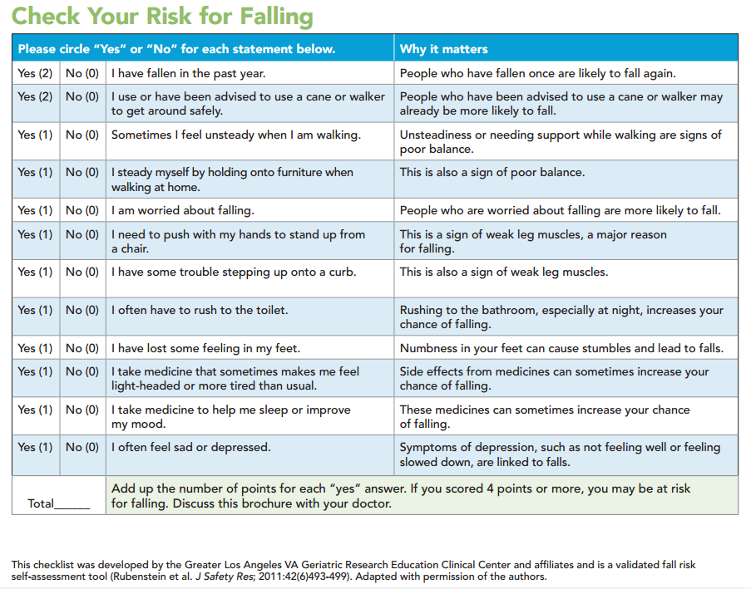

Attachment 3

Examples of additional strategies/interventions to consider:

- Referral to primary care physician for multifactorial falls risk assessment
- Encourage use of assistive device for ambulation
- Encourage consumer to get up from a sitting or lying position slowly
- Encourage proper foot wear during ambulation
- Encourage consumer to take medications as prescribed and report concerns or side effects to their physician
- Encourage clear pathways
- Encourage use of grab bars while bathing, toileting, showering and on stairs
- Encourage adequate hydration
- Encourage use of prescribed eyewear
- Refer to exercise/physical therapy programs aimed at improving balance, gait, and strength
- Refer to Healthy Living Center of Excellence @ www.healthyliving4me.org to learn about evidence-based fall prevention programs
- Refer to toolkits such as STEADI 3.(Stopping Elderly Accidents, Deaths & Injures) www.cdc.gov/steadi
- Encourage medication review with pharmacist or primary care provider
- Encourage management of chronic health problems such as heart failure & diabetes
- Encourage management of foot problems and foot pain
- Discuss proper and properly fitting footwear
- Modify home environment
- Recommend Personal Emergency Response Systems (PERS)
- Encourage regular eye exams

Centers for Disease Control and Prevention, National Center for Injury Prevention and Control. Web–based Injury Statistics Query and Reporting System (WISQARS) [online]. Accessed August 15, 2013
Greene BR, Redmond SJ, Caulfield B. Fall risk assessment through automatic combination of clinical fall risk factors and body-worn sensor data, DOI 10.1109/JBHI.2016.2539098, IEEE Journal of Biomedical and Health Informatics 2015.

